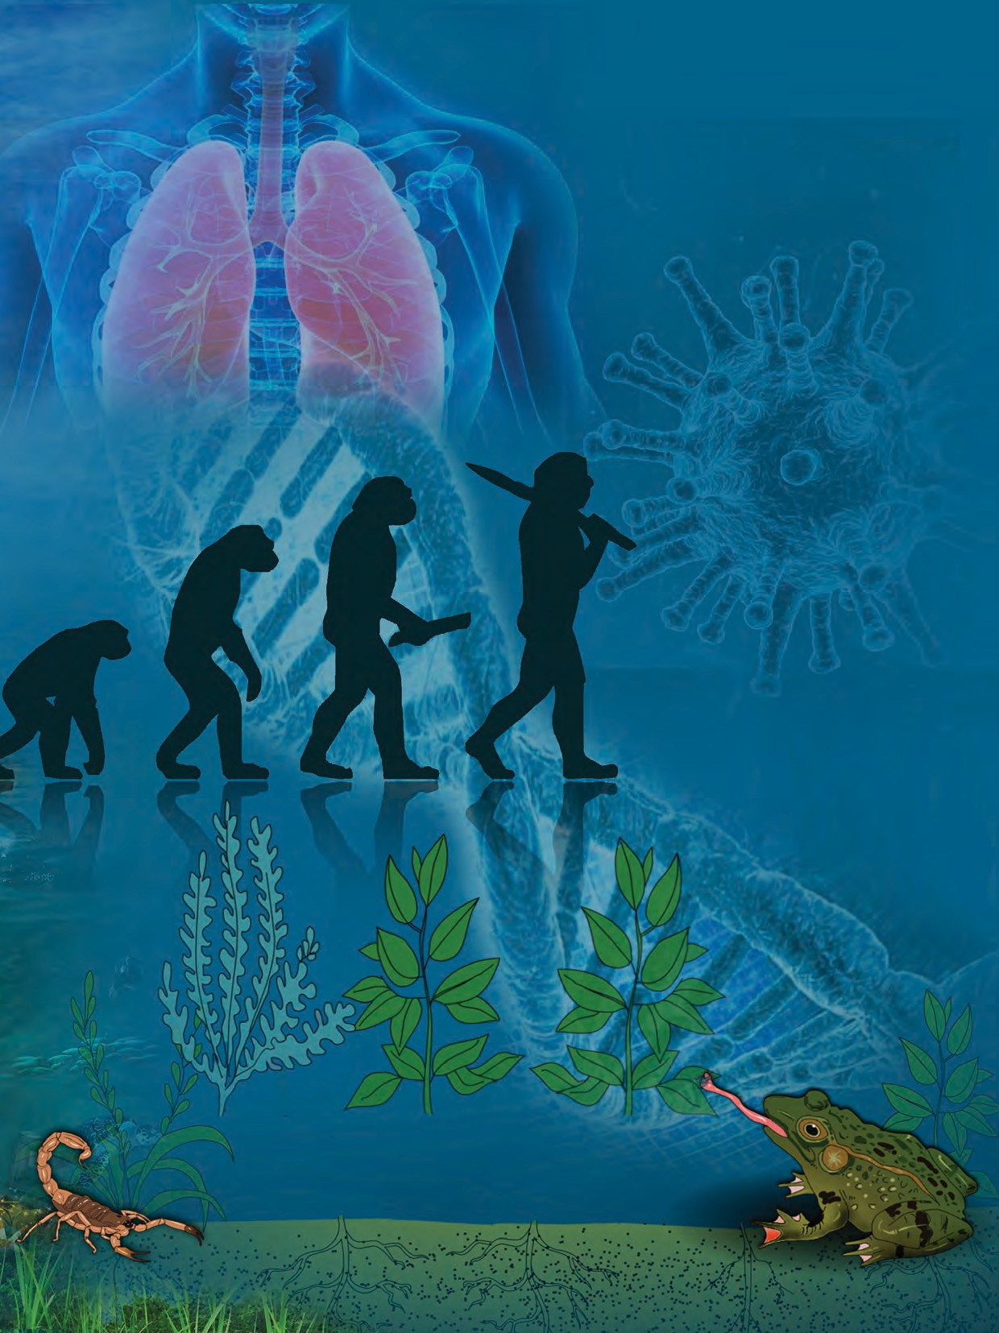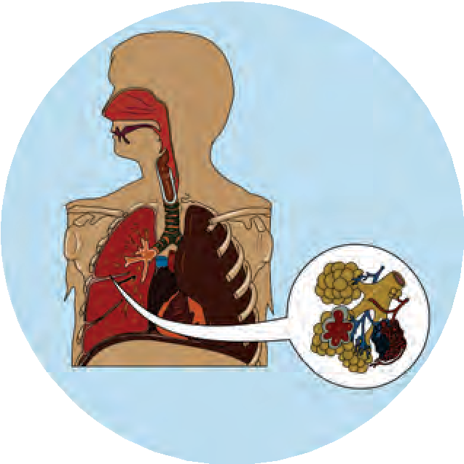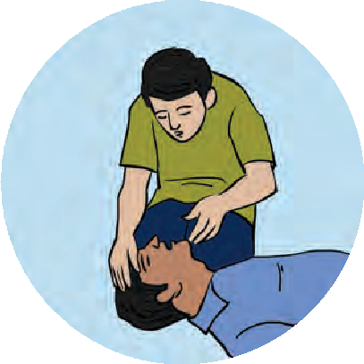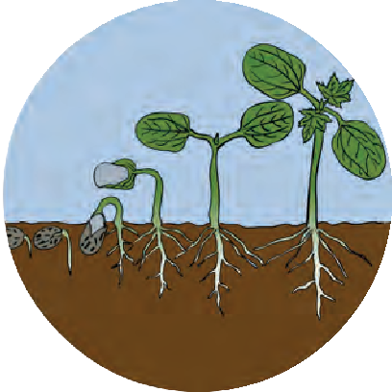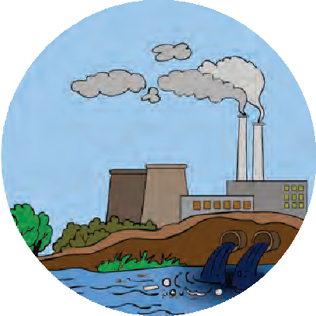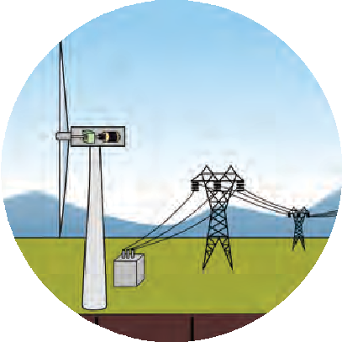

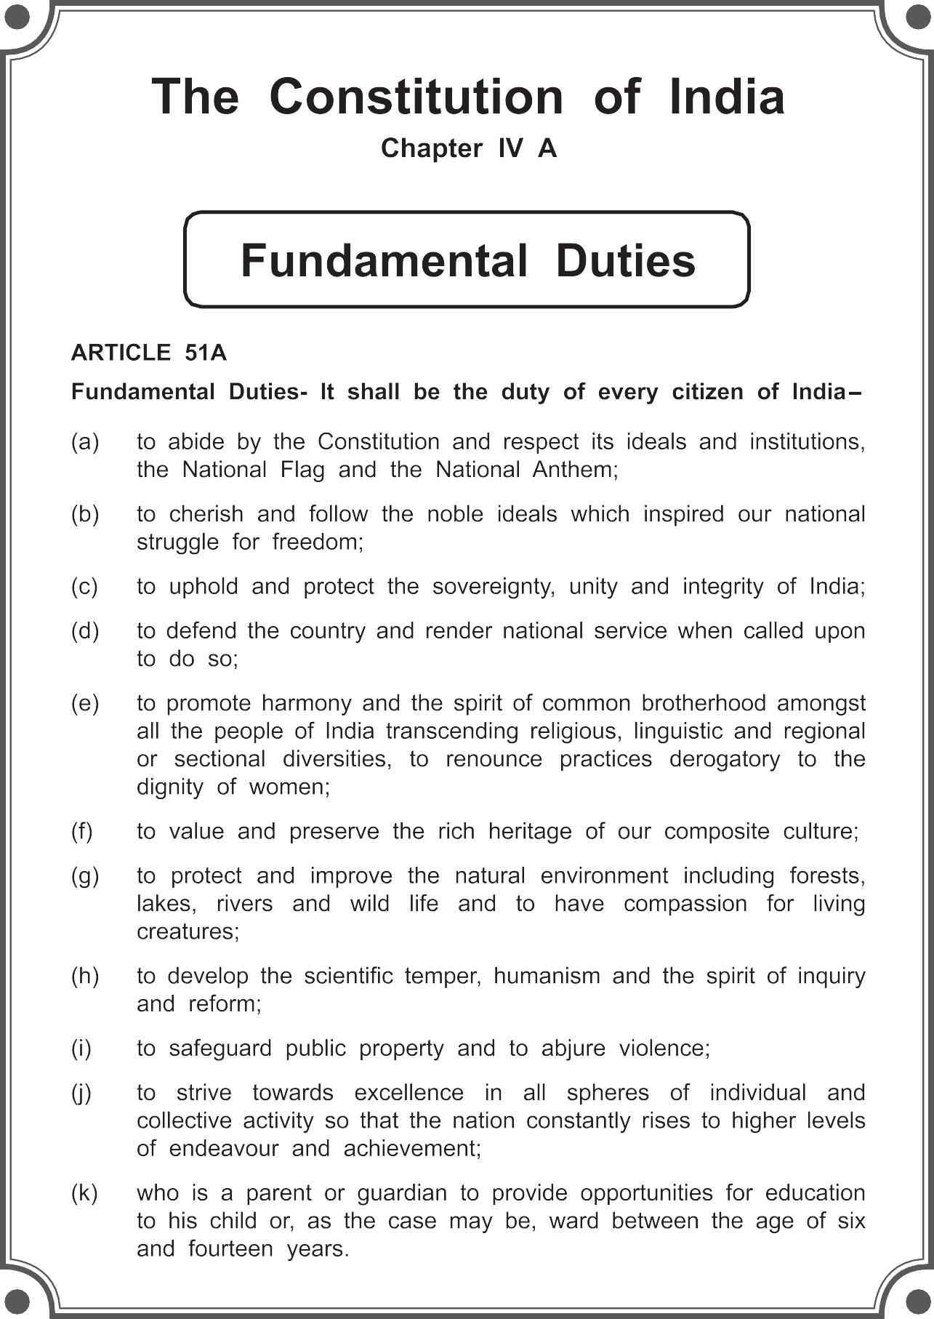

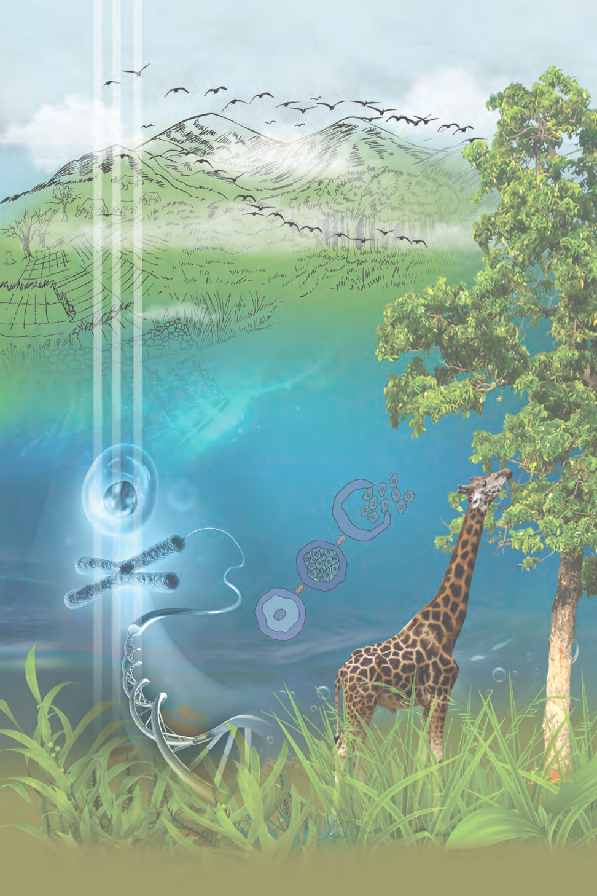

Permission is granted for enforcing this textbook from the academic year 2018-19 in the meeting, held on the date 29.12.2017, of the co-ordination committee constituted by the Government resolution No: Abhyas-2116/(Pra.kra.43/16) S.D-4 dated 25.4.2016

SCIENCE AND TECHNOLOGY

STANDARD TEN PART – 2

Maharashtra State Bureau of Textbook Production and Curriculum Research, Pune.

The digital textbook can be obtained through DIKSHA App on a smartphone by using the

Q.R Code given on title page of the textbook and useful audio-visual teaching-learning material of the relevant lesson will be available through the

Q.R Code given in each lesson of this textbook.

**First Edition : 2018 Reprint : 2022**

**© Maharashtra State Bureau of Textbook Production and Curriculum Research, Pune - 400 004.**

The Maharashtra State Bureau of Textbook Production and Curriculum Research reserves all rights relating to the book. No part of this book should be reproduced without the written permission of the Director Maharashtra State Bureau of Textbook Production and Curriculum Research,'Balbharati', Senapati Bapat Marg. Pune 411 004

**Science Subject Committee:**

**Dr. Chandrashekhar Vasantrao Murumkar, Chairman**

Dr. Dilip Sadashiv Joag, Member Dr. Sushama Dilip Joag, Member Dr. Pushpa Khare, Member

Dr. Imtiaz Sirajuddin Mulla, Member Dr. Jaydeep Vinayak Sali, Member Dr. Abhay Jere, Member

Dr. Sulabha Nitin Vidhate, Member Smt. Mrinalini Desai, Member

Shri. Gajanan Shivajirao Suryawanshi, Member Shir. Sudhir Yadavrao Kamble, Member

Smt. Dipali Dhananjay Bhale, Member Shir. Rajiv Arun Patole, Member Secretary

**Cover and Illustrations:**

Shri. Vivekanand Shivshankar Patil Ashana Advani **Typesetting :**

DTP Section, Textbook Bureau, Pune

Coordination:

**Rajiv Arun Patole**

Special Officer for Science

**Translation :**

Dr. Jaydeep Vinayak Sali Shri. Sandip Popatlal Chordiya

Scrutiny :

Dr. Chandrashekhar V. Murumkar Dr. Pushpa Khare

**Science Study Group :**

Dr. Prabhakar Nagnath Kshirsagar Dr. Vishnu Vaze

Dr. Prachi Rahul Choudhary

Dr. Shaikh Mohammad Waquioddin H. Dr. Ajay Digambar Mahajan

Dr. Gayatri Gorakhnath Choukade Shri. Prashant Panditrao Kolse Shri. Sandip Popatlal Chordiya Shri. Sachin Ashok Bartakke

Smt. Shweta Dilip Thakur Shri. Rupesh Dinkar Thakur

Shri. Dayashankar Vishnu Vaidya Shri. Sukumar Shrenik Navale Shri. Gajanan Nagoraoji Mankar

Shri. Mohommed Atique Abdul Shaikh Smt. Anjali Lakshmikant Khadke

Smt. Manisha Rajendra Dahivelkar Smt. Jyoti Medpilwar

Smt. Dipti Chandansingh Bisht Smt. Pushpalata Gawande Smt. Anita Patil

Smt. Kanchan Rajendra Sorate Shri. Rajesh Vamanrao Roman Shri. Nagesh Bhimsevak Telgote Shri. Shankar Bhikan Rajput Shri. Manoj Rahangdale

Shri. Hemant Achyut Lagvankar Smt. Jyoti Damodar Karane Shri. Vishwas Bhave

**Paper**

70 GSM Creamwove **Print Order : Printer :**

**Production :**



**Shri. Sachchitanand Aphale** Chief Production Officer **Shri. Rajendra Vispute** Production Officer

**Publisher :**

**Shri. Vivek Uttam Gosavi**

Controller

Maharashtra State Textbook Bureau,

Prabhadevi, Mumbai - 400 025

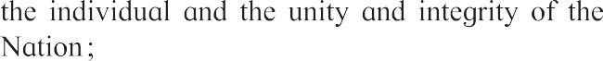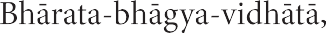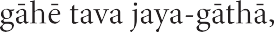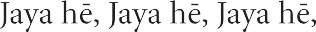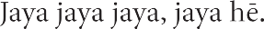

NATIONAL ANTHEM

# Preface

Dear students

Welcome to Std X. We have great pleasure in offering you this Science and Technology textbook based on the new syllabus. From the primary level till today, you have studied science from various textbooks. In this textbook, you will be able to study the fundamental concepts of science and technology from a different point of view through the medium of the different branches of Science.

The basic purpose of this textbook Science and Technology Part-2 can be said to be ‘Understand and explain to others’ the Science and Technology that relates to our everyday life. While studying the concepts, principles and theories in science, do make the effort to understand their connection with day to day affairs. While studying from this textbook, use the sections ‘Can you recall?’ and ‘Can you tell?’ for revision. You will learn science through the many activities given under the titles such as ‘Observe and discuss.’ and ‘Try this’ or ‘Let’s try this. Make sure that you perform all these activities. Activities like ‘Use your brain power!’, ‘Research’, ‘Think about it’ will stimulate your power of thinking.

Many experiments have been included in the textbook. Carry out these experiments yourself, following the given procedure and making your own observations. Ask your teachers, parents or classmates for help whenever you need it, interesting information, which reveals the science underlying the events we commonly observe and the technology developed on its basis, has been given in details in this textbook through several activities. In this world of rapidly developing technology, you have already become familiar with computers and smartphones. While studying the textbook, make full and proper use of the devices of information communication technology, which will make your studies easier. For more effective studies, you can avail additional audio-visual material for each chapter using the Q.R code through an App. This will definitely help you in your studies.

While carrying out the given activities and experiments, take all precautions with regard to handling apparatus, chemicals, etc. and encourage others to take the same precautions.

It is expected that while carrying out activities or observation involving plants and animals, you will also make efforts towards conservation of the environment. You must of course take all the care to avoid causing any harm or injury to them.

Do tell us about the parts that you like, as well as about the difficulties that you face as you read and study and understand this textbook.

Our west wishes for your academic progress.



Pune

Date: 18 March 2018, Gudhipadva

Indian Solar Year : 27 phalgun 1939

**(Dr. Sunil Magar) Director**

Maharashtra State Bureau of Textbook and Curriculum Research, Pune

**For Teachers**



* The real objective of science education is to learn to be able to think about events that are happening around us, logically and with discretion.
* In view of the age group of Std X students, it would be appropriate now, in the process of science education, to give freedom and scope to students’ own curiosity about the events of the world, their propensity to go looking for the causes behind them and to their own initiative and capacity to take the lead.
* As experimentation is necessary to learn the skills of observation, logic, estimation, comparison and application of available data, which form a part of science education, deliberate efforts must be made to develop these skills while dealing with laboratory experiments give in the textbook. All observations that the students have noted should be accepted and then they should be helped to achieve that the expected results.
* These two years in middle school lay the foundation of higher education in Science. Hence, it is our duty and responsibility to enrich and enhance the student’s interest in science. You all will of course always actively pursue the objective of developing their creativity and imbuing them with a scientific temper.
* You can use ‘Let’s recall’ to review the previous knowledge for a lesson and ‘Can you tell?’ to introduce a topic by eliciting all the knowledge that the students already have about it from their own reading or experience. You may of course use any of your own activities or questions for this purpose. Activities given under ‘Try this’ and ‘Let’s try this’ help to explain the content of the lesson. The former are for students to do themselves and the latter are those that you are expected to demonstrate. ‘Use your brain power!’ is meant for application of previous knowledge as well as the new lesson, and ‘Always remember’ gives important suggestions/information or values. ‘Research’, ‘Find out’, ‘Do you know?’ ‘ Introduction to scientists’ and ‘Institutes at work’ are meant to give some information about the world outside the textbook and to develop the habit of doing independent reference work to obtain additional information.
* This textbook is not meant for reading and explaining in the classroom but guiding students to learn the methods of gaining knowledge by carrying out the given activities. An informal atmosphere in the classroom is required to achieve the aims of this textbook. All students should be encouraged to participate in discussions, experiments and activities. Special efforts should be made to organize presentations or report-reading in the class based on students activities and projects, besides observing of Science Day and other relevant occasions/days.
* The science and technology content of the textbook has been complemented with Information Communication Technology. These activities are to be conducted under your guidance along with the learning of various new scientific concepts.

**Front and back covers :** Pictures of various activities, experiments and concepts in the book.

DISCLAIMER Note : All attempts have been made to contact copy righters (©) but we have not heard from them. We will be pleased to acknowledge the copy right holder (s) in our next edition if we learn from them.

**Competency Statements Std X**

The students are expected to achieve the following competency level after studying the text book Science and Technology II

|  |  |  |
| --- | --- | --- |
|  | **The Living World.** |  |
| * To analyze the scientific information about heredity and state opinions about new hybrid species. * To understand evolution theories or living and state there characteristics. * To explain reproductive systems of plants and animals. * To state importance of cell science by collection of information of cell on utility and various medical facilities. * To understand production processes of various biotic factors by experiments and prove them scientifically. * To collect and analyze useful data by observing diversity of animals through different tools. * To describe animals in the surroundings on scientific basis and classify them. * To develop awareness of hobbies like watching the things and their conservation. * To present documentary on animals. * To collect useful and scientific information on human reproductive system and explain effects on society. * To eradicate superstitions and rigid customs prevailing in society. | | |
|  |  |  |

|  |  |  |
| --- | --- | --- |
|  | **Natural resources and disaster management** |  |
| * To explain role of environmental guard by conservation of environment, various laws and rules. * To adapt scientific life style in the role of environmental guard. * Get attention of society towards negligence towards conservation of environment. * To plan and implement programs about conservation of environment. * To play self-role in disaster management considering international understanding, help and togetherness. | | |
|  |  |  |

|  |  |  |
| --- | --- | --- |
|  | **Diet and Nutrition** |  |
| * To set up the experiments, projects in our environment in small scale considering advantages and disadvantages of Biotechnology. * To aware farmers and components of society by various graphs of Biotechnology. * To take feedback of comparative study of progress of Biotechnology in India and the other countries. * To find out various problems regarding conservation of ecosystems. * To collect data on conservation of ecosystem and to take a distinct role to awake the society. * To change one’s lifestyle by taking into account the various aspects and effects which endanger social health. * To spread the roles of government and non-government organizations to nurture social health. | | |
|  |  |  |

|  |  |  |
| --- | --- | --- |
|  | **Energy** |  |
| * By considering the serious consequences of the energy crisis, adopt proper lifestyle and motivating others to decide their lifestyle accordingly. * Explain the steps involved in the process of generation of electrical energy. * To analyze the correlation of electricity generation processes and environment. * Knows the importance of green energy and saves energy in daily life. | | |
|  |  |  |

|  |  |  |
| --- | --- | --- |
|  | **Information Communication Technology.** |  |
| * Use of Information Communication Technology in daily life. * Exchange of knowledge about science and Technology with the help of internet. * Awareness about the proper use of information communication technology. * Based on the information gathering, with various types of information related to Science and Technology. To predict it. Ability of prediction on the basis of science and technology data collected from internet. * To understand dangers (cybercrimes) while using information communication technology and take precautions against them. | | |
|  | * Effective use of various systems developed through information communication technology in daily life. |  |

**CONTENT**

**No. Chapter**

**Page No.**

1.

2.

3.

4.

5.

6.

7.

8.

9.

Heredity and Evolution

1

Life Processes in Living Organisms Part -1 12

Life Processes in Living Organisms Part - 2 Environmental management Towards Green Energy Animal Classification Introduction to Microbiology Cell Biology and Biotechnology Social health

22

36

47

61

77

88

101

10. Disaster Management 109

**Academic Planning**

Two separate books have been prepared for science and technology. Science and technology part 2 contains ten chapters mainly related to Biology, Environment, Microbiology, Biotechnology. While thinking about science and technology, it is expected that an integrated approach will be taken while teaching and a connection will be made between different components of science and technology. In previous standards, we have studied various topics in science and technology together. For technical ease two separate books of science and technology part 1 and part 2 have been prepared, but it is necessary that an integrated perspective be taken while teaching.

Out of the ten chapters included in textbook science and technology part 2, the first five chapters are expected to be taught in the first session while the next five chapters in the second session. At the end of a session, a written examination for 40 marks and a practical examination for ten marks should be conducted. Exercises and projects have been given at the end of every chapter in the text book.

In view of evaluation, representative questions similar to those in the activity sheets of language books are given in exercises. You may make similar other questions for your use. The students should be evaluated based on these questions. Detailed information about this will be given in separate evaluation scheme.

1. Which component of the cellular nucleus of living organisms carries hereditary characters?



**Can you recall?**



**1. Heredity and Evolution**

* Heredity and Hereditary Changes
* Evolution
* Darwin’s Theory of Natural Selection
* Speciation
* Transcription, Translation & Translocation
* Evidences of Evolution
* Lamarckism
* Human Evolution

1. What do we call to the process of transfer of physical and mental characters from parents to the progeny?
2. Which are the components the DNA molecule?

Heredity and hereditary changes

You know that heredity is the transfer of biological characters from one generation to another via genes. Gregor Johann Mendel is pioneer of the modern genetics. It took a long time to understand the conclusions of his research about heredity. In 1901, the reasons behind the sudden changes were understood due to the mutational theory of Hugo de Vries. Meanwhile in 1902, Walter Sutton observed the paired chromosomes in the cells of grasshopper; until then it was not known to anyone. Research started in the direction of finding the nature of genetic material when it was proved that genes are carried via chromosomes. Through which 1944, trio of scientists Oswald Avery, Mclyn McCarty and Colin McLeod proved that except viruses, all living organisms have DNA as genetic material.

In 1961, the French geneticists Francois Jacob and Jack Monod proposed a model for process of protein synthesis with the help of DNA in bacterial cells. It helped to uncover the genetic codes hidden in DNA. Thereby, the technique of recombinant DNA technology emerged which has vast scope in the field of genetic engineering.

The science of heredity is useful for diagnosis, treatment and prevention of hereditary disorders, production of hybrid varieties of animals and plants and in industrial processes in which microbes are used.

Transcription, Translation and Translocation



Can you tell?

1. Sketch and explain the structure of DNA and various types of RNA.
2. Explain the meaning of genetic disorders and give names of some disorders.

With the help of RNA, the genes present in the form of DNA participate in the functioning of cell and thereby control the structure and functioning of the body. Information about protein synthesis is stored in the DNA and synthesis of appropriate proteins as per requirement is necessary for body. These proteins are synthesized by DNA through the RNA. This is called as ‘Central Dogma’. mRNA is produced as per the sequence of nucleotides on DNA. Only one of the two strands of DNA is used in this process. The sequence of nucleotides in mRNA being produced is always complementary to the DNA strand used for synthesis. Besides, there is uracil in RNA instead of thymine of DNA. This process of RNA synthesis is called as ‘transcription’.



1

Ribosome

mRNA

* 1. **Transcription**

Nucleus

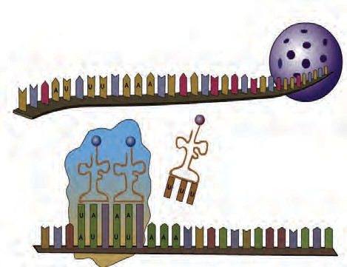

tRNA mRNA

Amino Acid

Codon

` The mRNA formed in nucleus comes in cytoplasm. It brings in the coded message from DNA. The message contains the codes for amino acids. The code for each amino acid consists of three nucleotides. It is called as ‘triplet codon’.

Dr Har Govind Khorana, a scientist of Indian origin has made an important contribution in discovery of triplet codons for 20 amino acids. For this work, he has been awarded with the Nobel Prize in 1968, along with two other scientists.

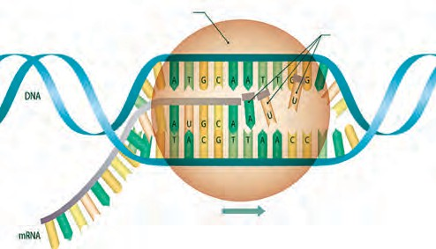

RNA Polymerase

RNA Nucleotides

Transcription

Each mRNA is made up of thousands of triplet codons. As per the message on mRNA, amino acids are supplied by the tRNA. For this purpose, tRNA has ‘anticodon’ having complementary sequence to the codon on mRNA. This is called as ‘translation’. The amino acids brought in by tRNA are bonded together by peptide bonds with the help of rRNA. During this process, the ribosome keeps on moving from one end of mRNA to other end by the distance of one triplet codon.

* 1. **Translation & Translocation**

Main Sequence

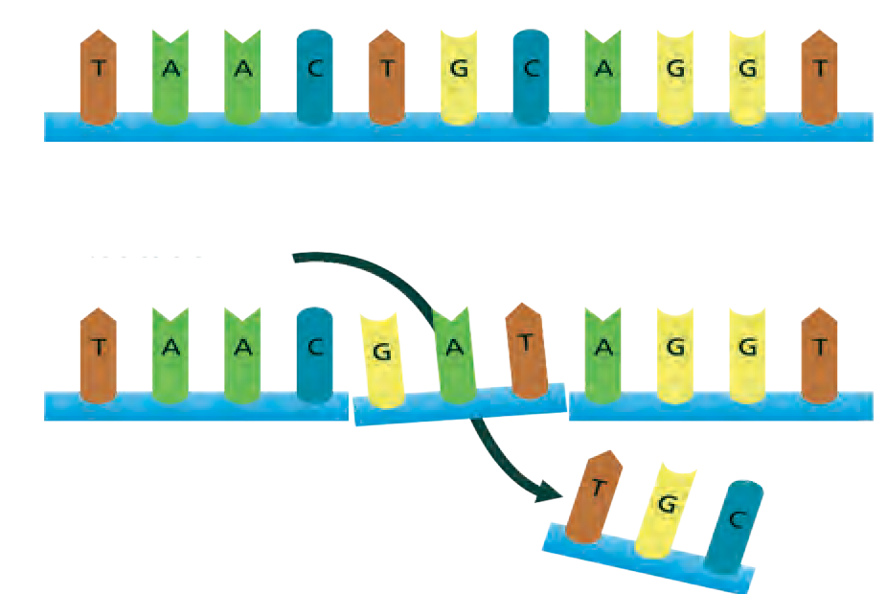

Replacement

* 1. **Mutation**

This is called as ‘translocation’. Such many chains come together to form complex proteins. These proteins control various functions in the body of living organisms and their appearance too.

Living organisms can produce new individuals like themselves due to genes only and some of those genes are transmitted to the next generation without any changes. Due to this, some of the characters of parents are transmitted to their offsprings. However, sometimes sudden changes occur in those genes. Sometimes, any nucleotide of the gene changes its position that causes a minor change which is nothing but the ‘mutation’.

Some mutations may be minor but some may be considerable. Ex. Mutation may cause the genetic disorders like sickle cell anaemia.



2

**Evolution**

1. What is the function of the appendix of our digestive system?
2. Are our wisdom teeth really useful for chewing the food?



**Can you recall?**

1. Why did the huge animals like dinosaur become extinct?
2. Why are many species of animals and birds getting extinct?

Evolution is the gradual change occurring in living organisms over a long duration. This is a very slow-going process through which development of organisms is achieved. All the stages in changes occurred in various components ranging from stars and planets in space to the biosphere present on the Earth should be included in the study of evolution. Formation of new species due to changes in specific characters of several generations of living organisms as a response to natural selection, is called as evolution.



3.5 billion years ago, life had been non existent on the Earth. At the beginning, there may have been only simple elements in the ocean on the Earth and simple type of organic and inorganic compounds may have been formed from those. Complex compounds like proteins and nucleic acids may have formed over the long period from those simple compounds. First primitive type of cells may have been formed from the mixture of different types of organic and inorganic compounds. Number of those cells may have increased at the cost of surrounding chemicals. There may had been some differences among those cells and according to the principle of natural selection, some may have shown good growth and some may have perished which could not adjust with the surrounding.

At present, crores of species of plants and animals with huge diversity regarding shape and complexity are present on the Earth. Animal diversity ranges from the unicellular *Amoeba* and *Paramecium* to man and giant whale. The plant diversity consists of various species ranging from unicellular *Chlorella* to the huge banyan tree. The life exists on Earth everywhere from equator to both the poles. Organisms are present at all the places like air, water, land, rock, etc. Humans have shown curiosity about origin of life and reasons for such a great diversity in life present on the Earth since ancient period. Different theories about origin and evolution of life have been proposed till today of which theory of 'Gradual development of living

organisms is accepted.

Internet is my friend

Collect the information from internet about Big-Bang theory related with the formation of stars and planets and present it in your class.

**A peek into History**

Many philosophers and religious scholars have written their views about formation of life. There seems to be a thorough discussion over the formation of Universe, in various cultures like Indian, Chinese, Roman, Greek, etc. Various cultures have noted different type of information about planets, stars, the ‘panchmahabhuta’, living organisms, etc. in the form of poetry, stories and religious / sacred books.

**Theory of Evolution:**

According to this theory, first living material (protoplasm) has been formed in ocean. In due course of time, unicellular organism was formed. Gradually, changes occurred in the unicellular organisms from which larger and more complex organisms were formed. All those changes were slow and gradual. Duration of all these changes is at most 300 crore years. Changes and development in living organisms had been all round and multi-dimensional and this led to evolution of different types of organisms. Hence, this overall process is called as evolution which is organizational. Progressive development of plants and animals from the ancestors having different structural and functional organization is called evolution.



3

Evidences of evolution

Collective thinking upon all above mentioned theories implies that evolution is everlasting process of changes. However, it needs proof to prove it. Following are various proofs available in support of the theories mentioned above.

1. Morphological Evidences

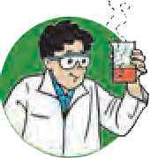

**Try this**

Observe the following images and note the similarities between given

#### animal images and plant images.

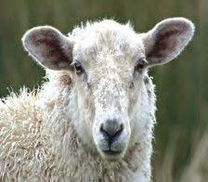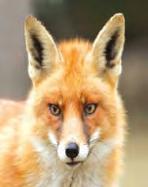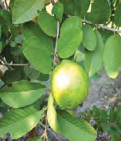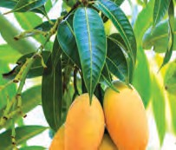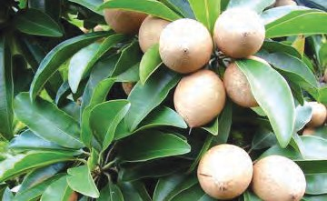Various similarities like structure of mouth, position of eyes, structure of nostrils and ear pinnae and thickly distributed hairs on body are seen in animals whereas similarities in characters like leaf shape, leaf venation, leaf petiole, etc. occur in case of plants. This indicates that there are some similarities in those groups and hence it proves that

their origin must be same and must have common ancestors

* 1. **Morphological evidences**

|  |  |  |  |
| --- | --- | --- | --- |
| Human | foreleg | Patagium | Flipper |
| hand | of ox | of Bat | of Whale |

* 1. **Structure of bones**

1. Anatomical Evidences

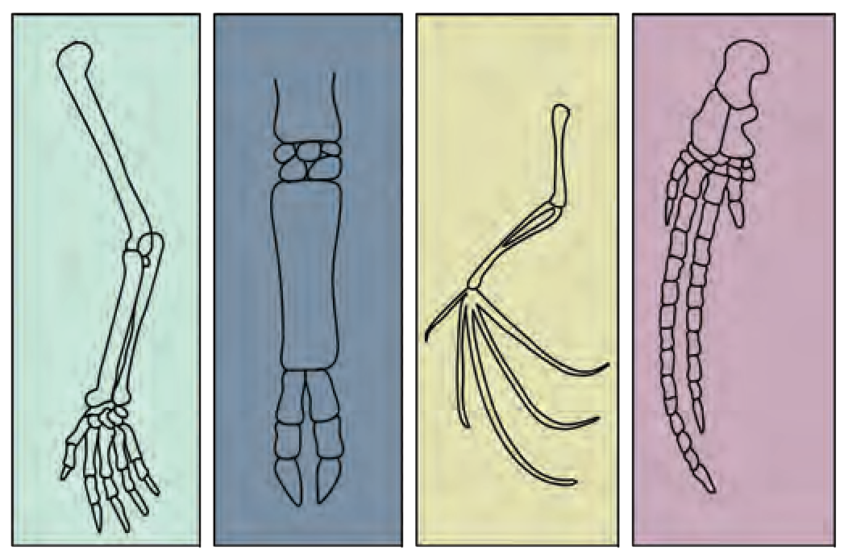If you carefully observe the pictures, there doesn’t seem any superficial similarity between human hand, foreleg of ox, flipper of whale and patagium of bat. Similarly, use of each of those structures is different in respective animals. However, there is similarity in structure of bones and joints in organs of each of those animals. This similarity indicates that those animals may have common ancestor.

* 1. Which are the different organs in body of organisms?



**Can you tell?**

* 1. Is each of the organs useful to organism?

**Use of ICT :**

Collect the information of geological dating and Present it classroom.



4

1. Vestigial Organs

Degenerated or underdeveloped useless organs of organisms are called as vestigial organs. In living organisms, sudden development of new tissues or organs for living in changing environment is not possible. Instead, existing organs undergo gradual changes. Mostly, a specific structure in the body is useful under certain situation. However, same structure under different situation may become useless or even harmful. Such structure begins to degenerate under such situation as per the principle of natural selection. It takes thousands of years for a structure to disappear. Such organs are seen in different phases of disappearance in different animals. Such organ, though non-functional in certain organisms, it may be functional in other organisms i.e. it is not vestigial in other organisms.

Appendix, which is useless to human, is useful and fully functional organ in ruminants. Similarly, muscles of ear pinna, which are useless to human, are useful in monkeys for movement of ear pinna. Various vestigial organs like tail-bone (coccyx), wisdom teeth, and body hairs are present in body of human being.

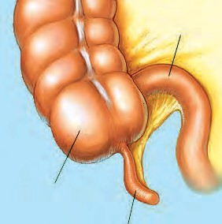

Small Intestine

Large

Intestine Appendix

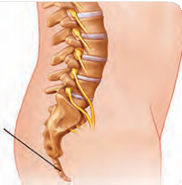**Ear muscles**

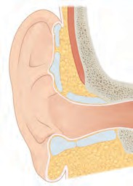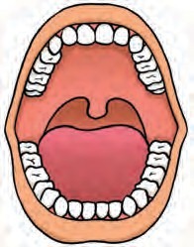

**Wisdom teeth**

**Tail bone (Coccyx)**

Observe and discuss.

* 1. **Vestigial organs**

Observe the following pictures.

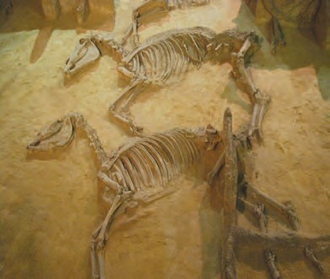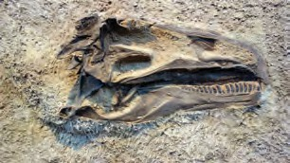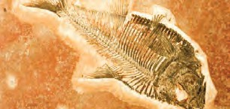

**Use of ICT**

Find how the vestigial organs in certain animals are functional in others. Present the information in your class and send it to others.

* 1. **Some fossils**

1. Palaeontological Evidences

A question may arise in your mind that which organisms existed millions of years ago? How can we tell this? Now this secret has been hidden in the Earth. Large number of organisms get buried due to disasters like flood, earthquake, volcano, etc. Remnants and impressions of such organisms remain preserved underground. These are called as fossils. Study of fossils is an important aspect of study of evolution.



5

Carbon consumption of animals and plants stops after death and since then, only the decaying process of C-14 occurs continuously. In case of dead bodies of plants and animals, instead of remaining constant, the ratio between C-14 and C-12 changes continuously as C-12 is non-radioactive. The time passed since the death of a plant or animal can be calculated by measuring the radioactivity of C-14 and ratio of C-14 to C-12 present in their body. This is ‘carbon dating’ method. It is used in palaeontology and anthropology for determining the age of human fossils and manuscripts. Once the age of fossil been determined by such technique, it becomes easy to deduce the information about other erstwhile organisms. It seems that vertebrates have been slowly originated from invertebrates.

**Aves (Birds) Mammals**

**Reptiles**

**Amphibia Pisces**

**Invertebrate**s

**Cenozoic era**

**Mesozoic era**

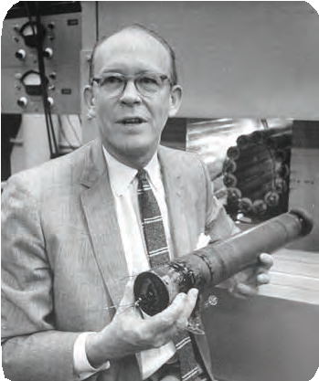

**Introduction to Scientists**

Carbon dating method is based

radioactive

upon the

decay of

naturally occurring C-14 and it is developed by Willard Libby.

He has been awarded with Nobel Prize (1960) for this invention. The age of the materials determined by this method are published in the journal ‘Radio Carbon’

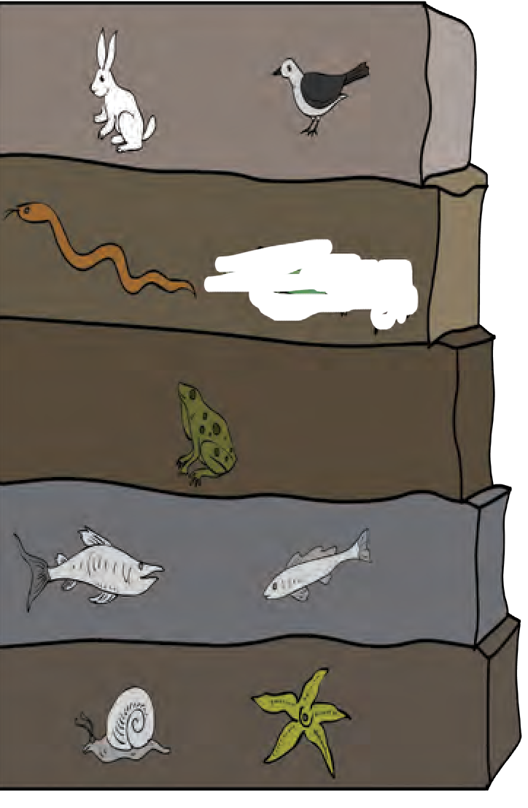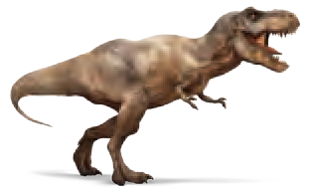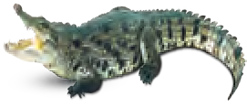

**Palaeozoic era**

* 1. **Sedimentary rocks and fossils**

1. Connecting Links



**Observe and discuss.**

Observe the following pictures and discuss the characters observed.

**Duckbill Platypus**

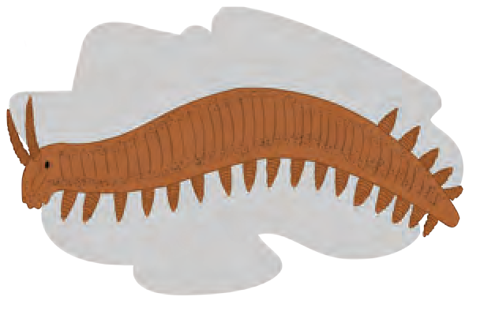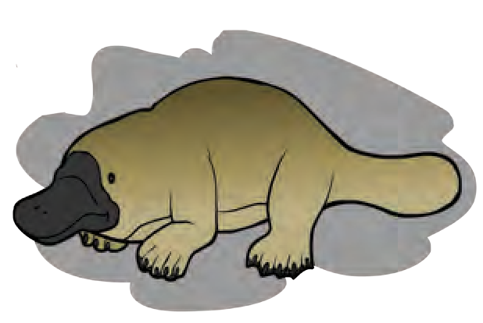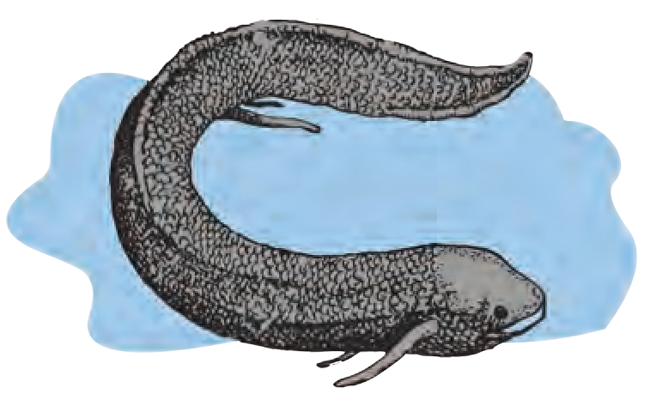

**Lungfish**

* 1. **Some animals with special characteristics**



6

**Peripatus**

Some plants and animals show some morphological characters by which they can be related to two different groups; hence they are called as ‘connecting links’. Ex. In *Peripatus*, characters like segmented body, thin cuticle, and parapodia-like organs are present. Similarly, these animals show tracheal respiration and open circulatory system similar to arthropods. This indicates that *Peripatus* is connecting link between annelida and arthropoda. Similarly, duck billed platypus lays eggs like reptiles but shows relationship with mammals too due to presence of mammary glands and hairs. Lung fish performs respiration with lungs irrespective of being fish. These examples indicate that mammals are evolved from reptiles and amphibians from fishes.

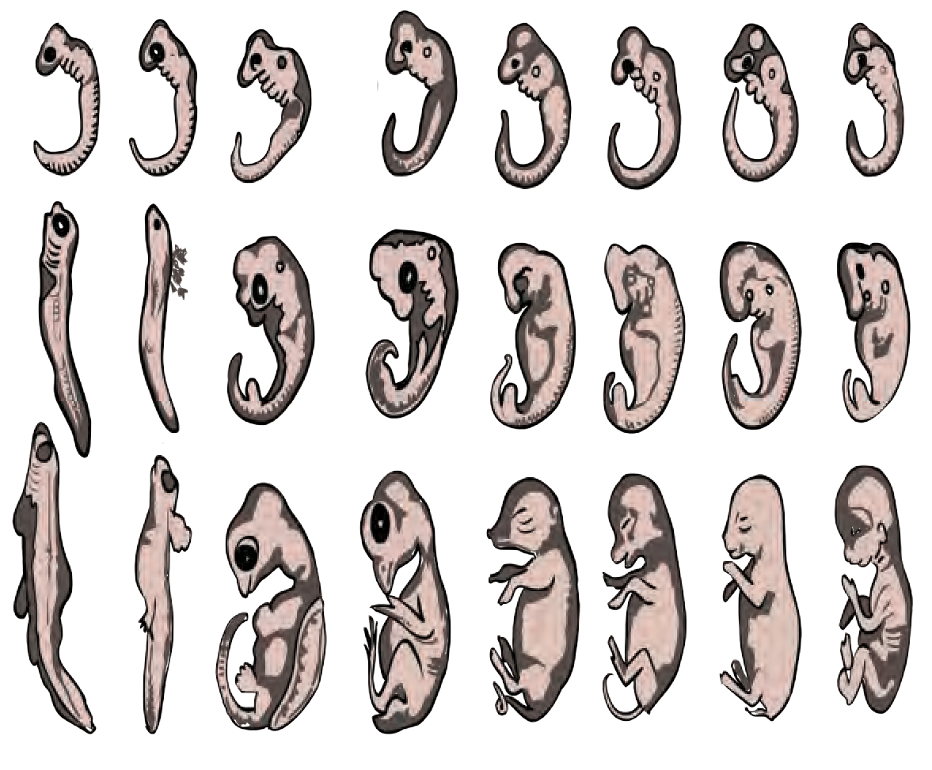

**Observe and discuss.**

## I

Carefully observe the stages of embryonic development of some animals shown in fig. 1.10

1. Embryological Evidences:

Comparative study of embryonic developmental stages of various vertebrates given in the picture shows that all embryos show extreme similarities during initial stages and those similarities decrease gradually. Similarities in initial stages indicate the common

## II

III

Fish Salamander Tortoise Chicken Pig Cow Rabbit Man

origin of all these animals. **1.10 Embryos during different stages**

Darwin’s theory of natural selection

Charles Darwin had collected innumerable specimens of plants and animals and depending upon the observations of those specimens; he published the theory of natural selection which preaches the survival of fittest. For this purpose, Darwin had published a book titled **‘Origin of Species’**. While explaining the concept, Darwin says that all the organisms reproduce prolifically. All the organisms compete with each other in a life-

-threatening manner. In this competition, only those organisms sustain which show the modifications essential for winning the competition. However, besides this, natural selection also plays important role because nature selects only those organisms which are fit to live and the rest perish. Sustaining and selected organisms can perform reproduction and thereby give rise to the new species with their own specific characters. Darwin’s theory of natural selection was widely accepted for long duration. However, some objections were raised against the theory. Some of the main objections are-

1. Natural selection is not the only factor responsible for evolution.
2. Darwin did not mention any explanation about useful and useless modifications.
3. There is no explanation about slow changes and abrupt changes.

Irrespective of all these objections, Darwin’s work on evolution has been a milestone.



7

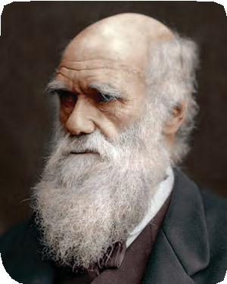

**Introduction to Scientists**

**Charles Robert Darwin (1809-1882)**

This English biologist proposed the theory of evolution. He showed that all the species of living organisms have been gradually evolved over the period of thousands of years from common ancestor. He proposed that principle of natural selection is responsible for this evolution.

Lamarckism

Jean-Baptiste Lamarck proposed that morphological changes occurring in living organisms are responsible for evolution and the reason behind those morphological changes is activities or laziness of that organism. He called this concept as principle of ‘use or disuse of organs’.

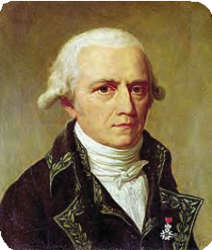

**Introduction to Scientists**

Jean-Baptiste Lamarck (1744-1829)

Lamarck proposed that the activities of the organisms are responsible for their evolution. This French naturalist proposed that each animal or plant undergo some changes in its life span and those changes are transferred to the next generation and such changes occur in next subsequent generations too.

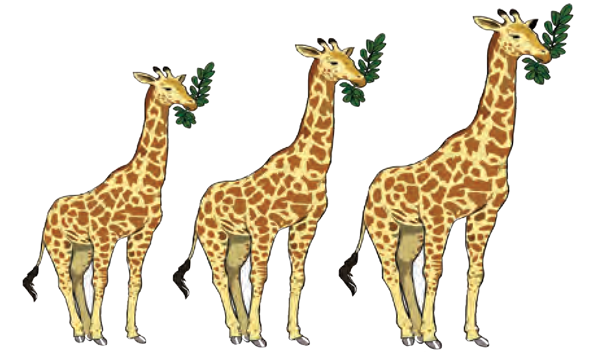Further, he said that the neck of giraffe has become too long due to browsing on leaves of tall plants by extending their neck for several generations; similarly, shoulders of the ironsmith have become very strong due to frequent hammering movements. Wings of birds like ostrich and emu have become weak due to no use. Legs of the birds like swan and duck have become useful for swimming due to living in water and snakes have lost their legs by modifications in their body for burrowing habit. All these examples are types of ‘acquired characters’ and are transferred from one to another generation. This is called as theory of inheritance of acquired characters or Lamarckism.

* 1. **Giraffe**

Development of organs due to specific activities or their degeneration due to no use at all was widely accepted but transfer of those characters from generation to generation was rejected. Because it had been verified many times that modifications brought in us are not transferred to next generation and thereby Lamarck’s theory was disproved.



The living organism can transfer the characters which it has acquired, to the next generation. This is called ancestry of acquired characters.

### 8

Internet is my friend

Collect the pictures and information of various species of monkeys from internet.

Speciation

Formation of new species of plants and animals is the effect of evolution. Species is the group of organisms that can produce fertile individuals through natural reproduction. Each species grows in specific geographical conditions. Their food, habitat, reproductive ability and period is different. However, genetic variation is responsible for formation of new species from earlier one. Besides, geographical and reproductive changes are also responsible. Similarly, geographical or reproductive isolation also leads to speciation **Human Evolution**

The biodiversity that is known today has been said to be formed from very simple unicellular organism due to evolution. In this evolution, origin of human evolution can be shown as per the picture given below. Last dinosaurs disappeared approximately seven crore years ago. At that time, monkey-like animals are said to be evolved from some ancestors who were more or less similar to the modern lemurs. Tail of these monkey-like animals of Africa is said to be disappeared about 4 crore years ago. They developed due to enlargement in brain their hands were also improved and thus ape-like animals were evolved. Meanwhile, these ape-like animals reached the South and North-East Asia and finally evolved into gibbon and orang-utan.

Remaining ape-like animals stayed in Africa and from them, gorilla and chimpanzee evolved about 2.5 crore years ago. Evolution of some of the 2 crore year old species of apes seems to be occurred in different way. They had to use their hands more for eating food and other work.

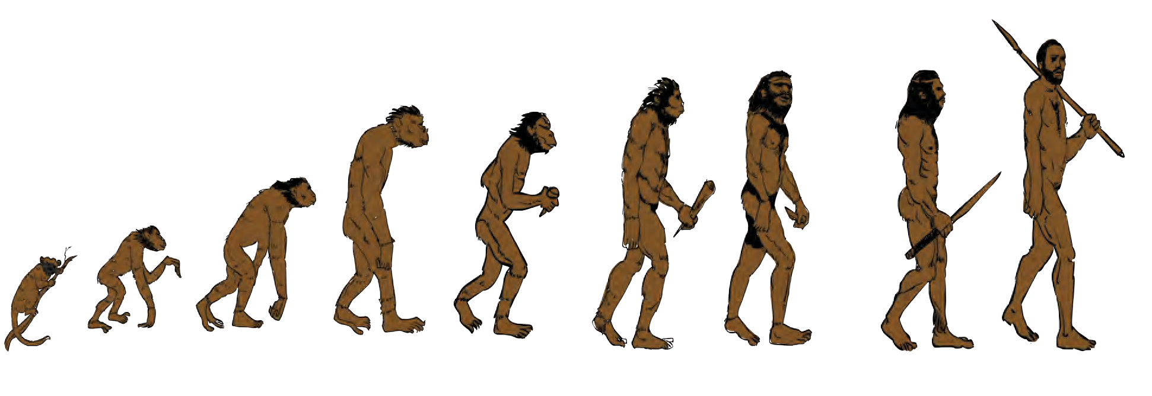

Ancient animals like lemurs 7,00,00000Years ago

Egyptopithecus 4,00,00000Years ago

Dryopithecus 2,50,00000 Years ago

Rama pithecus 1,00,00000Years ago

Austrelopithecus 40,00000 Years ago

Skilled Human 20,00,000 Years ago

man with erect posture 15,00,000 Years ago

Neanderthal 1,50,000 Years ago

Cro-Magnon man 50,000 Years ago

* 1. **Journey of human**

Those apes started to live on land as the forests started to decline due to dry environment. Their pelvic girdle developed in such a way that they started to stand in erect posture in grasslands and thereby their hands became available for use, anytime. These first human-

-like animals with erect posture which were using their hands have evolved about 2 crore years ago.

First record of human-like animal is with us in the form of ‘Ramapithecus’ ape from North India and East Africa. Afterwards, this ape grown up in size and became more intelligent and thus the ape of South Africa evolved about 40 lakh years ago.



9

The morphology of these human-like animals started to appear like to be the member of the genus *Homo*, about 20 lakh years ago and thus skilled human developed. About 15 lakh years ago, human walking with erect posture was evolved. It may have existed in China and Indonesia of Asian continent.

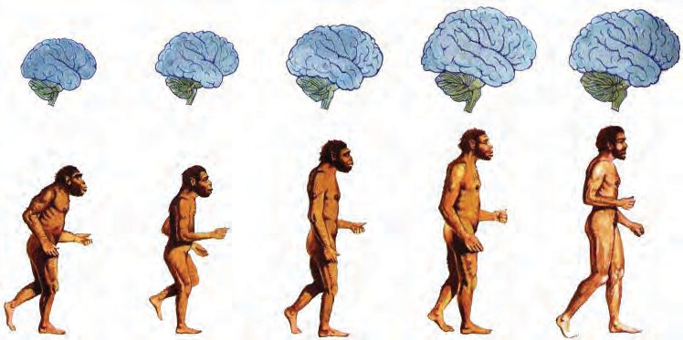

* 1. **Development of human brain**

Evolution of upright man continued in the direction of developing its brain for the period of about 1 lakh years and meanwhile it discovered the fire. Brain of 50 thousand year old man had been sufficiently evolved to the extent that it could be considered as member of the class- wise-man (*Homo sapiens*).

Neanderthal man can be considered as the first example of wise-man. The Cro-Magnon man evolved about 50 thousand years ago and afterwards, this evolution had been faster than the earlier.

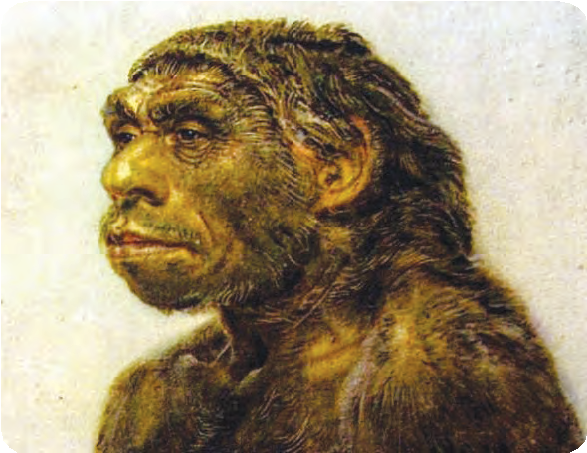

* 1. **Neanderthal man**

About 10 thousand years ago, wise-man started to practice the agriculture. It started to rear the cattle-herds and established the cities. Cultural development took place. Art of writing was invented about 5000 years ago and thus the history had been started. Modern sciences emerged about 400 years ago and industrial society was established about 200 years ago and now we have reached at this stage, and still we are searching the details of roots of human ancestry.



**Exercise**



1. **Complete the following diagram.**



**Evidences of Evolution**

Similarities in bones structure

Morphological

1. Read the following statements and justify the same in your own words with the help of suitable examples.
   1. Human evolution began approximately 7 crore years ago.
   2. Geographical and reproductive isolation of organisms gradually leads to speciation.
   3. Study of fossils is an important aspect of study of evolution.
   4. There is evidence of fatal science among chordates.



10

1. **Complete the statements by choosing correct options from bracket.**

(Gene, Mutation, Translocation, Transcription, Gradual development, Appendix)

* 1. The causality behind the sudden changes was understood due to -- -- principle of Hugo de Vries.
  2. The proof for the fact that protein synthesis occurs through was

given by George Beadle and Edward Tatum.

* 1. Transfer of information from molecule of DNA to mRNA is called as process.
  2. Evolution means --.
  3. Vestigial organ present in

human body is proof of evolution.

1. **Write short notes based upon the information known to you.**
   1. Lamarckism
   2. Darwin’s theory of natural selection.
   3. Embryology.
   4. Evolution.
   5. Connecting link.
2. **Define heredity. Explain the mechanism of hereditary changes.**
3. **Define vestigial organs. Write names of some vestigial organs in human body and write the names of those animals in whom same organs are functional.**
4. **Answer the following questions.**
   1. How are the hereditary changes responsible for evolution?
   2. Explain the process of formation of complex proteins.
   3. Explain the theory of evolution and mention the proof supporting it.
   4. Explain with suitable examples importance of anatomical evidences in evolution.
   5. Define fossil. Explain importance of fossils as proof of evolution.
   6. Write evolutionary history of modern man.

Project :

1. Make a presentation on human evolution using various computer softwares and arrange a group discussion over it in the class room.
2. Read the book – ‘Pruthvivar Manus Uparach’ written by Late Dr. Sureshchandra Nadkarni and note your opinion on evolution.







11



1. **Life Processes in Living Organisms Part -1**
   * Living Organisms & Life Processes ➢ Living Organisms & Energy

Production

* + Some Nutrients & Energy Efficiency ➢ Cell Division- A Life Process
  1. How are the food stuffs and their nutrient contents useful for body?



**Can you recall?**

* 1. What is the importance of balanced diet for body?
  2. Which different functions are performed by muscles in body?
  3. What is the importance of digestive juices in digestive system?
  4. Which system is in action for removal of waste materials produced in human body?
  5. What is the role of circulatory system in energy production?
  6. How are the various processes occurring in human body controlled? In how many ways ?

Living Organisms and Life Processes

Various organ-systems are continuously performing their functions in human body. Along with the various systems like digestive, respiratory, circulatory, excretory and control systems, different external and internal organs are performing their functions independently but through a complete co-ordination. This overall system is in action in more or less same way in all the organisms. Those are in need of continuous source of energy for this purpose. Carbohydrates, fats and lipids are the main sources of this energy and it is harvested by the mitochondria present in each cell. It is not like that only foodstuff is sufficient for energy production but oxygen is also necessary. All these i.e. food stuffs and oxygen are transported up to the cell via circulatory system. Besides, it is coordinated by the control system of the body. i.e. each life process contributes in its own way in the process of energy production. Functioning of all these life processes also requires the energy.

Human and other animals consume the fruits and vegetables. Plants are autotrophs. They prepare their own food. They utilize some of the food for themselves whereas remaining is stored in various parts like fruits, leaves, stem, roots, etc. We consume all these various plant materials and obtain different nutrients like carbohydrates, fats, proteins, vitamins, minerals, etc. Which food materials do we consume to obtain these nutrients?

We obtain the carbohydrates from milk, fruits, jaggary, cane sugar, vegetables, potatoes, sweet potatoes, sweetmeats and cereals like wheat, maize, ragi, jowar, millet, rice, etc. We get 4Kcal energy per gram of carbohydrates. Let us study the way by which this energy is obtained.

Many players are seen consuming some food stuffs during breaks of the game.

Why may be the players consuming these food stuffs?



**Use your brain power**

* + 1. What is respiration? How does it occur?



**Can you recall?**



12

Living organism and Energy production

Observe and Label the diagram given beside.



**Observe**

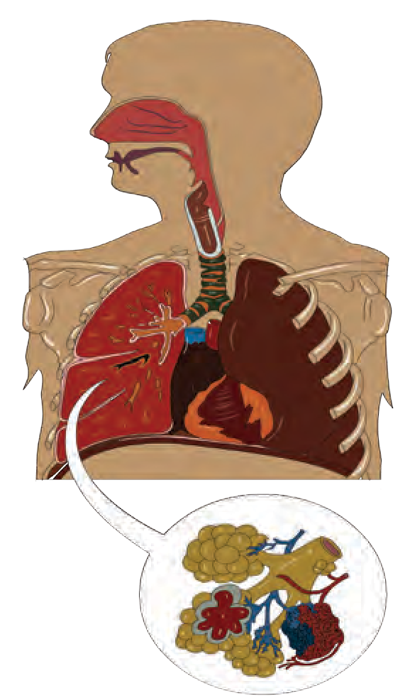

In living organisms, respiration occurs at two levels as body and cellular level. Oxygen and carbon dioxide are exchanged between body and surrounding in case of respiration occurring at body level. In case of respiration at cellular level, foodstuffs are oxidized either with or without help of oxygen.



**Can you tell?**

1. How many atoms of C, H and O are respectively present in a molecule of glucose?
2. Which types of chemical bonds are present between all these atoms?
3. In terms of Chemistry what happens actually when a molecule is oxidized?
   * 1. **Human respiratory system**

Carbohydrates of the food that we consume everyday are mainly utilized for production of energy required for daily need. This energy is obtained in the form of ATP. For this purpose, glucose, a type of carbohydrates is oxidized step by step in the cells. This is called as cellular respiration. Cellular respiration occurs among the living organisms by two methods. Those two methods are aerobic respiration (oxygen is involved) and anaerobic respiration (oxygen is not involved). In aerobic respiration, glucose is oxidized in three steps.

1. Glycolysis

Process of glycolysis occurs in cytoplasm. A molecule of glucose is oxidized step by step in this process and two molecules of each i.e. pyruvic acid, ATP, NADH2 and water are formed.

Molecules of pyruvic acid formed in this process are converted into molecules of Acetyl-Coenzyme-A. Two molecules of NADH2 and two molecules of CO2 are released during this process.

1. Tricarboxylic acid cycle (Krebs cycle)

Both molecules of acetyl-CoA enter the mitochondria. Cyclic chain of reactions called as tricarboxylic acid cycle is operated on it in the mitochondria. Acetyl part of acetyl-CoA is completely oxidized through this cyclical process and molecules CO2, H2O, NADH2, FADH2 are derived.



13

* 1. Electron transfer chain reaction

Molecules of NADH2 and FADH2 formed during all above processes participate in electron transfer chain reaction. Due to this, 3 molecules of ATP are obtained from each NADH2

molecule and 2 molecules of ATP

**Pyruvic acid**

**Outer**

**Acetyl Co A**

TCA

Cycle

**Fatty acids**

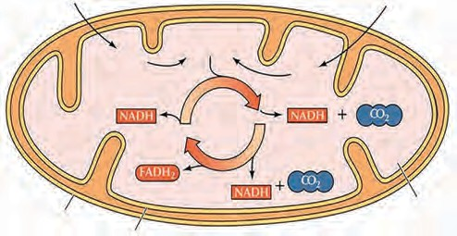**Mitochondrial**

from each FADH2

molecule.

**Membrane Inner**

**Membrane**

**Matrix**

Besides ATP, water molecules are also formed in this reaction. Electron transfer chain reaction is operated in mitochondria only.

Thus, a molecule of glucose is completely oxidized in aerobic

respiration and molecules of CO

ATP: Adenosine triphosphate is energy-rich molecule and energy is stored in the bonds by which phosphate groups are attached to each other. These molecules are stored in the cells as per need. Chemically, ATP is triphosphate molecule formed from adenosine ribonucleoside. It contains a nitrogenous compound-adenine, pentose sugar- ribose and three phosphate groups. As per the need, energy is derived by breaking the phosphate bond of ATP; hence ATP is called as ‘energy currency’ of the cell.

**2.2 Mitochondria and Tri-carboxylic acid cycle**

2

and H2O are produced along with

energy.



**Always Remember.**

NAD -

FAD -

Nicotinamide Adenine dinucleotide

Flavin adenine dinucleotide

Both coenzymes are formed in the cells and used in cellular respiration.

**Adenine**

**Ribose**

##### ATP ADP

**Adenine**

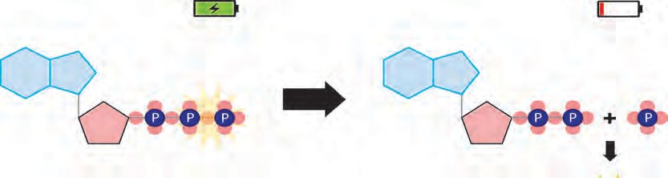

**Phosphate bonds with**

**more energy** Inorganic Phosphate

**Ribose**

**3.3 ATP: Energy Currency**

**Energy released**

If there is insufficient amount of carbohydrates in body due to exceptional conditions like fasting and hunger, then lipids and proteins are used for energy production. In case of lipids, they are converted into fatty acids whereas proteins into amino acids. Fatty acids and amino acids are converted into acetyl-CoA and energy is obtained through complete oxidation of acetyl-CoA by the process of Krebs cycle in mitochondria.



14

Introduction To Scientists

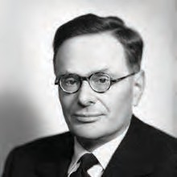

Process of glycolysis was discovered by three scientists Gustav Embden, Otto Meyerhof, and Jacob Parnas along with their colleagues. For this purpose, they performed experiments on muscles. Hence, glycolysis is also called as Embden-Meyerhof- Parnas pathway (EMP pathway).

The cyclical reactions of tricarboxylic acid cycle were discovered by Sir Hans Krebs. Hence, this cyclical process is also called as Krebs cycle. He has been awarded the Nobel Prize in 1953 for this discovery.

**Sir Hans Krebs (1900-1981)**

Process of energy production through aerobic respiration of carbohydrates, proteins and fats.

**Anaerobic respiration in living organisms/ cells**

Glycolysis

Pyruvic acid

Acetyl-CoA

Krebs Cycle

Carbohydrates

CO2 + H2O + Energy

Fatty acids

Lipids

Amino acids

Proteins

Yeast

Erythrocytes, Muscle cells,

Energy Production in Microorganisms through Anaerobic Respiration

Lactic acid

Fermentation

Fermentation

Different Products Ex: Vinegar,

Vitamins, etc.

Pyruvic acid

Various Microbes

Pyruvic acid

Pyruvic acid

Fermentation

Alcohol

Glucose

Glycolysis

Some organisms cannot live in presence of oxygen. Ex. Many bacteria. Such living organisms have to perform anaerobic respiration for energy production. Glycolysis and fermentation are two steps of anaerobic respiration. Glucose is incompletely oxidized and less amount of energy is obtained in this type of respiration. Pyruvic acid produced through glycolysis is converted into other organic acids or alcohol with the help of some enzymes in this process. This is called as fermentation. Some higher plants, animals and aerobic microorganisms also perform anaerobic respiration instead of aerobic respiration if there is depletion in oxygen level in the surrounding.

Ex. Seeds perform anaerobic respiration if the soil is submerged under water during germination. Similarly, our muscle cells also perform anaerobic respiration while performing the exercise. Due to this, less amount of energy is produced in our body and lactic acid accumulates due to which we feel tired.



15

1. Which type of cellular respiration performs complete oxidation of glucose?



**Can you tell?**

1. Which cell organelle is necessary for complete oxidation of glucose?

Energy from different food components

Excess of the carbohydrates are stored in liver and muscles in the form of glycogen.

What is the source of proteins? What are they made up of?

Proteins are the macromolecules formed by bonding together many amino acids. Proteins of animal origin are called as ‘first class’ proteins. We get 4 Kcal of energy per gram of proteins. Amino acids are obtained after digestion of proteins. Those amino acids are absorbed in the body and transported up to each organ and cell via blood. From these amino acids, organs and cells produce various proteins necessary for themselves and the whole body. Those examples are given in the following diagram.



Always remember

Excess of amino acids obtained from proteins are not stored in the body. They are broken down and the ammonia formed is eliminated out of the body. If necessary, excess of proteins are converted into other useful substances like glucose through the process of *gluconeogenesis.*

Plants produce the necessary amino acids from minerals *denovo* and thereby produce different proteins. An enzyme RUBISCO present in the plant chloroplasts is most abundant protein found in nature.

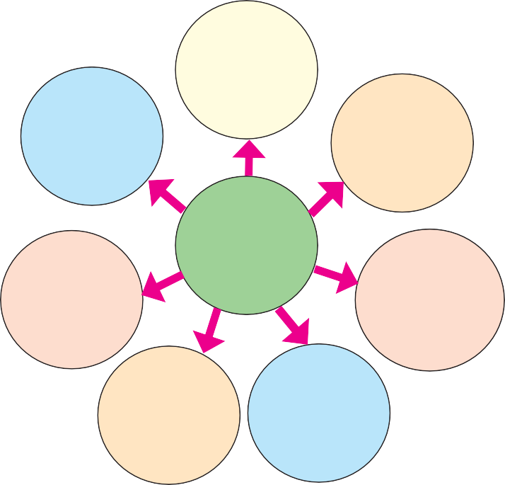

Blood:

Haemoglobin, Antibodies

Skin: Melanin , keratin

Bones: Ossein

Muscles:

Actin and Myosin flexible proteins

Amino

Acids

Cells :

various proteins of cell membrane, various enzymes

Pituitary Gland :

Various hormones

Pancreas:

Insulin, Trypsin

* 1. **Proteins and different amino acids obtained**



**Can you recall?**

From where do we obtain the lipids?

The substances formed by specific chemical bond between fatty acids and alcohol are called as lipids. Digestion of lipids consumed by us is nothing but their conversion into fatty acids and alcohol. Fatty acids are absorbed up and distributed everywhere within the body. From those fatty acids, different cells produce various substances necessary to themselves. Ex. the molecules called as phospholipids which are essential for producing plasma membrane are formed from fatty acids. Besides, fatty acids are used for producing hormones like progesterone, estrogen, testosterone, aldosterone, etc. and the covering around the axons of nerve cells. We get 9 KCal of energy per gram of lipids. Excess of lipids are stored in adipose connective tissue in the body.



16

* + 1. Many times, you cannot eat hot food due to inflammation / ulceration in mouth.



Think:

* + 1. Some persons experience difficulty in night vision since their childhood or adolescence.

Vitamins are a group of heterogeneous compounds of which, each is essential for proper operation of various processes in the body. There are main six types of vitamins,

e.g. A, B, C, D, E and K. Out of these, A, D, E and K are fat-soluble whereas B and C are water-soluble. We have seen that, FADH2 and NADH2 are produced in the processes like glycolysis and Krebs cycle. Vitamins like riboflavin (Vitamin B2) and nicotinamide (Vitamin B3) respectively are necessary for their production.



**Use your brain power**

* + - 1. Many times, we experience dryness in mouth.
      2. Oral rehydration solution (Salt-sugar-water) is frequently given to persons experiencing loose motions.
      3. We sweat during summer and heavy exercise.



Internet is my friend

Collect information

1. What are symptoms of diseases like night blindness, rickets, beriberi, neuritis, pellagra, anaemia, scurvy?
2. What do you mean by coenzymes?
3. Find the full forms of FAD, FMN, NAD, NADP.
4. How much quantity of each vitamin is required every day?

There is about 65 – 70% water in our body. Each cell contains 70% water weight by weight. Blood-plasma also contains 90% of water. Functioning of cells and thereby whole body disturbs even if there is a little loss of water from the body. Hence, water is an essential nutrient.

Along with all above mentioned nutrients, fibers are also essential nutrients. In fact, we cannot digest the fibers. However, they help in the digestion of other substances and egestion of

undigested substances. We obtain the fibers from leafy vegetables, fruits, cereals, etc.

Cell Division: An Essential Life Process



**Can you tell?**

1. What happens to the cells of injured tissue?
2. Whether new cells are formed during healing of wound?
3. Do the plants get injured when do we pluck the flowers? How are those wounds healed?
4. How does the growth of any living organism occur? Does the number of cells in their body increase? If yes, how?
5. How the new individual of a species is formed from existing one of same species?

Cell division is one of the very important properties of cells and living organisms. Due to this property only, a new organism is formed from existing one, a multicellular organism grows up and emaciated body can be restored.

There are two types of cell division as mitosis and meiosis. Mitosis occurs in somatic cells and stem cells of the body whereas meiosis occurs in germ cells. Before study of cell division, we should know the structural organization of cell that we have studied earlier. Each cell has a nucleus. Besides, other cell organelles are also present. Let us study the cell division with the help of this information.



17

Before any type of cell division, the cell doubles up its chromosome number present in its nucleus i.e. if chromosome number is 2n, it is doubled up to 4n.

What is the shape of chromosome? Give its names in the figure.



**Can you recall?**

A pair of each type of chromosome is present in 2n condition whereas single chromosome of each type is present in n condition and their structure is like the one shown in figure given beside.

Mitosis

Somatic cells and stem cells divide by mitosis. Mitosis is completed through two main steps. Those two steps are karyokinesis (nuclear division) and cytokinesis (cytoplasmic division). Karyokinesis is completed through four steps.

1. **Prophase :** In prophase, condensation of basically thin thread-like chromosomes starts. Due to this, they become short and thick and they start

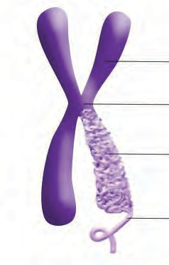

* 1. **Chromosome**

to appear along with their pairs of sister chromatids. Centrioles duplicate and each centriole moves to opposite poles of the cells. Nuclear membrane and nucleolus start to disappear.

1. **Metaphase :** Nuclear membrane completely disappears in metaphase. Chromosomes complete their condensation and become clearly visible along with their sister chromatids. All chromosomes are arranged parallel to equatorial plane (central plane) of the cell. Special type of flexible protein fibers (spindle fibers) are formed between centromere of each chromosome and both centrioles.
2. **Anaphase :** In anaphase, centromeres split and thereby sister chromatids of each chromosome separate and they are pulled apart in opposite directions with the help of spindle fibers. Separated sister chromatids are called as daughter chromosomes. Chromosomes being pulled appear like bunch of bananas. In this way, each set of chromosomes reach at two opposite poles of the cell.

**Chromosomes**

**Prophase**

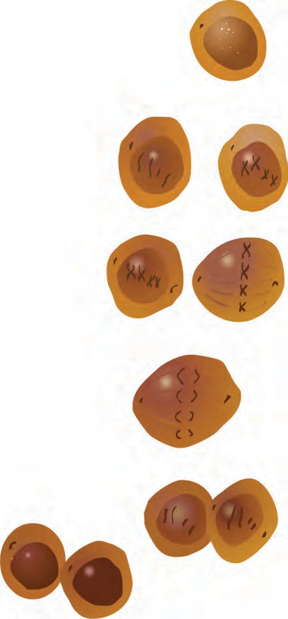

### 2n

**Genetic Material**

### 4n

**Metaphase**

**Anaphase**

**Telophase** 2n

### 2n 2n

* 1. **Mitosis**



18

1. **Telophase :** The chromosomes which have reached at opposite poles of the cell now start to decondense due to which they again become thread-like thin and invisible. Nuclear membrane is formed around each set of chromosomes reached at poles. Thus, two daughter nuclei are formed in a cell. Nucleolus also appears in each daughter nucleus. Spindle fibers completely disappear.

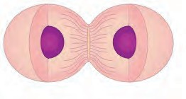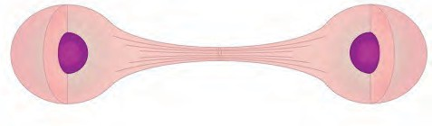

In this way, karyokinesis completes and cytokinesis begins.

The cytoplasm divides by cytokinesis and two new cells are formed which are called as daughter cells. In this process, a notch is formed at the equatorial plane of the cell which deepens gradually and thereby two new cells are formed. However, in case of plant cells, instead of the notch, a cell plate is formed exactly

along midline of the cell and thus cytokinesis is completed.

* 1. **Cytokinesis**

Mitosis is essential for growth of the body. Besides, it is necessary for restoration of emaciated body, wound healing, formation of blood cells, etc.

Meiosis:

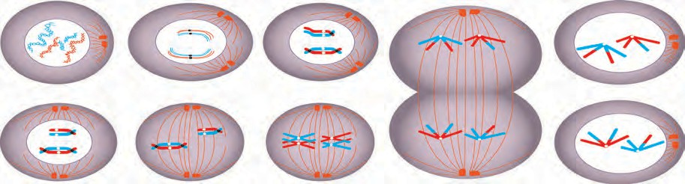

**1**

**2**

**3**

**4**

**Prophase- I (1-5) 5**

**Metaphase I**

**Anaphase I**

**Telophase I**

* 1. **Meiosis Part-I**

Meiosis is completed through two stages. Those two stages are meiosis-I and meiosis-

II. In meiosis-I, recombination / crossing over occur between homologous chromosomes and thereafter those homologous chromosomes (Not sister chromatids) are divided into two groups and thus two haploid cells are formed.

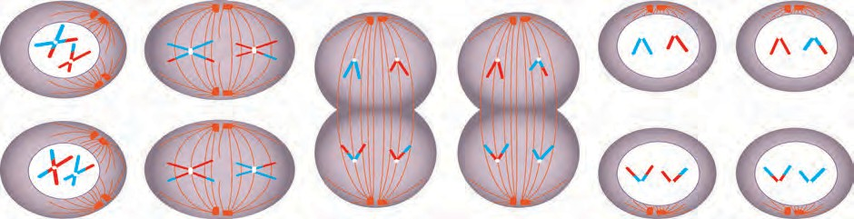

**Prophase II**

Metaphase II

**Anaphase II**

**Telophase II**

* 1. **Meiosis Part -II**



19

Meiosis-II is just like mitosis. In this stage, the two haploid daughter cells formed in meiosis-I undergo division by separation of recombined sister chromatids and four haploid daughter cells are formed. Process of gamete production and spore formation occurs by meiosis. In this type of cell division, four haploid (n) daughter cells are formed from one diploid (2n) cell. During this cell division, crossing over occurs between the homologous chromosomes and thereby genetic recombination occurs. Due to this, all the four daughter cells are genetically different from parent cell and from each other too.

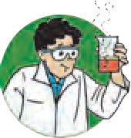

**Try this**

**Apparatus :** Conical flask, glass slides, cover slips, forceps, compound microscope, watch glass, etc.

**Materials :** a medium sized onion , iodine solution, etc.

**Procedure :** Take a medium sized onion. Keep it in a conical flask filled with water in such a way that the roots of onion will be in contact with water. Observe the roots of onion after 4 – 5 days. Cut the tips of some of the roots and put them in a watch glass. Pour some drops of iodine in watch glass. Take one of the root tip on glass slide press it with the help of forceps. Add 1 – 2 drops of water and carefully place cover slip over it in such a way that air will not be trapped between. Observe the prepared glass slide under the compound microscope. Which phase of cell division did you observe? Sketch its figure.

Various phases of cell division occurring in root tips of onion are shown in the following figure. Which one of those could you see in the slide?



**Use your brain power**

1. What do you mean by diploid (2n) cell?
2. What do you mean by haploid

(n) cell?

1. What do you mean by homologous chromosomes?
2. Whether the gametes are diploid or haploid? Why?
3. How are the haploid cells formed?
4. What is the importance of haploid cells?
   1. 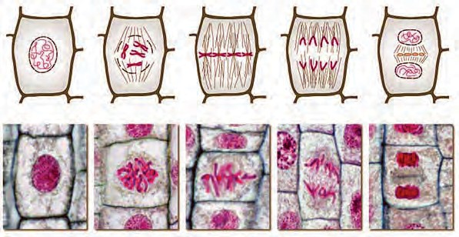**Phases of mitosis in onion root tip**

Use of ICT



Collect videos and photographs of different life processes in living organisms. Prepare a presentation and present it on the occasion of science exhibition

Books are my friend

Read different Encyclopaedias of technical terms in biology and anatomy and other reference books.

### 20





**Exercise**

* 1. **Fill in the blanks and explain the**

**statements.**

* + 1. After complete oxidation of a glucose molecules, ---- --- --- number of ATP molecules are formed.
    2. At the end of glycolysis, ---- --- -- molecules are obtained.
    3. Genetic recombination occurs in --

-- -- phase of prophase of meiosis-I.

* + 1. All chromosomes are arranged parallel to equatorial plane of cell in

- phase of mitosis.

* + 1. For formation of plasma membrane,

- molecules are necessary.

* + 1. Our muscle cells perform type

of respiration during exercise.

* 1. **Write definitions.**
     1. Nutrition. b. Nutrients

c. Proteins. d. Cellular respiration

1. Aerobic respiration.
2. Glycolysis.
   1. **Distinguish between**
      1. Glycolysis and TCA cycle.
      2. Mitosis and meiosis.
      3. Aerobic and anaerobic respiration.
   2. **Give scientific reasons.**
      1. Oxygen is necessary for complete oxidation of glucose.
      2. Fibers are one of the important nutrients.
      3. Cell division is one of the important properties of cells and organisms.
      4. Sometimes, higher plants and animals too perform anaerobic respiration.
      5. Krebs cycle is also known as citric acid cycle.
   3. Answer in detail.
      1. Explain the glycolysis in detail.
      2. With the help of suitable diagrams, explain the mitosis in detail.
      3. With the help of suitable diagrams,

explain the five stages of prophase-I of meiosis.

* + 1. How all the life processes contribute to the growth and development of the body?
    2. Explain the Krebs cycle with reaction.

1. How energy is formed from oxidation of carbohydrates, fats and proteins? Correct the diagram given below.

Amino acids

Acetyl Co-Enzyme A

Proteins

Lipid

Glycolysis

krebs cycle

Pyruvic Acid

Fats

**Project :**

With the help of information collected from internet, prepare the slides of various stages of mitosis and observe under the compound microscope.





21



1. Life Processes in Living Organisms Part - 2
   * **Reproduction: Asexual and Sexual reproduction.**
   * **Reproduction and modern technology**
   * **Reproductive health**
   * **Population Explosion**
   1. Which are the important life processes in living organisms?



**Can you recall?**

* 1. Which life processes are essential for production of energy required by body?
  2. Which are main types of cell-division? What are the differences?
  3. What is the role of chromosomes in cell-division?

We have studied various life processes in previous classes. All those life processes i.e. nutrition, respiration, excretion, sensation & response (control & co-ordination), etc. are essential to each living organism to remain alive. Besides these life processes, one more life process occurs in living organisms; it is reproduction. However, reproduction does not help the organism to remain alive but it helps to maintain the continuity of the species of that

organism. a.

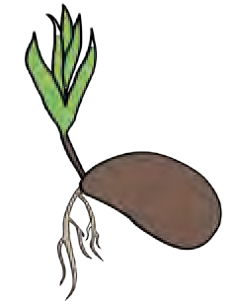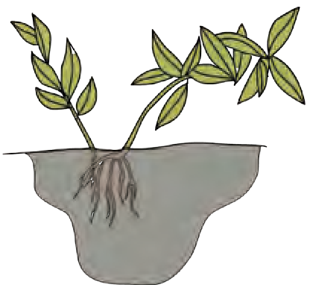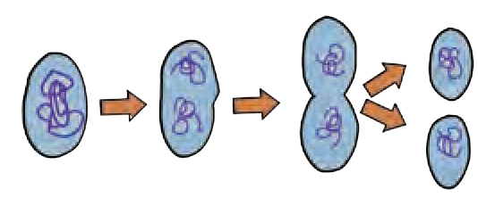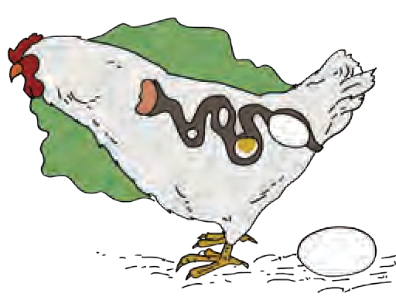

b.



**Observe**

Observe the pictures and tell the life process which you identified.



**Can you tell?**

1. What do we mean by maintenance of species?

### d.

c.

* 1. **Some Life processes**

1. Whether the new organism is genetically exactly similar to earlier one that has produced it?
2. Who determines whether the two organism of a species will be exactly similar or not?
3. What is the relationship between the cell division and formation of new organism of same species by earlier existing organism?

Formation of new organism of same species by earlier existing organism is called as reproduction. Reproduction is one of the various important characters of living organisms. It is also one of the various reasons responsible for evolution of each species. In living organisms, reproduction occurs mainly by two methods. Those two methods are- asexual and sexual reproduction.

Asexual reproduction

Process of formation of new organism by an organism of same species without involvement of gametes is called as asexual reproduction. As this reproduction does not involve union of two different gametes, the new organism has exact genetic similarity with the reproducing organism. This is uniparental reproduction and it occurs by mitotic cell division. Absence of genetic recombination is a drawback whereas fast process is advantage of this reproductive method.



22

1. Asexual reproduction in unicellular organisms
   1. **Binary Fission**



**Try this**

**Daughter Amoeba**

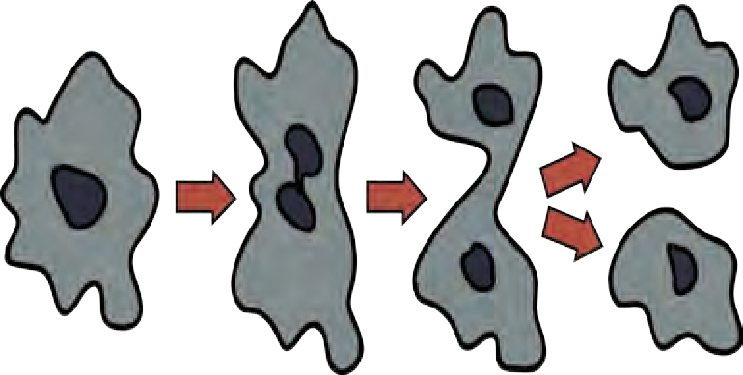

**Parent Amoeba**

**Activity 1 :** Take a conical flask and collect the water in it from a pond having stagnant water and aquatic plants. Add some wheat grains and aquatic plants to it. Keep it for 3 – 4 days so that wheat grains & plants will decompose. Early in the morning on fourth day, take a glass slide and put a drop of that water over it. Carefully, put a cover-slip on that drop and observe under compound microscope.

You will be able to see many paramecia performing the binary fission.

Prokaryotes (Bacteria), Protists (*Amoeba*, *Paramecium*, *Euglena*, etc.) and eukaryotic cell-organelle like mitochondria and chloroplasts perform asexual reproduction by binary fission. In this process, the parent cell divides to form two similar daughter cells. Binary fission occurs either by mitosis or amitosis.

Axis of fission / division is different in different protists. Ex.: *Amoeba* divides in any plane due to lack of specific shape; hence it is called as ‘simple binary fission’. *Paramecium* divides by ‘transverse binary fission’ whereas *Euglena* by ‘longitudinal binary fission’.

Binary fission is usually performed by living organisms during favourable conditions

i.e. availability of abundant food material.

* 1. Multiple Fission
  2. **Simple binary fission:** *Amoeba*

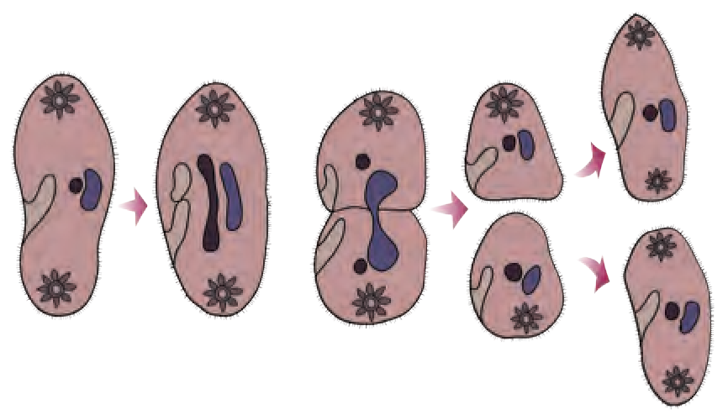

**Parent** *Paramecium*

**Daughter**

*Paramecium*

* 1. **Transverse binary fission : Paramecium**

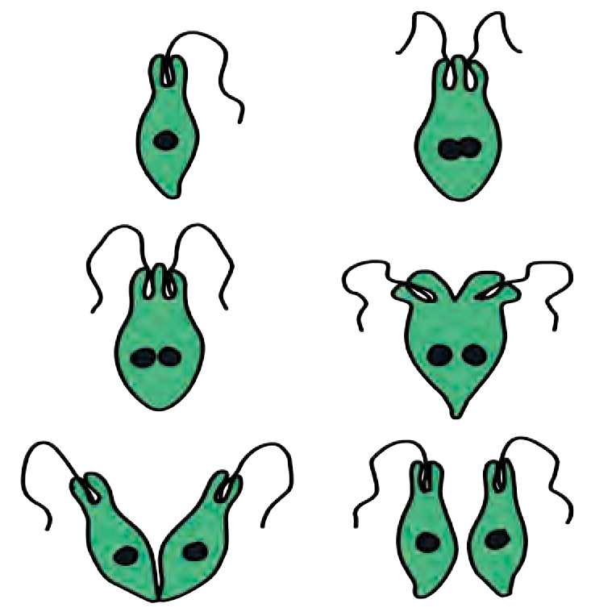

* 1. **Longitudinal binary fission:** *Euglena*

Asexual reproduction by multiple fission is performed by Amoeba and other similar protists. Amoeba stops the formation of pseudopodia and thereby movements whenever there is lack of food or any other type of adverse condition. It becomes rounded and forms protective covering around plasma membrane. Such encysted Amoeba or any other protist is called as ‘Cyst’.

Many nuclei are formed by repeated nuclear divisions in the cyst. It is followed by cytoplasmic division and thus, many amoebulae are formed. They remain encysted till there are adverse conditions. Cyst breaks open on arrival of favourable conditions and many amoebulae are released.



23

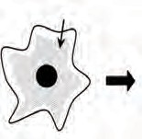**Parent Amoeba**

**Division of nucleus and cytoplasm**

**Daughter amoeba**

**Cyst**

* 1. Budding:



**Use your brain power**

Does the parent cell exist after asexual reproduction- fission?

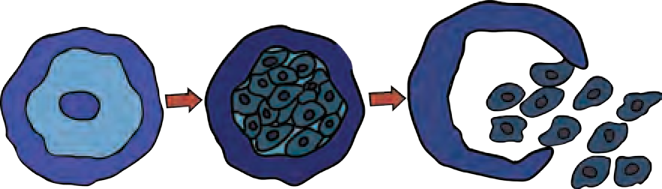

* 1. **Multiple fission**

**Activity 2 :** Bring the active dry yeast powder from market. Take 50 ml lukewarm water in a conical flask. Add 5 gm of active dry yeast powder and 10 gm table sugar to that water and mix well the mixture. Keep the flask in warm place and after an hour take a drop of that mixture on a clean glass slide. Put a cover-glass on that drop and observe it under the compound microscope.

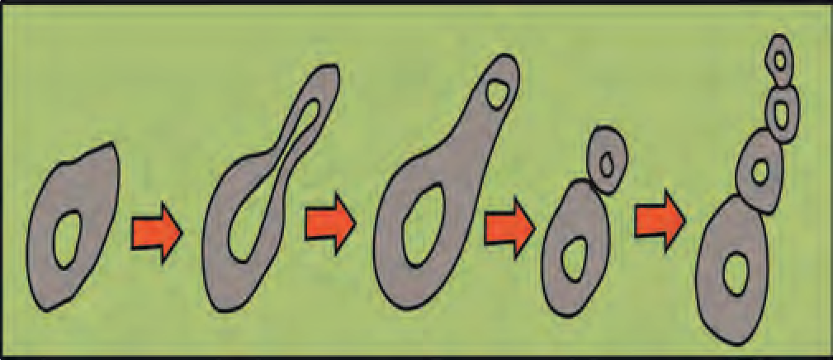

**Parent yeast cell**

**Bulge**

**New Bud**

**Daughter yeast**

* 1. **Budding**

You will see the yeast cells performing budding i.e. a small bud coming out of many

parent cells. Asexual reproduction occurs by budding in yeast- a unicellular fungus. Yeast cell produces two daughter nuclei by mitotic division, so as to reproduce by budding. This yeast cell is called as parent cell. A small bulge appears on the surface of parent cell. This bulge is actually a bud. One of the two daughter nuclei enters this bud. After sufficient growth, bud separates from the parent cell and starts to live independently as a daughter yeast cell.

1. Asexual reproduction in Multicellular organisms
   1. **Fragmentation:**

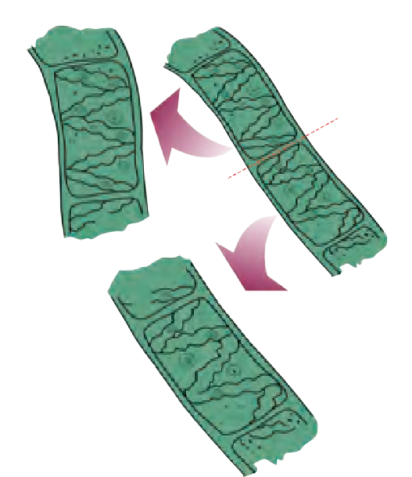

**Spirogyra**

This type of asexual reproduction occurs in multicellular organisms. In this type of reproduction, the body of parent organism breaks up into many fragments and each fragment starts to live as an independent new organism. This type of reproduction occurs in algae like *Spirogyra*, and sponges like *Sycon*.

Whenever there is plenty of water and nutrients are

available to *Spirogyra*, its filaments grow up very fast and break up into many small fragments. Each fragment starts

to live independently as a new *Spirogyra* fiber.If the body of *Sycon* breaks up accidentally into many fragments, each fragment develops into new *Sycon*.

* 1. Regeneration

You may know that the wall lizard breaks up and discards some part of its tail in emergency. Discarded part is regenerated after a period. This is an example of limited regeneration. However, under certain situations, an animal- Planaria breaks up its body into two parts and thereafter each part regenerates remaining part of the body and thus two new Planaria are formed. This is called as regeneration.

* 1. **Fragmentation**

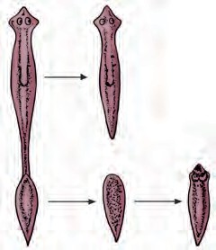

* 1. **Regeneration**



24

* 1. Budding

In case of *Hydra*, under favourable conditions, at specific part of its body, an outgrowth is formed by repeated divisions of regenerative cells of body wall. This outgrowth is called as bud. Bud grows up progressively and finally forms a small hydra. Dermal layers and digestive cavity of the budding hydra are in continuity with those of parent hydra. Parent hydra supplies nutrition to the budding hydra. Budding hydra separates from parent hydra and starts to lead an independent life when it grows up and becomes able to lead an independent life.

* 1. Vegetative Propagation

Reproduction in plants with the help of vegetative parts like root, stem, leaf and bud is called as vegetative reproduction. Vegetative propagation in potatoes is performed with the help of ‘eyes’ present on tuber whereas in *Bryophyllum* it is performed with the help of buds present on leaf margin. In case of plants like sugarcane & grasses, vegetative propagation occurs with the help of buds present on nodes.



**Try this**

* 1. Spore Formation

Take a piece of wet bread or ‘bhakari’ and keep it in humid place. Fungus will grow on it within 2 – 3 days. Observe the fungus under compound microscope and draw its diagram. Fungi like *Mucor* have filamentous body. They have sporangia. Once the spores are formed, sporangia burst and spores are released. Spores germinate in moist and warm place and new fungal colony is formed.

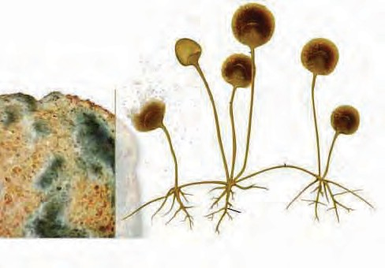

**Sporangium**

**Greenish Layer**

**Spores**

**Hyphae**

**Rhizoid**

**Piece of bread**

* 1. **Budding**

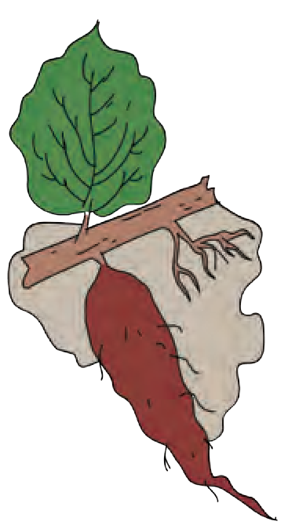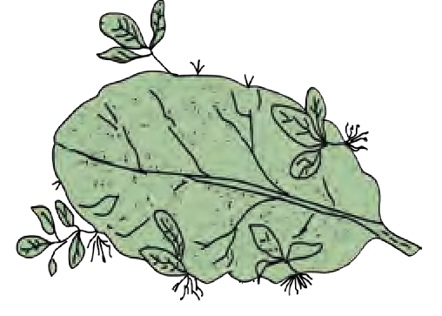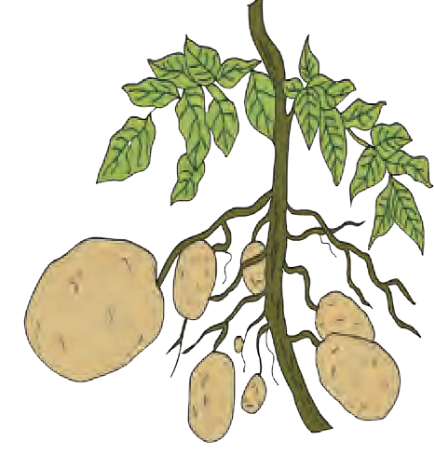

**Bryophyllum**

**Sweet Potato**

**3.10 Vegetative reproduction**

**Potato**

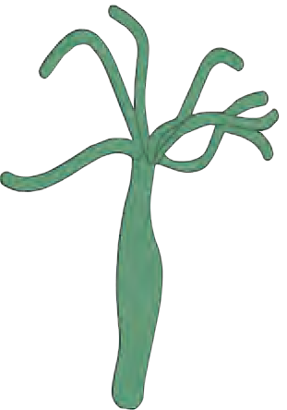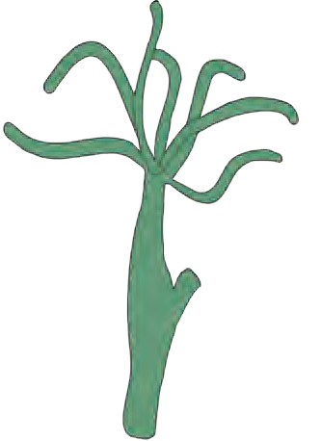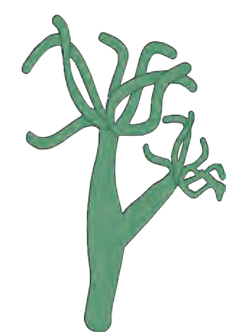

**Hydra**

**Bud**

**Nascent Hydra**

Sexual Reproduction

* 1. **Spore formation**

Sexual reproduction always occurs with the help of two germ cells. Female gamete and male gamete are those two germ cells. Two main processes occur in the sexual reproduction.

1. **Gamete formation:** Gametes are formed by the meiosis. In meiosis, chromosome number is reduced to half; hence haploid gametes are formed.



25

1. **Fertilization:** A diploid zygote is formed in this process by union of haploid male and female gametes. The zygote divides by mitosis and embryo is formed. The embryo develops to form new individual.

Two parents i.e. male parent and female parent are involved in this type of reproduction. Fusion of male gamete of male parent and female gamete of female parent occurs. Due to this, new individual always has the recombined genes of both the parents. Hence, the new individual shows similarities with the parents for some characters and has some characters different than both parents. Diversity in living organisms occurs due to genetic variation. Genetic variation helps the organisms to adjust with the changing environment and thereby to maintain their existence. Due to this, plants and animals can save themselves from being extinct.

* 1. What would have been happened if the male and female gametes had been diploid?



Let’s Think

* 1. What would have been happened if any of the cells in nature had not been divided by meiosis?

1. Sexual reproduction in plants

Flower is structural unit of sexual reproduction in plants. It consists of four floral whorls as calyx, corolla, androecium and gynaecium; arranged in sequence from outside to inside. Androecium and gynoecium are called ‘essential whorls’ because they perform the function of reproduction whereas calyx and corolla are called as ‘accessory whorls’ because they are responsible for protection of inner whorls. Members of calyx are called as ‘sepals’ and they are green coloured. Members of corolla are called as ‘petals’ and they are variously colored.

**Corolla (Petals) Stigma**

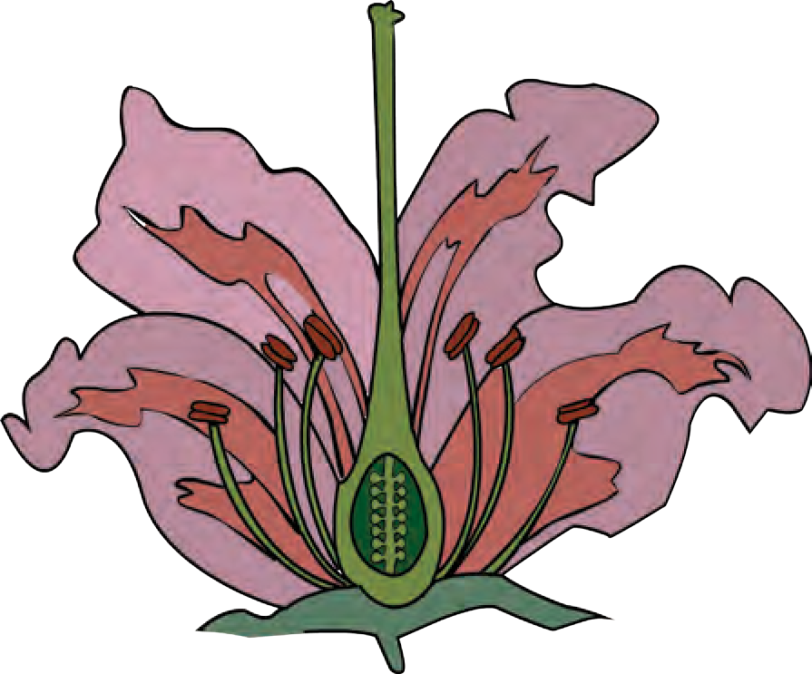

**Style**

**Ovary**

**Gynoecium**

##### Female flower

**Calyx (Sepals)**

**Pedicel**

* 1. **Parts of flower**

**Anther Filament**

**Androecium**

##### Male flower

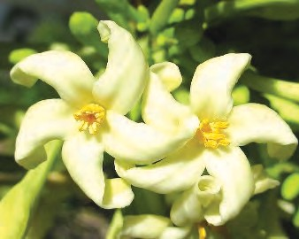

* 1. **Papaya Flower**

A flower is called as ‘bisexual’ if both whorls i.e. androecium and gynoecium are present in the same flower. Ex. *Hibiscus*. A flower is called as ‘unisexual’ if any one of the abovementioned two whorls is present in the flower. If only androecium is present, it is ‘male flower’ and if only gynoecium is present, flower is ‘female flower’. Ex. Papaya.



26

Many flowers have the stalk for support, called as ‘pedicel’ and such flowers are called as ‘pedicellate’ whereas flower without stalk is called as ‘sessile’.

Androecium is male whorl and its members are called as stamens. Gynaecium is female whorl and its members are called as carpels.

These may be separate or united. Ovary is present at the basal end of each carpel. A hollow ‘style’ comes up from the ovary. Stigma is present at the tip of style. Ovary contains one or many ovules. Embryo sac is formed in each ovule by meiosis. Each embryo sac consists of a haploid egg cell and two haploid polar nuclei.

Pollen grains from anther are transferred to the stigma. This is called as pollination.

Pollination occurs with the help of abiotic agents (wind, water) and biotic agents (insects and other animals). Stigma becomes sticky during pollination Pollens germinate when they fall upon such sticky stigma i.e. a long pollen tube and two male gametes are formed. The pollen tube carries male gametes. Pollen tube reaches the embryo sac via style. Tip of the pollen tube bursts and two male gametes are released in embryo sac. One male gamete unites with the egg cell to form zygote. This is fertilization. Second male gamete unites with two polar nuclei and endosperm is formed. As two male nuclei participate in this process, it is called as double fertilization.

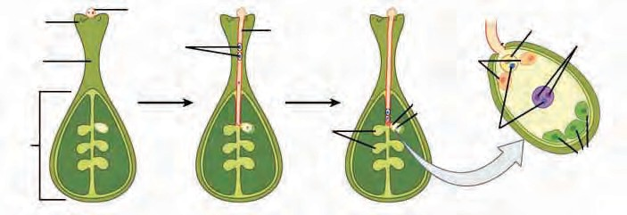

**Stigma**

**Style**

**Pollen grain**

**Male Gametes**

**Pollen tube**

**Egg cell**

**Synergids**

**Polar Nuclei**

**Ovules**

**Ovary**

**Embryo sac**

**Male gametes**

**Antipodals**

* 1. **Double fertilization in angiosperms**

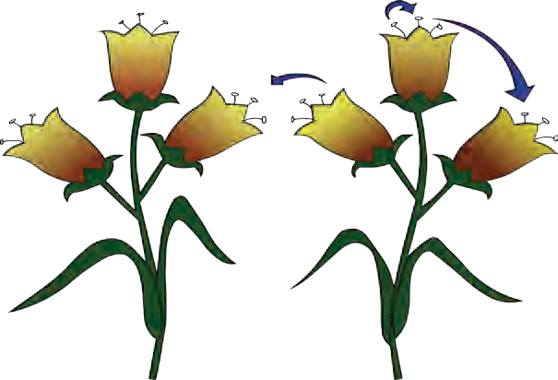

**Do you know?**

When pollination involves only one flower or two flowers borne on same plant, it is called as self-pollination whereas if it involves two flowers borne on two plants of same species, it is cross-pollination. While discovering the new high yielding and resistant varieties of plants, scientists bring about the pollination with the help of brush.

Use of ICT Make an video album of pollination and show it in the class.



27

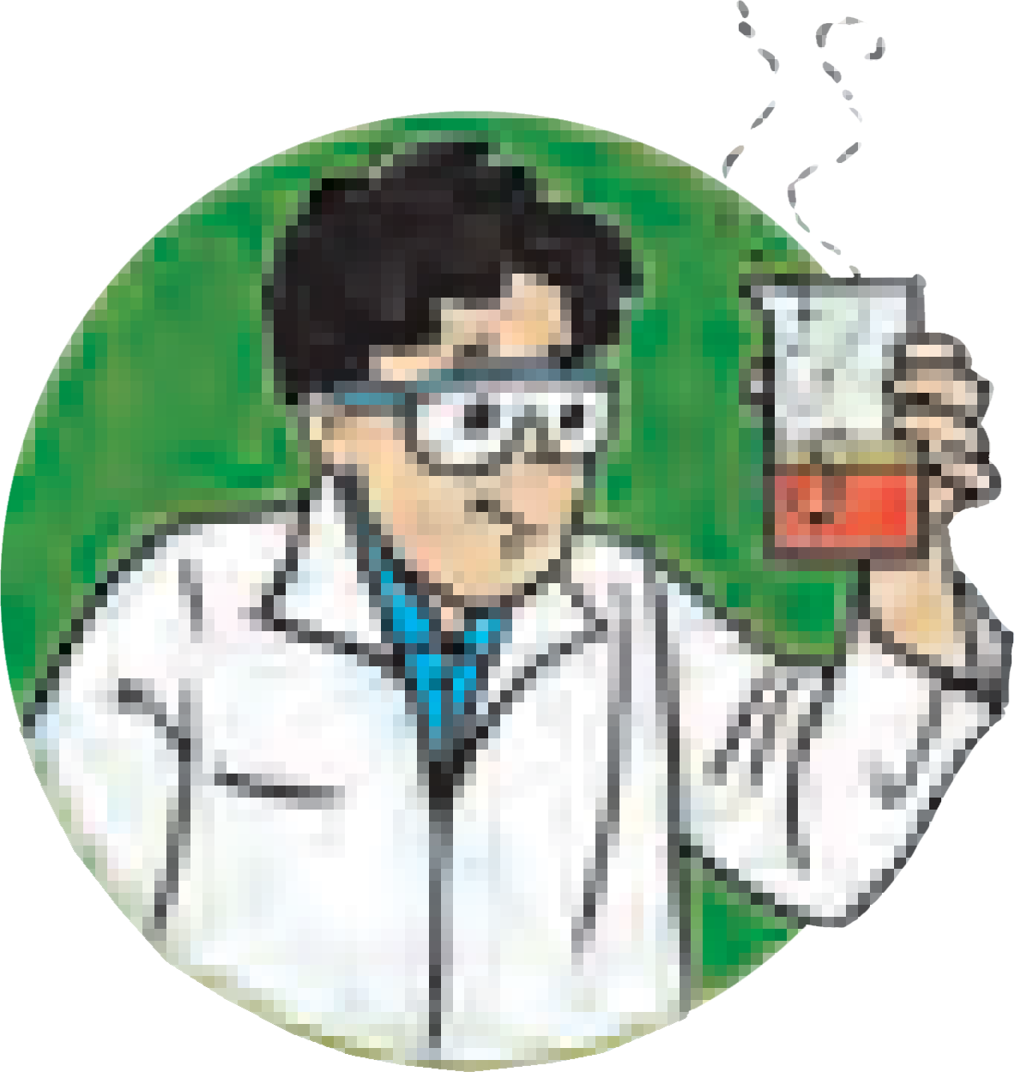

**Try this**

Take a suitable glass vessel like conical flask or beaker. Add some garden soil in it and sow some pulse grains in it in such a way that you can observe them through glass. Water it every day and record the changes.

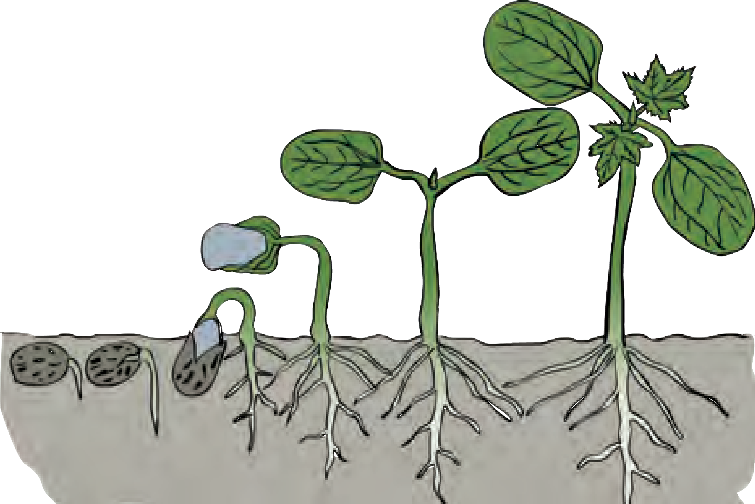

**3.15 Seed germination**

Ovule develops into seed and ovary into fruit after fertilization. Seeds fall upon the ground when fruits break up and they germinate in the soil under favourable conditions. Zygote develops at the cost of food stored in endosperm of seed and thus a new plantlet is formed. This is called as seed germination.

1. Sexual reproduction in human being
   1. Which different hormones control the functions of human reproductive system through chemical coordination?



**Can you recall?**

* 1. Which hormones are responsible for changes in human body occurring during on set of sexual maturity?
  2. Why has the Government of India enacted the law to fix the minimum age of marriage as 18 in girls and 21 in boys?

We have studied in the chapter of heredity and variation that men have XY sex- chromosomes and women have XX sex-chromosomes. Reproductive system with specific organs develops in the body of men and women due to these sex-chromosomes only. X-chromosome is present in men and women whereas Y-chromosome is present in men only. Now we shall study the structure and functions of human reproductive system.

**Urinary bladder**

Human male reproductive system

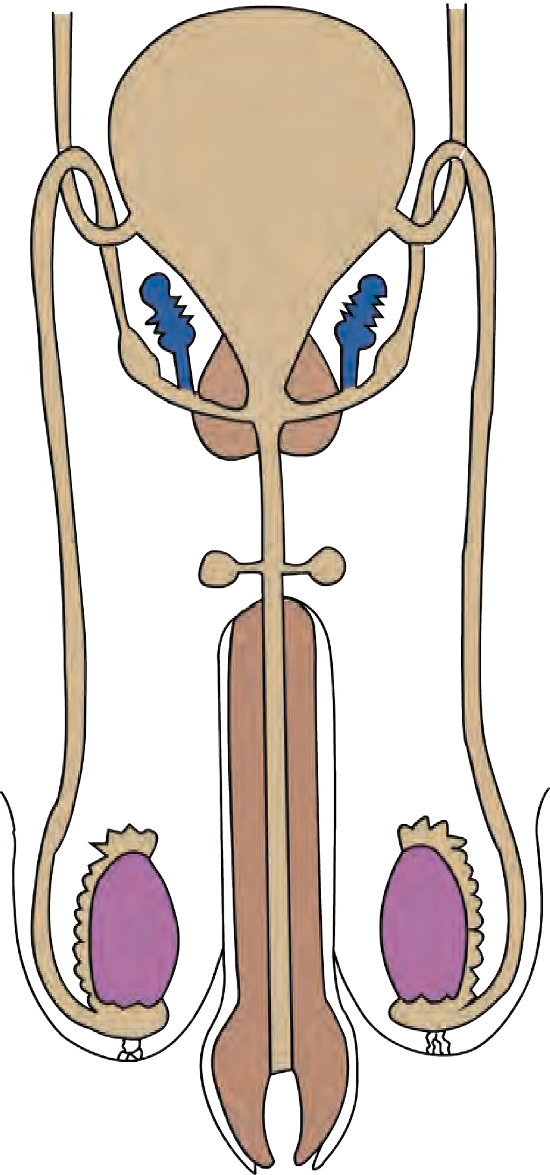

Male reproductive system of humans consists of testes, various ducts and glands. Testes are present in the scrotum, outside the abdominal cavity. Testes contain numerous seminiferous tubules. Germinal epithelium present in the tubules divide by meiosis to produce sperms. Those sperms are sent forward through various tubules. Sequence of those tubules is as-rete testis, vas eferens, epididymis, vas deferens, ejaculatory duct and urinogenital duct. As the sperms are pushed forwards from one duct to next, they become mature and

**Seminal vesicle**

**Prostate gland Vas deferens**

**Cowper's gland**

**Urino genital duct**

**Epididymis**

**Scrotum**

**Ejaculatory duct**

able to fertilize the ovum.

**Penis**

**Testis**

* + 1. **Male reproductive system of human**



28

Seminal vesicles secrete their secretion in ejaculatory ducts whereas prostate gland and Cowper’s glands secrete their secretions in urinogenital duct. Semen is formed of sperms and secretions of all these glands. Semen is ejaculated out through penis. All the organs of male reproductive system are paired except urinogenital duct, prostate gland, penis & scrotum.

Surprising Facts

1. Length of each epididymis is about 6 meters.
2. Length of a sperm is about 60 micrometers.
3. Such a small sperm has to cross the distance of approximately 6.5 meter while passing out of male reproductive system.
4. Sperm needs large amount of energy. For this purpose, fructose is present in the semen.

**Human female reproductive system** All organs of female reproductive system are in abdominal cavity. It includes a pair of ovaries, a pair of oviducts, single uterus and a vagina.

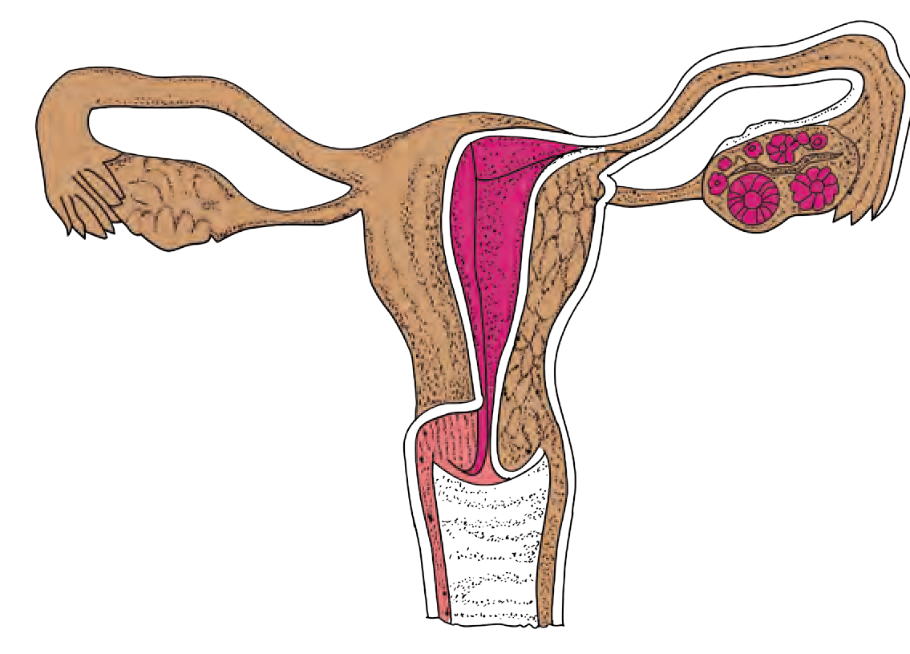

**Ovary**

**Uterus**

**Vagina**

Besides, a pair of Bartholin's gland is also present.

Generally, every month, an ovum is released in abdominal cavity alternately from each ovary. Free end of oviduct is funnel-like. An opening is present at the center of it. Oocyte enters the oviduct through that opening. Cilia are present on inner surface of oviduct. These cilia push the oocyte towards uterus.

Gamete Formation

**Oviduct**

* + 1. **Human female reproductive system**

Both gametes i.e. sperm and ovum are formed by meiosis. Sperms are produced in testes of men from beginning of maturation (puberty) till death. However, in case of women, at the time of birth, there are 2 – 4 million immature oocytes in the ovaries of female foetus. An oocyte matures and is released from ovary every month from the beginning of maturity up to the age of menopause (approximately 45 years of age). Menopause is the stoppage of functioning of female reproductive system. At the age of about 45 – 50 years, secretion of hormones controlling the functions of female reproductive system either stops or becomes irregular. This causes the menopause.

Fertilization

Formation of zygote by union of sperm and ovum is called as fertilization. Fertilization is internal in humans. Semen is ejaculated in vagina during copulation. Sperms, in the numbers of few millions start their journey by the route of vagina – uterus – oviduct. One of those few million sperms fertilize the only ovum present in the oviduct.

From the age of puberty up the menopause (from 10 – 17 years of age up to 45 – 50 years), an ovum is released every month from the ovary. i.e. out of 2 – 4 million oocytes, approximately only 400 oocytes are released up to the age of menopause. Remaining oocytes undergo degeneration.



29

**Sperms Oocyte**

Oocytes released from ovaries during last few months nearing the age of menopause are 40 – 50 years old. Their ability of division has been diminished till now. Due to this, they cannot complete meiotic division properly. If such oocytes are fertilized, the new-borns produced from them may be with some abnormalities like Down’s syndrome.

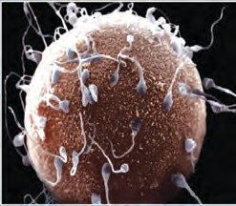

* + 1. **Fertilization**

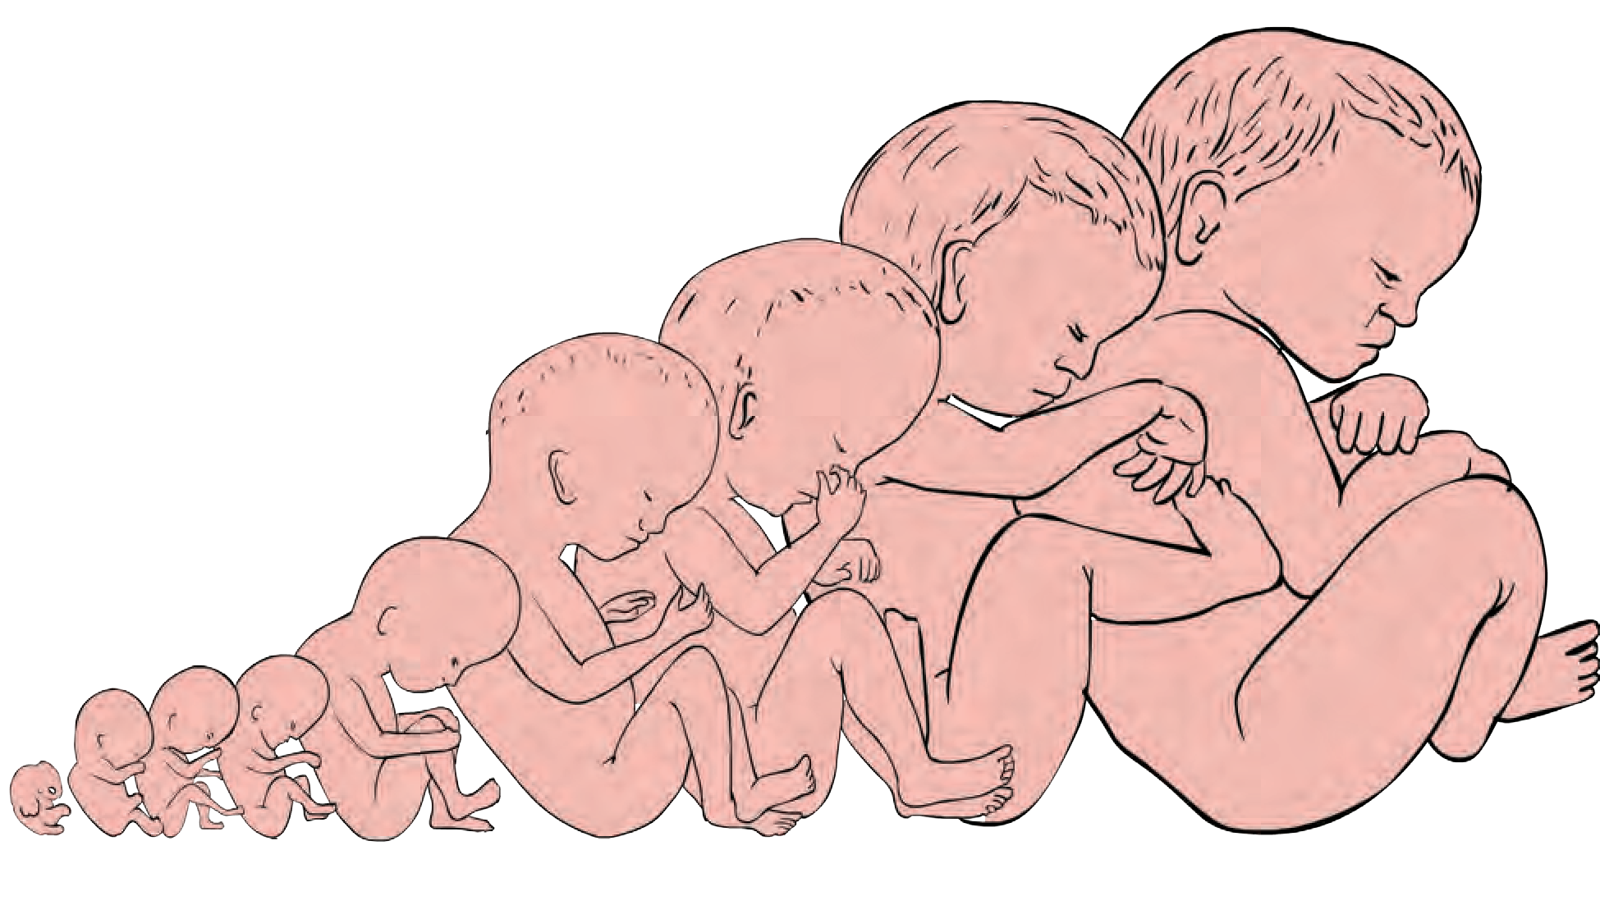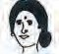

**Do you know?**

1. The chromosome number in germ cells producing the gametes are diploid i.e. 2n. It includes 22 pairs of autosomes and 1 pair of sex-chromosomes i.e. (44 + XX or 44 + XY). These germ cells divide by meiosis. Due to this, gametes contain only haploid (n) number of chromosomes i.e. (22 + X or 22 + Y). Two types

Sperms Oocytes

#### (22 + X) **or** (22 + Y) (22 + X)

of sperms are produced as (22 + X) or (22 + Y)

**Girl** (44 + XX)

**Boy**(44 + XY)

whereas oocytes are produced of only one type as (22 + X).

* + 1. **Sex determination in human being**

1. Both, sperms and oocytes are produced by meiosis. In case of sperms, process of meiotic division is completed before the sperms leave male reproductive tract. However, in case of oocytes, process of meiotic division completes after ovulation; during fertilization in oviduct.

Development and Birth

The zygote formed after fertilization in the oviduct, undergoes repeated mitotic divisions and embryo is formed. Meanwhile, it is pushed towards uterus. Once it reaches the uterus, it is implanted and further development occurs after implantation. An organ called as placenta is formed for supply of food material during the growth in uterus. Embryonic development is completed approximately within nine months after the fertilization.

### 4 8 12 16 20 24 28 32 36 Weeks

* + 1. **Growth of an embryo**



30



**Can you tell?**

Menstrual Cycle:

1. Which hormone is released from pituitary of mother once the foetal development is completed?
2. Under the effect of that hormone, which organ of the female reproductive system starts to contract and thereby birth process (Parturition) is facilitated?



**Always remember**

The man is totally responsible, whether the couple will have a boy or a girl child. During zygote formation, man contributes either X or Y chromosome to the next generation, but woman contributes only X-sex chromosome to the next generation. At the time of fertilization, if X- chromosomes comes from male, the child will be a girl and if Y-chromosome comes then the child will be a boy. **Thinking of this, is it right to consider the mother responsible for a girl child? We all must take efforts to stop female foeticide.**

Female reproductive system undergoes some changes at puberty and those changes repeat at the interval of every 28 – 30 days. These repetitive changes are called as menstrual cycle. Menstrual cycle is a natural process, controlled by four hormones. Those four hormones are follicle stimulating hormone (FSH), luteinizing hormone (LH), estrogen and progesterone. One of the several follicles in the ovary starts to develop along with the oocyte present in it, under the effect of follicle stimulating hormone. This developing follicle secretes estrogen. Endometrium of the uterus starts to develop (during first cycle) or regenerate (during subsequent cycles) under the effect of estrogen. Meanwhile, developing follicle completes its development. It bursts under the effect of luteinizing hormone and oocyte is released. This is called as ovulation. Remaining tissue of the burst follicle forms the corpus luteum. Corpus luteum starts to secrete progesterone. Endometrial glands secrete their secretion under the effect of progesterone. Such endometrium is ready for implantation of embryo.

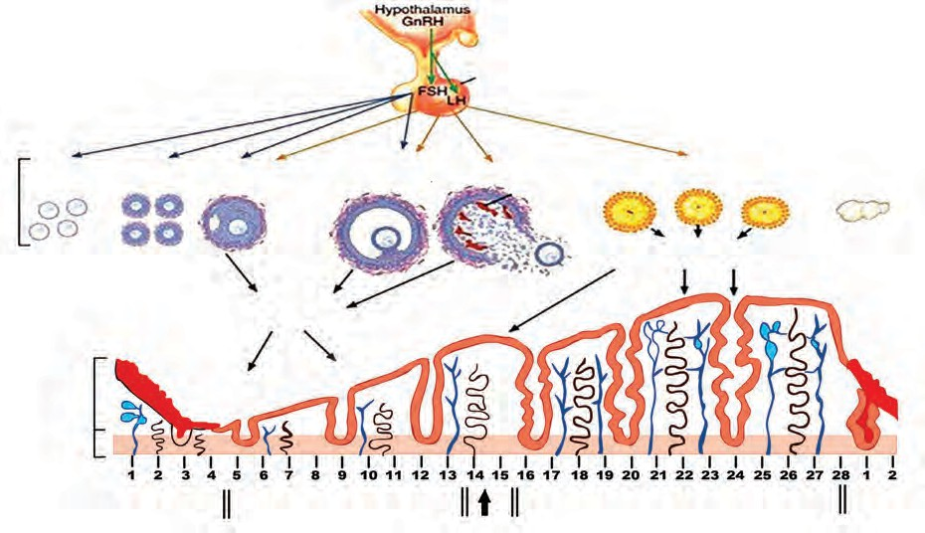

Changes in the ovary during menstruation

Pituitary gland

Fully grown follicle

Ovulation

Corpus luteum

Corpus

albicans

Progesterone and estrogen

**Estrogen**

changes in the uterus during Menstruation

Beginning

of new Menstruation

Period of Menstruation

Period of regeneration

of endometrium Ovulation period

Period of secretions of glands in endometrium

* + 1. **Menstrual cycle**



31

If oocyte is not fertilized within 24 hours, corpus luteum becomes inactive and transforms into corpus albicans. Due to this, secretion of estrogen and progesterone stops completely. Endometrium starts to degenerate in absence of these two hormones. Tissues of degenerating endometrium and unfertilized ovum are discarded out through vagina. This is accompanied with continuous bleeding. Bleeding continues approximately for five days. This is called as menstruation.

Unless the oocyte is fertilized and embryo is implanted, this process is repeated every month. If the embryo is implanted, repetition of this cycle is temporarily stopped till the parturition and thereafter period of breast feeding. Menstrual cycle is a natural process and the women experience severe pains during this period. Severe weakness is felt due to heavy bleeding. There is higher possibility of infections too during this overall period. Due to all such reasons, there is need of rest along with special personal hygiene.

Reproduction and Modern Technology

Many couples cannot have children due to various reasons. In case of women, irregularity in menstrual cycle, difficulties in oocyte production, obstacles in the oviduct, difficulties in implantation in uterus and many other reasons are responsible for this. Absence of sperms in the semen, slow movement of sperms, anomalies in the sperms are the reasons in case of males. But now with the help of advanced medical techniques like

IVF, Surrogacy, Sperm bank the childless couples can have a child.

Sperms being

**In Vitro Fertilization (IVF)**

Micro pipette

Ovum

introduced

In this technique, fertilization is brought about in the test-tube and the embryo formed is implanted in uterus of woman at appropriate time. IVF technique is used for having the child in case of those childless couples who have problems like less sperm count, obstacles in oviduct, etc.

**Surrogacy**

Some women have problems in implantation of embryo in uterus. Such women can take the help of the modern remedial technique called as surrogacy. In this technique, oocyte is collected from the ovary of the woman having problem in implantation in uterus. That oocyte is fertilized in test-tube with the help of sperms collected from her husband. The embryo formed from such fertilization is implanted in the uterus of some other woman having normal uterus. Such a woman, in whose uterus the embryo is implanted, is called as surrogate mother.

**Sperm Bank/ Semen Bank**

* + 1. **Fertilization in a test tube**

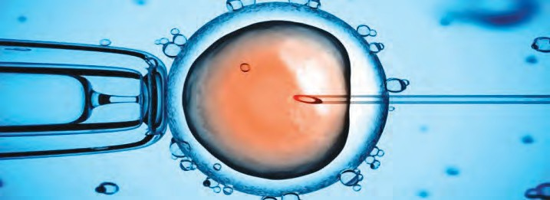

through micro needle

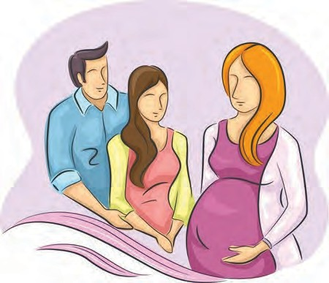

* + 1. **Surrogacy**

There are various problems in sperm production as mentioned above, in case of many men. So as to have the children in case of such couples, new concept of sperm bank has been introduced. This concept is similar to blood bank. Semen ejaculated by the desired men is collected after their thorough physical and medical check-up and stored in the sperm bank.



32

As per the wish of needful couple, oocyte of woman of the concerned couple is fertilized by IVF technique using the semen from sperm bank. Resultant embryo is implanted in the uterus of same woman. Name of the semen donor is strictly kept secret as per the law.

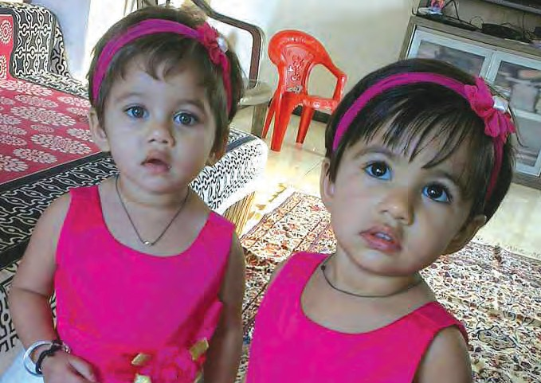Twins

Two embryos develop simultaneously in the same uterus and thus two offsprings are delivered simultaneously. Such offsprings are called as twins. Many couples have twins. There are two main types of twins as- monozygotic twins and dizygotic twins. Monozygotic twins are formed from single embryo. During early period of embryonic development (within 8 days of zygote formation), cells of that embryo

divide into two groups.

* + 1. **Twin girls: age 18 months**

Those two groups develop as two separate embryos and thus monozygotic twins are formed. Such twins are genetically exactly similar to each other. Due to this, such twins are exactly similar in their appearance and their gender is also same i.e. both will be either boys or girls.

In case of monozygotic twins, if the embryonic cells are divided into two groups 8 days after the zygote formation; there is high possibility of formation of conjoined twins (Siamese twins). Such twins are born with some parts of body joined to each other. Some organs are common in such twins.

Occasionally, two oocytes are released from the ovary of woman and both oocytes are fertilized by two separate sperms and thus two zygotes are formed. Two embryos are formed from those two zygotes and both of those embryos are separately implanted in the uterus and thus dizygotic twins are delivered after complete development. Such twins are genetically different and may be same of different by gender.

Reproductive health



Internet is my friend

You may have read that sometimes a woman may deliver more than two offsprings at a time. Collect more information from internet about reasons for such incidences.

A person’s state of being physical, mental and social strongness is called as health. In our country, there seems to be lack of awareness regarding reproductive health due to various reasons like social customs, traditions, illiteracy, shyness, etc. Especially, there seems to be indifference towards the reproductive health of women.

Occurrence of menstrual cycle is related with reproductive and overall health of women. Now a day, women are working at par with men. Due to this, they have to stay outdoors for whole day. Bleeding occurs during menstrual cycle. Due to this, private organs (genitals) need to be maintained clean time to time, otherwise, problems regarding reproductive health may arise. Some problems regarding reproductive health may arise in men too. It is essential to maintain the cleanliness of their genitals.



33

Among the various sexual diseases, syphilis and gonorrhoea occur on large scale. Both of these diseases are caused by bacteria. Occurrence of chancre (patches) on various parts of body including genitals, rash, fever, inflammation of joints, alopecia, etc. are the symptoms of syphilis. Painful and burning sensation during urination, oozing of pus through penis and vagina, inflammation of urinary tract, anus, throat, eyes, etc. are symptoms of gonorrhoea.



**Do you know?**

**Population Explosion**

Excessive growth of population within short duration is called as population explosion. You may have realized from the table given besides about fast population growth of India. We have to face various problems like unemployment, decreasing per capita income and increasing loan, stress on natural resources, etc. There is only one solution for all such problems and it is population control. Family planning is essential for this.

|  |  |
| --- | --- |
| Year | Population |
| 1901 | 238396327 |
| 1911 | 252093390 |
| 1921 | 251321213 |
| 1931 | 278977238 |
| 1941 | 318660580 |
| 1951 | 358142161 |
| 1961 | 439234771 |
| 1971 | 548159652 |
| 1981 | 683329097 |
| 1991 | 846421039 |
| 2001 | 1028610328 |
| 2011 | 1210854977 |

Visit a public health center nearby your place and collect the information through an interview of health officer about mean- ing and various methods of family planning.



Get information





**Exercise**

1. Complete the following chart.

|  |  |
| --- | --- |
| **Asexual reproduction** | **Sexual reproduction** |
| 1. Reproduction that occurs with the help of somatic cells is called as asexual reproduction.  2 …………………………………………  …………………………………..   1. This reproduction occurs with the help of mitosis only. 2. ………………………………...............   ……………………………….............…   1. Asexual reproduction occurs in different individuals by various methods like binary fission, multiple fission, budding, fragmentation, regeneration, vegetative propagation, spore production, etc. | 1. ………………………………...........   ……………………………….............…  …………………………….....................   1. Male and female parent are necessary for sexual reproduction. 2. ……………………………………...   ……………………………......................   1. New individual formed by this method is genetically different from parents. 2. ………………………………..............   ……………………………….............…  ……………………………....................  ……………………………….............…  ……………………………....................  ……………………………….............…  …………………………….................... |



34

1. **Fill in the blanks.**
   1. In humans, sperm production occurs in the organ --.
   2. In humans, ------ chromosome is responsible for maleness.
   3. In male and female reproductive system of human, gland is

same.

* 1. Implantation of embryo occurs in ------
  2. ---------- type of reproduction occurs without fusion of gametes.
  3. Body breaks up into several fragments and each fragment starts to live as a new individual. This is -- -- -- -- -- -- -- type of reproduction.
  4. Pollen grains are formed by -- ----- -- --

-- division in locules of anthers.

1. **Complete the paragraph with the help of words given in the bracket.**

(Luteinizing hormone, endometrium of uterus, follicle stimulating hormone, estrogen, progesterone, corpus luteum) Growth of follicles present in the ovary occurs under the effect of This

follicle secretes estrogen. -- --- - -- --

-- grows / regenerates under the effect of estrogen. Under the effect of ,

fully grown up follicle bursts, ovulation occurs and -- --- -- -- is formed from remaining part of follicle. It secrets ---

--- -- -- and --- --- -- -- --. Under the effect of these hormones, glands of -- --

- are activated and it becomes ready

for implantation.

1. **Answer the following questions in short.**
   1. Explain with examples types of asexual reproduction in unicellular organism.
   2. Explain the concept of IVF.
   3. Which precautions will you follow to maintain the reproductive health?
   4. What is menstrual cycle? Describe it in brief.
2. **In case of sexual reproduction, new-born show similarities about characters. Explain this statement with suitable examples.**
3. **Sketch the labelled diagrams.**
   1. Human male reproductive system.
   2. Human female reproductive system.
   3. Flower with its sexual reproductive organs.
   4. Menstrual cycle.
4. **Give the names.**
   1. Hormones related with male reproductive system.
   2. Hormones secreted by ovary of female reproductive system.
   3. Types of twins.
   4. Any two sexual diseases.
   5. Methods of family planning.
5. **Gender of child is determined by the male partner of couple. Explain with reasons whether this statement is true or false.**
6. **Explain asexual reproduction in plants.**
7. **Modern techniques like surrogate mother, sperm bank and IVF technique will help the human beings. Justify this statement.**
8. **Explain sexual reproduction in plants. Activity :**
9. Collect the official data about present and a decade old population of various Asian countries and plot a graph of that data. With the help of it, draw your conclusions about demographic changes.
10. With the help of your teacher, compose and present a road show to increase the awareness about prenatal gender detection and gender bias.





35



**4. Environmental management**

* **Ecosystem – A review** ➢ **Environment and Eco-system**
* **Environment Conservation** ➢ **Environment management**
* **Biodiversity hotspots**
  1. What is ecosystem? Which are its different components?



**Can you recall?**

* 1. Which are the types of consumers? What are the criteria for their classification?
  2. What may be the relationship between lake and birds on tree?
  3. What is difference between food chain and food web?



**Think and Answer**

1. 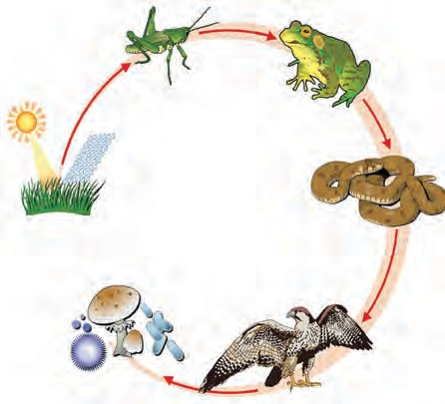Write the name and category of each of the component shown in picture.
2. What is necessary to convert this picture into food web? Why?

Ecosystem A review

Ecosystem is formed by biotic and abiotic factors and their interactions with each other. Each factor plays very important role in the ecosystem. Producers like plants are important. Herbivores like deer, goats, sheep, cattle, horses, camels, etc. feeding upon producers are also important. Predators like lion and tiger which prevent the overpopulation of herbivores are also equally important. A question may arise in our mind that whether the caterpillars found in nature, organisms present in filthy places, termites, insects present in dung, are really useful? However, those organisms are also important though they are dirty. They are responsible for cleaning the environment.

It means that our existence is due to these factors present around us. Hence, we should care for these factors.



**Discuss**

**‘Jivo Jivasya Jivanam’**

* 1. Food chain



Think:

If fallen foliage in forest, dead trees, and carcasses in and around villages had not been decomposed for years……

* + 1. Which are different trophic levels in food chain?



**Can you recall?**

* + 1. What is energy pyramid?



36

Let's Think

A bird building nest on a tree feeds upon the fishes in nearby pond. Whether this bird is part of both i.e. tree as well as pond ecosystem?

Complete the chart

Fill up the blank boxes and display the completed chart in classroom.



Decomposers

Producer

Autotrophic

Tertiary consumer

Hydrogen, Oxygen, Nitrogen,

Calcium, Iron, Sodium, Potassium

**Ecosystem**

Animals

Physical factor

Abiotic components

Air, water, vapour, minerals, soil, sunlight

Proteins, Carbohydrates, fats

Inorganic substances

Paddy is cultivated on large scale in various states of South India. Paddy fields are frequently attacked by grasshoppers. Similarly, frogs are also present in large number in the mud of paddy fields, to feed upon grasshoppers and snakes are also present therein to feed upon their favourite food- frogs.

However, if frog population declines all of a sudden,

1. What will be the effect on paddy crop?



**Let's Think**

1. Number of which consumers will decline and which will increase?
2. What will be overall effect on that ecosystem?



**Can you tell?**

* 1. What is environment?
  2. What is included in environment?

Relationship between Environment and Ecosystem

Environment is a broad concept. Physical, chemical and biological factors affecting the living organisms in any possible way is collectively called as environment. In short, environment is the condition in surrounding. It includes many biotic, abiotic, natural and artificial factors. There are two main types of environment. One is natural environment and other is artificial environment.



37

Natural environment consists of air, atmosphere, water, land, living organisms, etc. Continuous interactions occur between biotic and abiotic factors. Their interactions are very important. Artificial environment is also affecting the natural environment directly or indirectly. Basically, environment consists of two basic factors- 1. Biotic factors,

2. Abiotic factors. The science that deals with the study of interactions between biotic and abiotic factors of the environment is called as ecology. Basic functional unit used to study the ecology is called as ecosystem.

Environment consists of many ecosystems. We have studied some ecosystems in earlier classes. A small pond is an ecosystem whereas the Earth is largest ecosystem. In brief, biotic and abiotic factors occupying a definite geographical area and their interactions collectively constitute the ecosystem.

Which cycles are operated in environment? What is their importance?



**Can you recall?**

Environmental balance is maintained through continuous operation of various natural cycles like water cycle, carbon cycle, gaseous cycles like nitrogen cycle, oxygen cycle, etc. Environmental balance is also maintained due to various food chains of ecosystem.

Human existence is totally impossible without the existence of nature. Hence, it is basic responsibility of human being to preserve the nature without disturbing its balance. It is said that we have got this Earth planet on lease from our future generations and not as an ancestral property from our ancestors. Hence we should not forget to conserve it for ourselves and for future generations.

Environmental Conservation

1. Which factors affect the environment? How?



**Can you tell?**

1. What will happen if number of consumers in environment goes on increasing gradually?
2. What will be the effect of industry established on river bank on the river ecosystem?

When some natural factors of environment and some artificial polluted factors harm the environment, it creates imbalance between various factors of the environment and ultimately affects the existence of biotic factors.



**Observe and fill the information**

Observe the environment around you. Complete the following flow chart.

**Factors affecting environment**



“The Earth is sufficient to satisfy

**Natural factors**

Earthquakes .................

..................................

**Manmade factors**

Deforestation......................

......................................

### 38

everyone’s need but not the greed.”

* Mahatma Gandhi

At present, many environmental problems have been arisen due to effect of various natural and artificial factors on the Earth. Environmental pollution is one of those main factors. Generally, contamination of any material is its pollution. Unnecessary and unacceptable change in the surrounding environment due to natural events or human activities are called as environmental pollution. i.e. direct or indirect changes in physical, chemical and biological properties of air, water and soil which will be harmful to humans and other living beings is environmental pollution. Various reasons like population explosion, fast industrialization, and indiscriminate use of natural resources, deforestation, and unplanned urbanization are responsible for environmental pollution.

* 1. Which are the types of pollution?



**Can you recall?**

* 1. What do we mean by natural and artificial pollution?

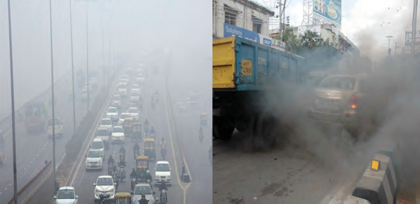Pollution is a broad concept. Various types of pollutions like that of air, water, sound, soil, thermal, light, pollution occur around us. Ultimate adverse effect of all these is on existence of all the living organisms and out of this, environmental conservation has become the need

* 1. **Fog and pollution in city- A problem**



**Complete the Chart**

of hour.

We have studied the air pollution, water pollution and soil pollution in detail in earlier classes. Based on that, complete the following chart.

|  |  |  |  |
| --- | --- | --- | --- |
|  | **Air pollution** | **Water pollution** | **Soil pollution** |
| **Compo-** | **Gases :** CO2, CO, Hydro- |  |  |
| **nents** | carbons, Sulphur, NOx,  Hydrogen sulphide, etc. |
|  | **Solid** : dust, ash, carbon, |
|  | lead, asbestos, etc. |
| **Source** |  | Industrial wastes, Domestic waste, Sewage, Chemicals discharged from Industries, Pesticides used in agriculture. |  |
| **Effect** |  |  | Soil erosion, Retarded growth of plants/ crops,  Nutritional deficiency etc. |
| **Control Measure** |  |  |  |



39



**Do you know?**

**Radioactive pollution:** Radioactive pollution can occur due to two reasons as natural and artificial. UV and IR radiations are natural radiations whereas X-rays and radiations from atomic energy plants are artificial radiations. Chernobyl, Windscale, and Three Miles Island mishaps are the major mishaps of the world till present. Thousands of people have been affected for long term due to these accidents. Some of the effects of radiations are as follows-

1. Cancerous ulceration occurs due to higher radiations of X-rays.
2. Tissues in the body are destroyed.
3. Genetic changes occur.
4. Vision is adversely affected.

**Use your brain power**

Why is it said that pollution control is important?

Need of environmental conservation

General public is not aware about the rules of environment conservation. There should be large scale participation of the people in environment conservation. It will be possible to answer the environmental problems only if environmental protection-conservation becomes an effective public movement. For this purpose, values like positive attitude and affection towards environment, knowledge about it, etc. should be inculcated among the children since their childhood. This will help to make the future generations more aware about environmental conservation and protection. So as to achieve this, it is necessary to increase the awareness through education.

**A peek into the history**

In 1972, United Nations Environment Program (UNEP) has been established in a conference arranged on human and environment in which environmental problems were discussed. Afterwards, in India, a separate environmental department had been established after through discussion on environmental problems. Ministry of environment and forests is involved in planning, inducting and increasing awareness about environment and forest through various programs since 1985.

Today, all the developed, developing and underdeveloped countries have accepted the responsibility of environmental protection. Their efforts are in that direction. They have defined the future plans about environmental protection and have constituted the necessary laws.



**Complete the Chart**

Nowadays, we are observing the environmental degradation everywhere. Complete the flow chart given besides with the help of environment.

Need of

Environmental conservation

40

To maintain the balance in nature

To solve the natural and artificial problems

Environmental Conservation. Our social responsibility

Since existence of human, there is interrelationship between human and environment. Human stepped on the Earth long after formation of Earth. On the Earth, human being proved its superiority as compared to other animals with the help of characters like intelligence, memory, imaginary ability, etc. Human established domination over the nature. Human utilized all the natural resources as much as possible. In an attempt to live a satisfactory life, human kept on snatching from the nature as much as possible and this led to increase in problems. From this entire scenario, we can understand that human has crucial role in maintaining the environmental balance. If human has disturbed the environmental balance, then human itself only can conserve and improve the quality of nature. Many times, general public is unknown that its activities are harmful to environment and thereby unknowingly many activities happen.



**Search**

How do butterflies contribute to environmental balance?

**Do You Know?**



**Laws enacted about environmental conservation:**

**Forest (Conservation) Act, 1980.**

The land reserved for forest conservation has been prohibited to use for any other purpose by this law. Ex. Permission of central government is compulsory for mining activities. Any person who disobeys this law is entitled to imprisonment for 15 days.

Environmental (Protection) Act, 1986.

Purpose of this act is to control the pollution and punish the persons or institutes harming the environment. Any person or factory is prohibited by this act from releasing the pollutants in atmosphere beyond a permissible limit. The person breaching this rule is entitled for either five year imprisonment or fine up to Rs. 1 lakh. National Green Tribunal has been established in 2010 for effective implementation of environment related laws.

Let’s Discuss

Collect the information about Chipko Movement and discuss between two groups of your class about its importance in present situation.

Internet is my friend

1. Sound Pollution (Control & Prevention) Rule, 2000.
2. Biomedical Waste (Management & Handling) Rule, 1998.
3. E-waste (Management & Handling) Rule, 2011.

Always remember

**As per wildlife protection Act 1972**

**As per clause 49 A,** trading of rare animals has been completely banned.

**As per clause 49 B,** use of articles prepared from skin or organs of wild animals has been banned.

**As per clause 49 C,** disclosure of the stock of artefacts made form rare wild animals is compulsory.

### 41

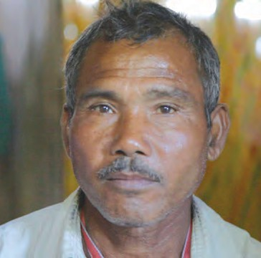

**The big story of a small man**

Jadav Molai Payeng is a highly capable person in Assam.

Born in 1963, he is working as a forest worker since the age of 16 years. Once, large number of snakes died in the flood of Brahmaputra River flowing by the village. As a preventive measure, Molai planted 20 bamboo plantlets. In 1979, the local Social Forestry Department began a social afforestation project on 200 hectares of land. ‘Molai’ was one of the few forest workers who were looking after that project. Molai continued to plant the trees even after completion of the project. As a result of his continuous work of planting and caring for the trees, the barren area witnessed the forest cover over the 1360 acres.

Today, this jungle in Kokilamukh of Jorhat district of Assam is the result of the hard work for 30 years. He has been awarded with the prestigious ‘Padmashree’ award by government of India for this unparallel work. Now, it is well known as ‘Molai Jungle’. Many people come together to destroy the forest, **but a single person, if determined, can establish a new forest!**

Environmental Conservation and Biodiversity

Most harmful effect of the environmental pollution occurs on the living organisms. Have you seen some examples of this in your area? Our living world had been richly diverse. It consisted of varieties of plants and animals. However, we are not able to see some specific animals about which we had listened from our earlier generations. Who is responsible for this?

Biodiversity is the richness of living organisms in nature due to presence of varieties of organisms, ecosystems and genetic variations within a species. Biodiversity occurs at three different levels.

Genetic Diversity

Occurrence of diversity among the organisms of same species is genetic diversity. Ex. Each human being is different from other. Possibility of wiping out the species arises if there is decrease in the diversity within the species whose members involve in sexual reproduction.

Species Diversity

Innumerable species of organisms occur in the nature. This is called as species diversity.

Species diversity includes various types of plants, animals and microbes.

Ecosystem Diversity

Many ecosystems are present in each region. Ecosystem is formed through the interaction between plants, animals, their habitat and changes in the environment. Each ecosystem has its own characteristic animals, plants, microbes and abiotic factors. Ecosystems are also of two types are natural and artificial.



There should be positive attitude of human being towards the environment for welfare of entire living world. For this purpose, following roles are important. You can be a conservator, organizer, guide, plant-friend, etc. Describe about the role you wish to perform and your plans for that role.

42

* 1. Sacred grove

Sacred Groves

The forest conserved in the name of god and considered to be sacred is called as sacred grove. These are in fact ‘sanctuaries’ conserved by the society and not by the government forest department. As it has been conserved in the name of god, it has special protection. These clusters of thick forests are present not only in Western Ghats of India but in the entire country.

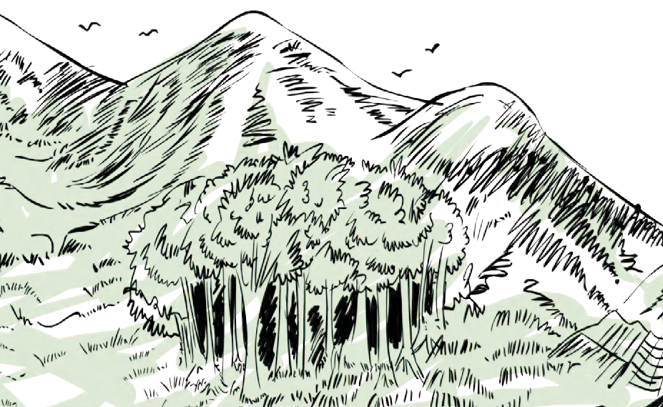

More than 13000 sacred groves have been reported in India. Where are such sacred groves in Maharashtra? Make a list and visit with your teachers.

Some symbols are given below. Find the meaning of those

Enlist and discuss

symbols in relation to environment conservation. Make a list of other such symbols.

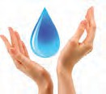Till now, we have studied the rules and regulations about environmental conservation and protection, in this lesson. Many people in the society are voluntarily coming together to perform this noble work. Many institutes at state, national and international level are involved in this work.

**How can biodiversity be conserved?**

1. Protecting the rare species of organisms.
2. Establishing national parks and sanctuaries.
3. Declaring some regions as ‘bioreserves’.
4. Projects for conservation of special species.
5. Conserving all plants and animals.
6. Observing the rules.
7. Maintaining record of traditional knowledge.

Stick here a symbol known to you.

**Voluntary Organizations**



1. Bombay Natural History Society, Mumbai.
2. CPR environment group, New Chennai.
3. Gandhi Peace Foundation, Environment Cell, Delhi.
4. Chipko Centre, Tehri Garhwal.
5. Centre for Environment Education, Ahmadabad.
6. Kerala Science Literature Council, Trivandrum.
7. Indian Agro Industries Foundation, Pune.
8. Vikram Sarabhai Community Science

International Environment Organizations

1. International Union for Conservation of Nature (IUCN), Gland VD, Switzerland.
2. Intergovernmental Panel on Climate Change (IPCC), Geneva.
3. United Nations Environment Program, Geneva.
4. World Wildlife Fund, New York.
5. Bird Life International, Cambridge.
6. Green Climate Fund, Songdo, S. Korea

Centre, Ahmadabad. Green Peace is world’s largest organization engaged in environmental activities. More than 25 lakh people from 26 different countries are members of this organization.

Collect more information about the work of above mentioned organizations.

### 43

Attempts at various levels are performed for conserving environment. Role of the person is defined as per these levels. Some roles are given below. Which role would you like to per form? Why ?



**Think and Answer**

**Conservation** Conserving the available resources

Preservation

1. Preserving whatever has been leftover.
2. Remedies to prevent further loss.
3. Preserving unknown regions.

Control

1. Preventing the harm.
2. Stopping the harmful activities.
3. Changing the mindset.

My Role in Environment

**Prevention**

* 1. Preventing possible harms.
  2. Designing new plans
  3. Factors harmful to environment

Production

1. Revival of harmed factors of environment.
2. Attempting innovation.

Awareness

* 1. Education
  2. Guidance
  3. Awareness
  4. Imitation
  5. Organization
  6. Participation

Hotspots of Biodiversity

34 highly sensitive biodiversity spots are reported all over the world. Such areas had once occupied 15.7% area of the Earth. At present, 86% of the sensitive areas are already destroyed. Presently, only 2.3% area of the Earth has been left over with sensitive spots. It includes 1,50,000 plant species which are 50% of the world count.

As far as India is considered, out of 135 species of animals, 85 species are found in the jungles of eastern region. About 1,500 endemic plant species are found in western ghat. Out of the total plant species in the entire world, 50,000 are endemic. Collect more

information about locations of these hotspots present in the world.



**Three Endangered Heritage Places of the Country**

The Western Ghat spread over the states of Gujarat, Maharashtra, Goa, Karnataka, Tamilnadu and Kerala these six states has been endangered due to mining industry and search for natural gas. Habitats of Asiatic lion and wild bison of this region have been under threat.

**Manas National Park** of the Assam is under threat due to dams and indiscriminate use of water. Tiger and rhino of that region are under threat.

**Sunderban National Park** of West Bengal is reserved for tigers. However, the tiger population and overall local environment is seriously challenged by dams, deforestation, excessive fishing, trenches dug for same, etc.

44

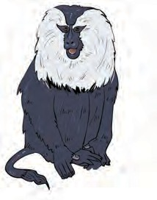Collect the names of extinct birds and animals of India and tell those names to others.



Recall a little

Classification of Threatened Species

1. **Endangered Species**

Either number of these organisms is declined or their habitat is shrunk to such an extent that they can be extinct in near future if conservative measures are not implemented. Example, Lion tailed monkey, lesser florican.

1. Rare Species

Number of these organisms is considerably declined. Organisms of these species being endemic may become extinct very fast. Example, Red panda, Musk deer.

1. Vulnerable Species

Number of these organisms is extremely less and continues to decline. Continuous decline in their number is worrisome reason. Example, Tiger, Lion.

1. Indeterminate Species

These organisms appear to be endangered but due to their some behavioural habits (like shyness) there is no definite and substantial information. Example, Giant squirrel (Shekru).



Do you know?

International Union for Conservation of Nature (IUCN) prepares the ‘Red List’ that contains the names of endangered species from different countries. Pink pages of this book contain the names of endangered species while green pages contain the names of previously endangered but presently safe species.

**Specialty of the Day**

22nd May: World Biodiversity Day Survey the plants and animals in your area. Maintain a record about their characteristics.

* 1. Lion-tailed Monkey

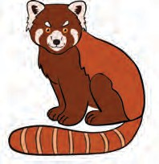

* 1. **Red Panda**

Always remember



Always Remember

Let us remember…. Let us behave accordingly……

1. Destroying a plant is to destroy everything.
2. Practice afforestation to conserve environment.
3. Forest is Wealth.
4. Environmental protection is value education.
5. Provident use of paper is prevention of deforestation.
6. To practice the environmental protection is to development of human society.
7. Pure air, pure water is key to healthy life.

### 45

Think

World Wildlife Fund (WWF) published a survey in 2008. According to it, about 30% of animal species have become extinct over the period of 35 years (1975 – 2005). What will happen in future if this continues as it is?



1. **Reorganize the following food chain. Describe the ecosystem to which it belongs.** Grasshopper – Snake – Paddy field – Eagle – Frog.
2. Explain the statement-‘wehavegotthis Earth planet on lease from our future generations and not as an ancestral property from our ancestors.’
3. **Write short notes.**
   1. Environmental Conservation.
   2. Chipko Movement of Bishnoi.
   3. Biodiversity.
   4. Sacred Groves.
   5. Disaster and its management.
4. **How will you justify that overcoming the pollution is a powerful way of environmental management?**
5. **Which projectswillyouruninrelation to environmental conservation? How?**
6. **Answer the following.**
   1. Write the factors affecting environment.
   2. Why does the human beings have important place in environment?
   3. Write the types and examples of biodiversity.
   4. How the biodiversity can be conserved?
   5. What do we learn from the story of Jadav Molai Peyang?



**Exercise**

* 1. Write the names of biodiversity hot spots.

f. Which are the reasons for endangering the many species of plants and animals? How can we save those?

1. 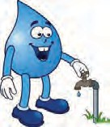What are the meanings of following symbols?Writeyourroleaccordingly?



**Project:**

Make a presentation on pollution of Ganga and Yamuna Rivers and effects of air pollution on Tajmahal.





**-: A Pledge for Life :-**

I am aware that the diversity on the Earth is for the existence of me, my family and the entire mankind. I am aware about the responsibility of conserving and protect- ing the rich diversity. I am aware about the fast declining number of wildlife, plants and animals. I am accepting the responsibility of judicious use of natural resources and management of biodiversity.

**I pledge for adopting the following principles for happy and satisfactory life of all organisms on the Earth.**

I will always try for conservation and sustainable management of natural resources. I will make the change that I am expecting.

I will be committed for safety of entire life on the Earth.

I will educate the people about benefits of conservation and co-existence.

46



**5. Towards Green Energy**

* **Use of various energy sources**
* **Generation of electrical energy**
* **Process of generation of electricity and environment**



**Can you recall?**



**Let’s Discuss**

1. What is Energy?
2. What are different types of Energy?
3. What are different forms of Energy?

Energy and use of energy

Make a list of the work that we do in our day to day life using energy. Which forms of energy do we use to do this work? Discuss with your friends.

In modern civilization, energy has become a primary need along with food, cloth and shelter. We need energy in different forms for diverse types of works. The energy that we need may be in the form of mechanical energy, chemical energy, sound energy, light energy or heat energy. How do we get these different forms of energy?

Make a table based on forms of energy and corresponding devices.



**Make a table**

We know that energy can be converted from one form to another. Different sources of energy are used to the different forms of energy necessary for us. In previous standards we have learnt about energy, sources of energy and various concepts related to them. Here we will learn about various sources that are now used for the generation of electrical energy, the methods that are used for this, the scientific principles that are used there, the

advantages and disadvantages of these methods and also what is meant by green energy.

* 1. Where do we use electrical energy in our day-to-day life?



**Can you tell?**

* 1. How Electric energy is produced ?

Generation of electrical energy

Most of the electric power plants are based on the principle of electromagnetic induction invented by Michael Faraday. According to this principle, whenever magnetic field around a conductor changes, a potential difference is generated across the conductor.

The field around a conductor can be changed in two ways. If a conductor is stationary and magnet is rotating, the field around the conductor changes or if a magnet is stationary, but the conductor is moving then also the field around the conductor will change. Thus, in both these cases, a potential difference is created across the conductor. (Figure 5.1). The electrical power generating machine based on this principle is called electric generator.



47

Such large generators are used in commercial power generation plants. Turbine is used to rotate the magnet in the generator. A turbine has blades .When a flow of liquid or gas is directed on the blades of the turbine, it rotates (see Figure 5.2). because of the kinetic energy of the flow.This turbine is connected to electric generator. Thus the magnet in electric gener- ator starts rotating and electric energy is produced (Fig.5.3)

Lines of flux

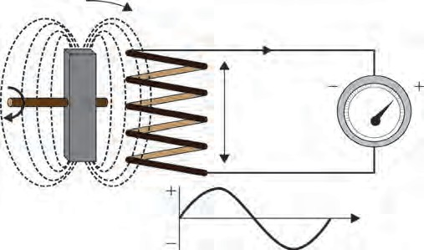

Coil

##### Induced emf

Voltmeter

Blade

Nozzle

##### High Velocity steam

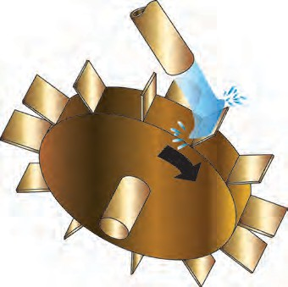

Rotating magnetic field

* 1. Electromagnetic Induction

Wheel

Shaft

##### Steam turbine

generated electrical energy

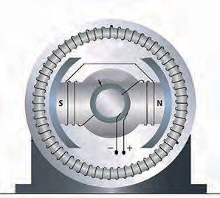

##### Rotating Electric magnet

* 1. Schematic of electric generator

This method of electric energy generation can be represented as below.

Thus, to generate electricity based on the principle of electromagnetic induction, we need a generator. To rotate the generator we need a turbine and to drive the turbine, we need an energy source. Based on which type of energy source is used to rotate the turbine, there are different types of power generating stations. The design of the turbine used in different types of power stations is also different.

Proper energy source to run turbine

Turbine

Generator

Electrical energy

* 1. **Flow chart showing generation of electrical energy**

Thermal energy based electric power station

In this the turbine is rotated using steam. Water is heated in a boiler. Using the ther- mal energy released due to burning of coal. Steam of very high temperature and pressure is generated. The energy in the steam drives the turbine. Thus, the generator connected to the turbine rotates and electrical energy is produced. The steam is converted back into water and the water is re-circulated to the boiler. This is shown in flow chart in fig 5.5

Fuel Coal

Boiler for conversion of water to steam

Steam turbine

Generator

Electrical energy

System for converting steam back to water

* 1. **Flow chart showing generation of electrical energy using thermal energy**



48

Since thermal energy is used here to generate electrical energy, such power plants are called thermal power plants. In thermal power plants, the chemical energy in the coal is converted into electrical energy through several steps which are shown in figure 5.6.

Chemical energy in coal

Thermal energy

Kinetic energy in steam

Kinetic Energy in turbine

Electrical energy

* 1. **Energy transformation in thermal power plant**
     1. Why the energy in the coal is called as chemical energy?

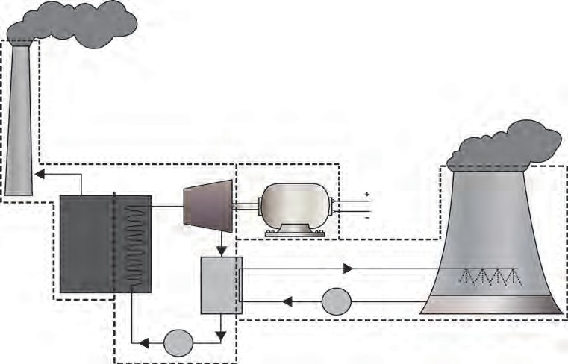

**Let's Think**

* + 1. Why steam is used to rotate the turbine?

Stack

Combustion gases to stack

vapour and hot air

Fuel Air

Pump

Generator

Condenser Warm water

Cooling tower

Boiler

Turbine Pump Cooled water

* 1. **Schematics of Thermal power plant**

If you see a thermal power station, you will observe two types of towers there. What are they? If you observe the schematic of the thermal power station in Figure 5.7 , you will get answer to this question.

Compare the schematic of the thermal power station with the block diagram above and you will understand how the boiler, turbine, generator and the condenser are arranged in the power station.

After combustion of fuel (here, coal) in the boiler, the emitted gases are released to the atmosphere through very high tower. Once the turbine is rotated using the steam at high temperature and high pressure, steam temperature and pressure decreases. This steam is converted back to water by taking out heat from it (i.e.by cooling it) . This is done in the condenser using water in the cooling tower. The water in cooling tower is circulated through the condenser. Heat energy in the steam is given to the water and the steam condenses back to water. The heat absorbed by the water is then released to atmosphere through vapour and heated air through cooling tower. Although, thermal power generation is a major way of electricity generation today, it suffers from certain problems



49

**Use of ICT**

Prepare a presentation about thermal power plant using computerized presenta- tion, animation, video, pictures, etc. Send it to others and upload on You Tube.

Problems



Do you know?

Some major thermal power plants in India and their capacity

**Place** Vindhyanagar Mundra Mundra Tamnaar Chandrapur

**State**

**Capacity (MW)**

Madhya Pradesh Gujarat

Gujarat Chhattisgarh Maharashtra

4760

4,620

4,000

3,400

3,340

1. Air pollution due to burning of coal: Burning of coal results in emission of gases like carbon dioxide, sulphur oxide and nitrogen oxide which are harmful to the health.
2. Along with the emission of gases due to burning of coal, soot particles are also released into the environment. This may cause serious health problems related to the respiratory system.
3. The reserves of fuel used in this method i.e. coal are limited. Therefore, in future, there will be limitations on the availability of the coal.

Power plant based on Nuclear Energy

In the power plant based on nuclear energy also , steam turbine is used to rotate the generator. However, here, the energy released by fission of nuclei of atoms like Uranium or Plutonium is used to generate the steam of high temperature and high pressure. The energy in the steam rotates the turbine, which in turn drives the generator producing electricity. The flow chart of nuclear power plant is shown in fig 5.8 .

Nuclear reactor for nuclear

fission

System for steam generation from water

Steam turbine Generator Electrical energy

Fuel: Uranium or Plutonium System for conversion of steam back into water

* 1. **Nuclear power plant**

Thus, here nuclear energy is converted into thermal energy, thermal energy is converted into kinetic energy of steam, kinetic energy of steam is converted into kinetic energy of turbine and finally the kinetic energy of the turbine is converted into electrical

energy .The step-by-step transformation of energy is shown in figure 5.5.

Nuclear energy

Thermal energy

Kinetic energy in steam

Kinetic energy in turbine

Electrical Energy

* 1. **Energy transformation in nuclear power plant**

How does nuclear fission take place?



**Can you tell?**

When neutron is bombarded on atom of Uranium - 235 , it absorbs the neutron and converts into its isotope Uranium - 236. Uranium - 236 being extremely unstable converts into atoms of Barium and Krypton through a process of fission releasing three neutrons and 200 MeV energy. The three neutrons generated in this process cause fission of three other Uranium - 235 atoms releasing more energy.



50

The neutrons released in this reaction release more energy through fission of more uranium nuclei. This process of fission of Uranium -235 atoms continues and is called the chain reaction. In nuclear power plants, a controlled chain reaction results in release

of thermal energy, which is used for electric energy generation.

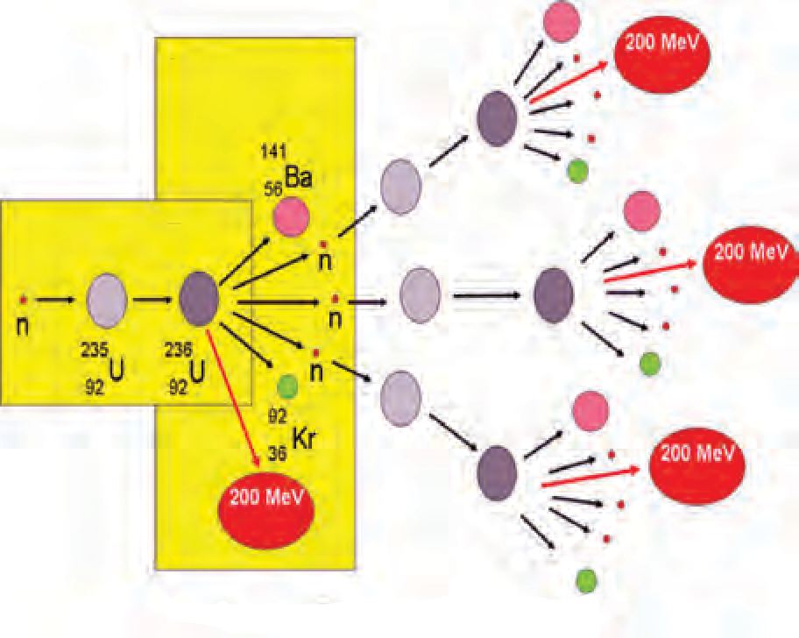Nuclear Fission Neutron absorption



**Internet is my friend**

Complete the following table for some important nuclear power plants in India.

|  |  |  |
| --- | --- | --- |
| **Place** | **State** | **Capacity (MW)** |
| Kudankulam | ......... | .......... |
| Tarapur | ......... | .......... |
| Ravatabhata | ......... | .......... |
| Kaiga | ......... | .......... |

Boiler

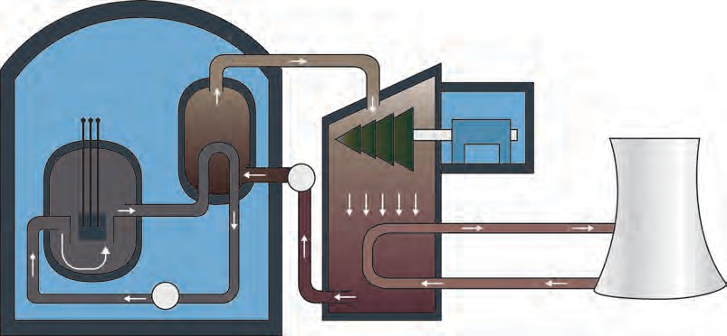

Turbine

Generator

Control pods

Pump

Pump

Warm water

Condenser

Cooling tower

* 1. **Nuclear fission (Chain reaction)**

Nuclear reactor

* 1. **Schematic diagram of nuclear power plant**

A nuclear power plant does not use fossil fuel like coal. Therefore, problems like air pollution do not arise. Also, if sufficient nuclear fuel is available, this can be a good source of electrical energy. However, there are few problems associated with nuclear power generation.

Problems:

1. The products after fission of nuclear fuel are also radioactive and emit harmful radiations. The products are called as nuclear waste. How to dispose the nuclear waste safely is a big challenge before the scientists.
2. An accident in nuclear power plant can be very fatal. This is because the accident may result in release of very harmful radiations.



**Compare**

Observe the schematic of thermal power plant and the nuclear power plant. Discuss what are the similarities and differences between the two?

51

Power generation plant based on energy of natural gas

In this plant, the turbine is run by a gas at very high temperature and pressure generated by combustion of natural gas. A flow chart showing various stages in the power generation plant based on natural gas energy is shown in figure 5.12.

Compressor for pressurised air

Combustion chamber

Gas turbine

Generator

Electrical energy

Natural gas

**5.12 Arrangement in power plant based on energy of natural gas**

There are three main sections in this type of plant. Pressurised air is introduced into the combustion chamber using a compressor. In the combustion chamber the natural gas burns in presence of the air. The gas at very high temperature and pressure generated in this chamber runs the turbine. The turbine then drives the generator to produce electricity.

Step-by-step transformation of energy in this plant is shown in fig 5.13.

Chemical energy in natural gas

Kinetic energy generated due to combustion of natural gas

Kinetic energy in turbine

Electrical energy

* 1. **Transformation of energy in power plant using energy of natural gas**

The efficiency of this type of power generation plant is higher than that of power generation plant based on coal. Moreover, since the natural gas does not contain sulphur, burning of natural gas results in less pollution. The schematic of power plant based on

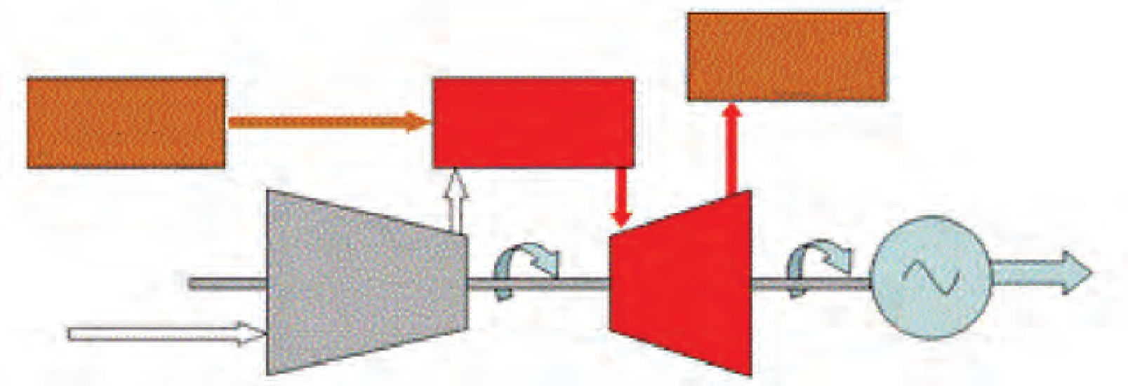natural gas is given in figure 5.14.

**Fuel**

**Combustion chamber**

**Emission of hot gases**

Generator



**Let's Think**

Which electricity generation process is eco-friendly and which not?

Gas turbine

Electrical energy

* 1. **Schematic of power plant based on natural gas**



**Always remember**

Though use of energy is unavoidable in our day to day life, it is necessary to use it carefully and only in the required amount.

52

|  |  |  |  |
| --- | --- | --- | --- |
| Some natural gas based power plants and their capacity  **Place State Capacity(MW)** | | |  |
| Samaralkota | Andhra Pradesh | 2620 |  |
| Anjanvel | Maharashtra | 2,220 |  |
| Bavanaa | Delhi | 1,500 |  |
| Kondapalli | Andhra Pradesh | 1466 |  |

Electric energy generation and environment

**Towards environment friendly energy…..towards green energy**:

There are other ways of electricity production which avoids above problems. Electricity generation from water reservoir, wind, sunlight, biofuels etc. are the examples of such methods. The energy sources used in such options i.e. water- reservoir, wind, sunlight, biofuel are never-ending i.e are perpetual. Moreover, use of these sources do not lead to environmental problems discussed above. Therefore, electricity generation through these sources can be called environment friendly. We can also call the energy generated by these processes as green energy. Looking at the problems in electricity generation using fuels like coal, natural gas and nuclear fuels, the world is now heading towards environment friendly energy

i.e. green energy.

Electricity generation based on fossil fuels like coal, natural gas and nuclear fuels like uranium and plutonium are not environment friendly. It means, that if electrical energy is generated using these fuels, it can lead to environmental degradation.

1. We have seen that burning of fossil fuels like coal, and natural gas leads to emission of certain gases and soot particles. This results in air pollution. Incomplete combustion of fuels leads to formation of carbon monoxide. It adversely affects our health. Increase in percentage of carbon dioxide in the air due to burning of fuels affects environment severely. The phenomena of global warming is an example of this. Nitrogen dioxide generated due to burning of fuels like coal, diesel, petrol, etc. leads to problems like acid-rain. Soot particles generated due to incomplete burning of fossil fuel cause air pollution. It can lead to problems related to respiratory system, like asthama.
2. It took millions of years for formation of fossil fuels like coal, crude oils and natural gases (LPG and CNG). Also, the reserves of these fuels are limited. They are going to deplete in future. It is said that with the current speed of their use, the coal reserves in the world would last for another about 200 years or so and the natural gas reserves for about 200- 300 years.
3. We have also discussed above about the problems in use of nuclear energy like the disposal of nuclear waste and possibility of disaster due to accident in nuclear power plant.

Considering all these points, it can be said that the energy generation from fossil fuels and nuclear fuels are not environment friendly.

Hydroelectric Energy

Kinetic energy in flowing water or the potential energy in water reservoir is a conventional source of energy. In hydroelectric power plant, the potential energy in water stored in dam is converted into kinetic energy of water. Fast flowing water is brought from the dam to the turbine at the bottom of the dam. The kinetic energy of the flowing water drives the turbine. The turbine in turn drives the generator to generate electricity.

The block diagram showing different components of hydroelectric power plant is shown in figure 5.15

Water reservoir with potential energy

Water turbine

Generator

Electrical energy

* 1. **Different stages in hydroelectric power plant**



53

Electricity generation using wind-energy

Potential energy in water

Kinetic energy in flowing water

Kinetic energy in turbine

Electrical energy

* 1. **Energy Transformation in hydroelectric power plant**

#### The schematic of hydroelectric plant is shown in Figure 5.17. Water from about middle of the total height of the dam is taken to the turbine, as shown by point B in the diagram.

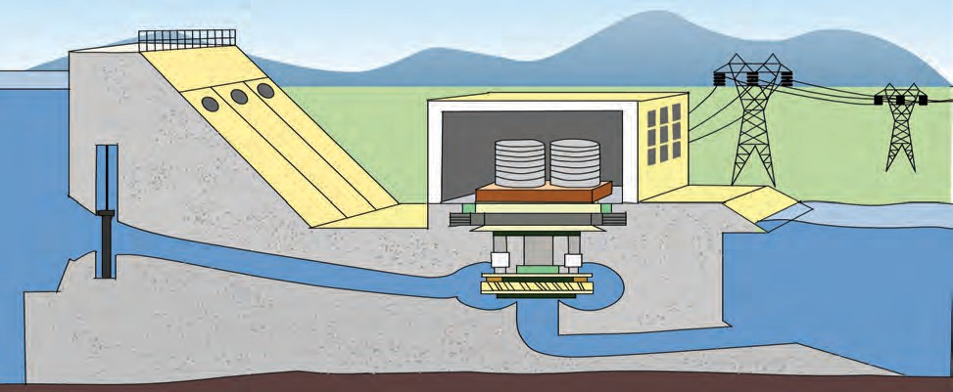

Wall

A

Power house

**Generator**

Sluice gates

B

Reservoir

C

Penstock

Turbine

**Schematic diagram of Hydroelectric power plant**

1. With reference to point B, potential energy of how much water reservoir in the dam will be converted into kinetic energy?



**Advantages generation**

**of**

**hydroelectric power**

**Problems associated with hydroelectric power plant**

1. Since no fuel is burnt in hydroelectric power generation, there is no pollution resulting from combustion of fuels.
2. If there is sufficient water storage in the dam, it is possible to generate electricity as and when necessary.
3. Although water reservoir is used for power generation, it can be replenished during rainy season leading to uninterrupted power generation.

1.

2.

The back-water due to storage of water in dam may submerge villages or towns in that area. This leads to the problems of rehabilitation of the displaced population. Moreover, this can also submerge forests as well as fertile land.

The obstruction of the flow of river water may have adverse effect on living world in the river.

54

Since no fuel is burnt in hydroelectric plant, no air pollution due to combustion of fuel results. However, considering the issues like forced migration of large community, submerging of forests and fertile land, adverse effect on living creatures in the river, it has always been a point of debate whether the hydroelectricity is environment friendly or not. What is your opinion about it?



**5.17**

**Use your brain power**

1. What will be the effect on electricity generation, if the channel taking water to turbine starts at point A?
2. What will be the effect on electricity generation, if the channel taking water to turbine starts at point C?

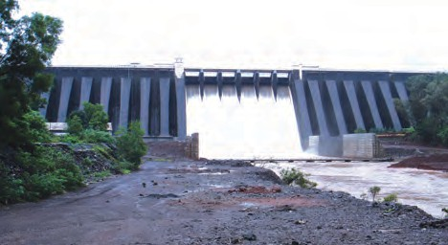

* 1. **Koyana Dam**



**Do you know?**

Some major hydroelectric plants in India and their capacity (MW)

Place State Capacity (MW)

Tehari Uttarakhand 2400

Koyana Maharashtra 1960

Srishailam Andhra Pradesh 1670

Nathpa Zakri Himachal Pradesh 1500



**Find out** What is lake tapping? Why it takes place?

The kinetic energy in wind has been used since long for lifting of water, for driving floor mill etc. The wind energy can also be used for electricity generation. The machine which converts the kinetic energy of wind to electrical energy is called wind-turbine. As the wind strikes the blades of the turbine, the blades rotate. The axel of the turbine is connected to electric generator through a gear-box. The function of the gear-box is to increase the rotations per unit time. Thus, the rotating blades drive the turbine and the turbine in turn drives the generator to generate electricity. Various stages in the wind- energy generation system can be shown in figure 5.19 and schematics of a wind mill is shown in figure 5.20.

Wind with required velocity

Wind Turbine with large fins

Electrical energy

**Generator**

* 1. **Stages in electric generator using wind energy**

The energy conversion process is shown in figure 5.21.

* 1. **Schematic of wind mill**

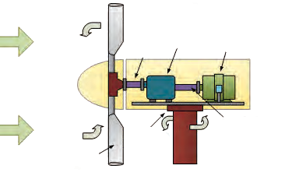

Gear box Shaft

Generator

Air

Shaft

Bearing

Blades

Support

**Kinetic Energy in wind**

**Kinetic energy in turbine**

**Electric energy**

* 1. **Transformation of energy in an electric generator using wind energy**

Wind turbines with capacity right from less than 1 kW to about 7 MW (7000 kW) are commercially available. Depending on the wind velocity available at the site of installation, wind-turbine with specific capacity is selected. The wind velocity at specific location depends on many geographical factors.



55

Wind velocity is usually high on sea shores and that environment is appropriate for installation of wind turbine. Wind-energy is a clean energy source. However, the wind-ve- locity necessary for wind-energy generation is not available everywhere. In that sense, use of wind-energy is limited.



**Get information**

Get information about major wind-power stations in India and their capacity. Make a table of their location, state and their power generation capacity in MW.

* 1. **Wind turbines of different capacities**

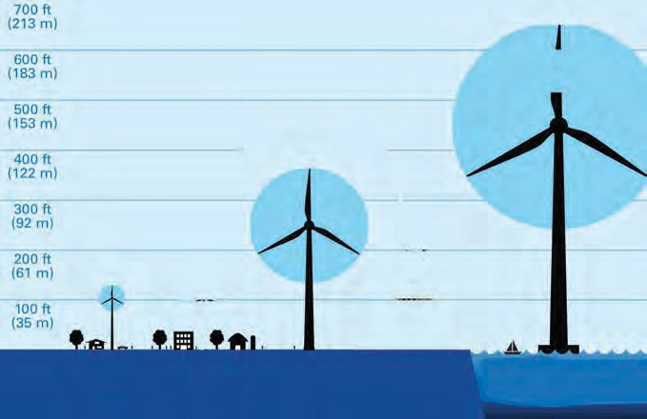

Blade length : 100 m Capacity: 6000-7000 kW

Blade length : 50 m Capacity: 2000 kW

Blade length : 1.5m Capacity: 2 kW

Home

Wind Farm

Offshore Wind turbine

Electric Energy generation using solar energy

Using the energy in the Sunlight, electric energy can be generated in two ways:

1. In all the above methods of electricity generation we have studied, the electric generator is driven by using some source of energy and electricity is generated by making use of the principle of electromagnetic induction. However, electrical energy can be generated directly from solar radiation without using generator and without using the principle of electromagnetic induction. This happens in solar photovoltaic cells. Solar photovoltaic cells convert the solar energy directly into electrical energy.
2. In the second method, the energy in solar radiation is converted into thermal energy first. Then a turbine-generator system is driven using that thermal energy to generate electricity.
3. Solar photovoltaic cell

Solar photovoltaic cell converts the solar radiation energy directly into electrical energy. This is called solar photovoltaic effect. The electrical energy generated through this energy transformation process is DC in nature. These solar cells are made of a special type of material called semiconductor (e.g. silicon). A silicon solar cell of dimension 1 cm2 generates current of about 30 mA and potential difference of about 0.5 V. Thus, a silicon solar cell of dimension 100 cm2 will generate about 3 A (30 mA/cm2 X 100 cm2=3000 mA= 3 A) current and 0.5 V. Remember that the potential difference available from a solar cell is independent of its area.

**Photovoltaic effect**

**Energy in Sunlight**

**DC Electric power**



56

If two solar cells are connected in series as shown in figure 5.23, the potential difference obtained from this combination is addition of the potential differences of individual solar cells. However, the current generated from this combination is equal to the current from an individual cell. It means that when solar cells are connected in series, currents from the individual cells are not added. Similarly as shown in figure 5.24, if two solar cells are connected in parallel, the current generated from this combination is the summation of the currents from an individual solar cells. However, the potential difference obtained from this combination is the same as the potential difference obtained from individual cell. Thus, if two solar cells are connected in parallel, the potential differences from the two cells are not added.

In this way, by connecting many solar cells

in series and in parallel solar panels generating required current and potential difference are made. See Figure 5.25. For example, if 36 solar cells, each of size 100 cm2 are connected in series in a solar panel, it will give potential difference of 18 V and current of 3 A. Many such panels are connected together to generate electricity on larger scale. A good solar cell can have an efficiency of around 15%. It means that if a solar panel receives power of 100 watt from solar radiation, the electrical

**5. 23 Solar cells in series**

Cell

* 1. 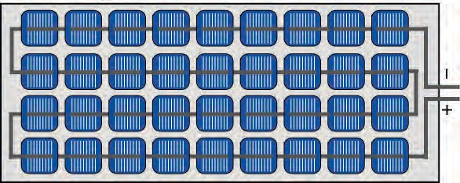**Solar cells in parallel**

2

I = I1+ I2

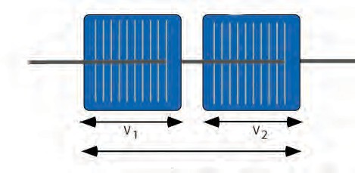

Cell 1

Cell 2

-

+

I = I1= I

VTotal= V1+V2

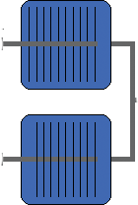

Cell 1

I

1

-

+

2

-

I2

+

V =V1 = V2

power output from the panel will be 15 watt.

Many solar panels are connected in series and in parallel to generate required current

* 1. **A solar panel made from 36 solar cells**

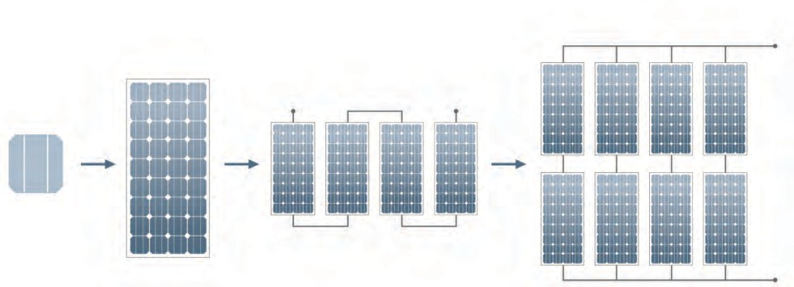**Array**

and potential difference. As shown in Figure 5.26, solar cell is the basic unit in solar electric plant . Many solar cells come together to form

**Module**

cells in series

**String**

Strings in parallel

a solar panel. Many solar panels connected in series form a solar strings, and, many solar strings connected in parallel form a solar array. As we can obtain as much electrical power as needed, they are used in applications which need marginal power (e.g. calculators that run on solar energy) to power station of MW capacity.

**Cell**

modules in series

* 1. **Solar cell to solar array**



57

The power available from the solar cells is DC. So, in applications which need DC power , e.g. electric lights based on Light Emitting Diodes, the energy can be directly used. However, since the energy from solar cell is available only in presence of sunlight, the energy has to be stored in batteries for use at later time.

However, most of the equipment in domestic as well as industrial use run on AC power. In such case, the DC solar power must be converted to AC power using an electronic device called

**Solar cell**

**Battery**

**Inverter**

Electric equipment working on AC power

inverter(Figure 5.27).

Energy from light

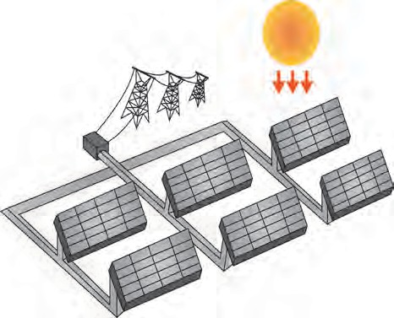

Power grid

Inverter and Transformer

Solar Array

* 1. **Conversion of energy generated by cells to AC form by using inverter**
  2. **Schematic of solar photovoltaic station**



**Find out**

Gather information about major solar photovoltaic power generating plants and their capacity in India.

Solar Thermal power plant

We have seen that many solar panels can be connected together to generate whatever energy we need. As shown in Figure 5.28, the DC power generated from these panels is first converted into AC power. A transformer transforms the voltage and current levels of the generated power and then it is fed into the electricity distribution network. Figure 5.28 is a schematic diagram of solar photovoltaic power station.

In this way, electricity is generated without any fuel combustion and so with- out any air pollution. However, since the energy is generated using solar radiation, solar cells can generate electricity during day-time only.

We have seen that thermal energy generated from coal and nuclear fuel can be used to generate electricity. Thermal energy can also be generated from solar radiation and can be used for electricity production. Different stages in such solar thermal power plant are as shown in figure 5.29

Concentrators for collecting sunlight

Absorber for absorbing the concentrated sunlight

Steam turbine

Electric generator

Electric energy

* 1. **Different stages in solar thermal power plant**



58

As shown in Figure 5.30 , many reflectors reflect and concentrate solar radiation on absorbers. There solar energy is converted into heat energy. Using this heat energy steam is generated to drive the turbine and generator.

Solar energy

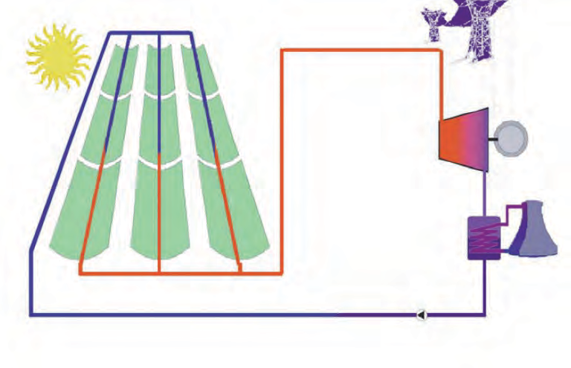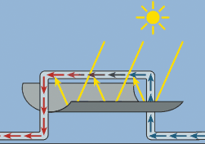

Solar energy

Steam

Flow of hot water Absorber

Turbine

Generator

Steam

Water

Condenser

Solar panel

Reflector

Pump

Cooling tower

**5.29 Schematic of solar thermal power plant**

**Do you know?**

Energy sources use for electrical power generation in the world.

**Sources World (%)**

Coal 41

Natural Gas 22

Hydroelectric 16

Nuclear energy 11

Petroleum 04

Renewable sources (wind, solar etc.) 06

**Total 100**

**India (%)**

60

08

14

02

0.3

15.7

**100**

Power grid





**Exercise**

1. **Remake the table taking into account relation between entries in three**

**columns.**

1. **Which fuel is used in thermal power plant? What are the problems asso- ciated with this type of power gener- ation?**
2. **Other than thermal power plant, which power plants use thermal en- ergy for power generation? In what different ways is the thermal energy obtained?**

|  |  |  |
| --- | --- | --- |
| I | II | III |
| Coal | Potential energy | Wind electricity plant |
| Uranium | Kinetic Energy | Hydro electric plant |
| Water Reservoir | Nuclear Energy | Thermal plant |
| Wind | Thermal Energy | Nuclear power plant |

1. **Which type/types of power genera- tion involve maximum number of steps of energy conversion? In which power generation is the number**

**minimum?**



59

1. **Solve the following crossword puzzle.**
   1. Maximum energy generation in India is done using. energy.
   2. ...... energy is a renewable source of energy
   3. Solar energy can be called. energy.

d .... energy of wind is used in wind mills.

e. ..... energy of water in dams is used for generation of electricity.

**a b**

**d**

**c**

e

1. **Explain the difference.**
   1. Conventional and Non-conventional Sources of energy.

b Thermal electricity generation and solar thermal electricity generation.

1. **What is meant by green energy? Which energy sources can be called as green energy sources and why? Give example.**
2. **Explain the following sentences.**
   1. Energy obtained from fossil fuels is not green energy.
   2. Saving energy is the need of the hour.
3. **Answer the following questions.**
   1. How can we get the required amount of energy by connecting solar panels?
   2. What are the advantages and limitations of solar energy?
4. **Explain with diagram step-by-step energy conversion in**
   1. Thermal power plant
   2. Nuclear Power Plant
   3. Solar thermal power plant
   4. Hydroelectric power plant
5. **Give scientific reasons**
   1. The construction of turbine is different for different types of power plants.
   2. It is absolutely necessary to control the fission reaction in nuclear power plants.
   3. Hydroelectric energy, solar energy and wind energy are called renewable energies.
   4. It is possible to produce energy from mW to MW using solar photovoltaic cells.
6. **Draw a schematic diagram of solar thermal electric energy generation.**
7. **Give your opinion about whether hydroelectric plants are environment friendly or not?**
8. **Draw neat and labelled diagrams.**
   1. Energy transformation in solar thermal electric energy generation.
   2. One solar panel produces a potential difference of 18 V and current of 3A. Describe how you can obtain a potential difference of 72 Volts and current of 9 A with a solar array using solar panels. You can use sign of a battery for a solar panel.
9. Write short note on

Electrical energy generation and environment.

**Project :**

1. Gather information about solar light, solar water heating system and solar cooker.
2. Gather information about a power plant near your locality by vising the plant.







60



**6. Animal Classification**

* **History of animal classification**
* **New (method) system of animal classification.**
* **Kingdom- Animalia**.

**Can you recall?**

Which criteria are used for classification of organisms?

You have studied the classification of living organisms in earlier classes. The living organisms present around us are mainly plants and animals. We have studied the criteria of their classification. With the help of that, complete the following chart.

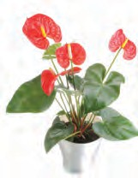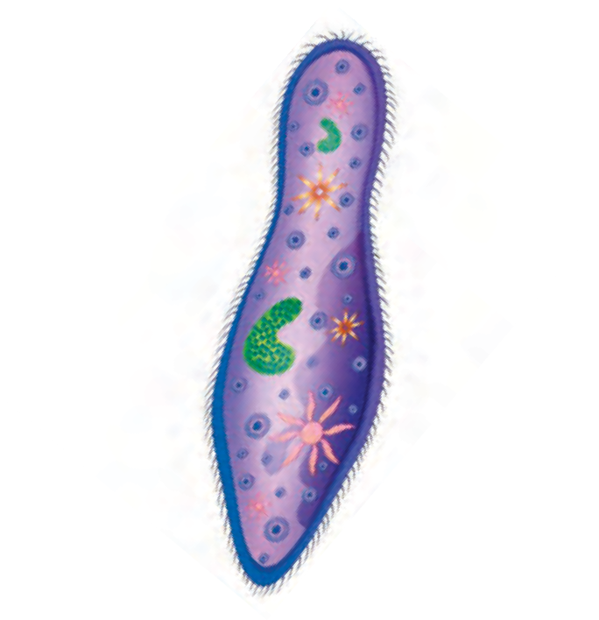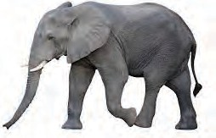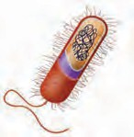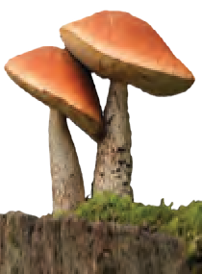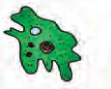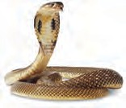

Kingdom: Monera

Unicellular organisms

Multicellular organisms

Kingdom: -----------

Kingdom: Animalia

Kingdom: Plantae

Kingdom: Fungi

Living organisms

* + 1. **Classification of living organisms**

How the plants are classified?



**Can you recall?**

We have studied the plants classification in last year. It helped us to understand the diversity of plants around us.

You must be looking varieties of animals around you. Some animals are too small whereas some are too big. Some animals are terrestrial where as some are aquatic. Some animals crawl on land, some swim in water whereas some fly in air. Some animals have scales on skin whereas some have feathers or hairs. In this way, there is huge diversity among the animals too. According to recent studies, estimated number of animal species on earth is approximately 7 million. It is impossible to study each and every species. However, if groups and sub-groups of animals are formed depending upon the similarities & differences, it will make it very easy to study such vast variety of animals.



61

Formation of groups and sub-groups of animals depending upon similarities and differences among animals is called as animal classification.

History of animal classification

Time to time, different scientists have tried to classify the animals. Greek philosopher Aristotle was the first to perform the animal classification. Aristotle classified the animals according to the criteria like body size, habits and habitats. Further, as per the new developments in sciences, references were changed and thereby the criteria of animal classification too. Classification proposed by Aristotle is known as ‘Artificial method’. Besides Aristotle, artificial method of classification was followed by Theophrastus, Pliny, John Ray, Linnaeus, etc. Later on, ‘Natural system of classification’ was followed. Natural system of classification was based on various criteria like body organization, types of cells, chromosomes, bio-chemical properties, etc. By the time, system of classification based on evolution was also brought into practice. It was used by Dobzhansky and Meyer. Recently, Carl Woese has also proposed the animal classification

**Benefits of animal classification**

1. Study of animals becomes convenient.
2. Study of few animals from a group helps to understand about that entire animal group.
3. It gives idea about animal evolution.
4. Animals can be easily identified with great accuracy.
5. It helps to understand the relationship of animals with other living organisms.
6. It helps to understand the habitat of each animal and it's exact role in the nature.
7. It helps to understand various adaptations shown by animals.

Traditional method of animal classification

Traditionally, depending upon presence or absence of the notochord, the animal kingdom has been divided into two groups- **Non-chordates and Chordates.**

**A. Non-Chordates :** Characters of non-chordate animals are as follows

1. Body is not supported by rod-like notochord.
2. Pharyngeal gill-slits are absent.
3. Nerve cord; if present, it is on ventral side. It is solid & paired.
4. Heart, if present, it is on dorsal side.



Non-chordates are classified / divided into ten phyla. Those phyla are- Protozoa, Porifera, Coelentarata / Cnidaria, Platyhelminthes, Aschelminthes, Annelida, Arthropoda, Mollusca, Echinodermata and Hemichordata

62

**Chordates :** Characters of chordates are as follows

* 1. Body is supported by notochord.
  2. Pharyngeal gill-slits or lungs are present for respiration.
  3. Nerve cord is present on dorsal side of body. It is hollow.
  4. Heart is present on ventral side of body.

Notochord is a long rod like supporting structure present on dorsal side of animal body. It keeps the nerve tissue isolated from remaining body.

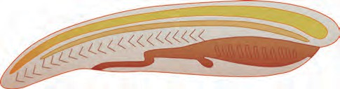

Muscle

Notochord

Nerve chord

Mouth

Tail fin

Anus

Gill slits



**6.2 Characteristics of Chordates**

**Do you know?**

All chordate animals are grouped together in a single phylum and the name of phylum is same i.e. Phylum- Chordata. This phylum has been divided into three subphyla as- Urochordata, Cephalochordata & Vertebrata. Sub-phylum Vertebrata has been further divided into six classes as- Class: Cyclostomata, Class: Pisces, Class: Amphibia, Class: Reptilia, Class: Aves and Class: Mammalia.

* 1. **Conventional System of Animal Classification**

**Sub Kingdom Non- chordates**

**Phylum**

**Kingdom: Animalia**

1. Protozoa 6. Annelida
2. Porifera 7. Arthropoda
3. Cnidaria 8. Mollusca
4. Platyhelminthes 9. Echinodermata
5. Aschelminthes 10. Hemichordata

**Sub Kingdom: Chordates**

Phylum- Chordata

1. Urochordata

1. Cephalochordata
2. Vertebrata

**Subphylum**

1. Cyclostomata
2. Pisces
3. Amphibia
4. Reptilia
5. Aves
6. Mammalia

Class

This system of animal classification was in practice till now. However, now a days, new system of classification is followed. We will study this new system of animal classification in brief.

At present, according to the five kingdom classification system of Robert Whittaker, all multicellular animals are included in Kingdom: Animalia. This system of classification is based upon some criteria like Body organization, Body symmetry, Body cavity, Germinal layers, Segmentation, etc.



63

Criteria for new system of classification

1. **Grades of organization**

Body of animals is made up of cells. In case of multicellular animals, many cells are performing different functions in their body.

In case of multicellular animals, if tissues are not formed, their body organization is called as ‘Cellular grade organization’. Ex. Phylum-Porifera.

In case of some animals, cells come together to form tissues with the help of which all the body functions are performed. Such animals show ‘Cell - tissue grade’ organization. Ex. Animals from phylum- Cnidaria.

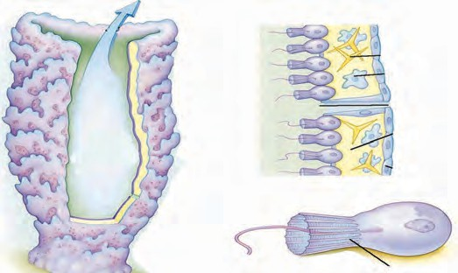

Flat worms show ‘Tissue- Organ grade’ organization. In this type of organization, tissues are organized to form some organs. However, complete organ systems are not formed.

* 1. **Protoplasmic-grade organization.**

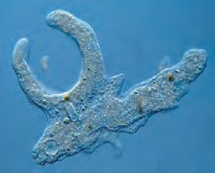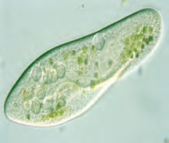

Do you know?

In unicellular organisms all the functions of life are performed by same cell. Body organization of these unicellular organisms is called 'Protoplasmic grade' of organization

**Amoeba Paramecium**

**Outlet (Osculla)**

**Spicule Amoebocyte**

**Ostium**

**Non living part**

**Sycon**

**Collar cells**

* 1. **Cellular grade organization**

**Bell Tube**

**Muscle ring**

**Gonads**

**Pharynx**

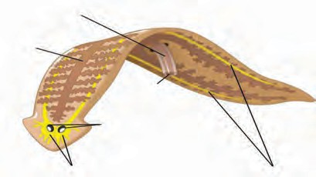**Gastrovascular Cavity**

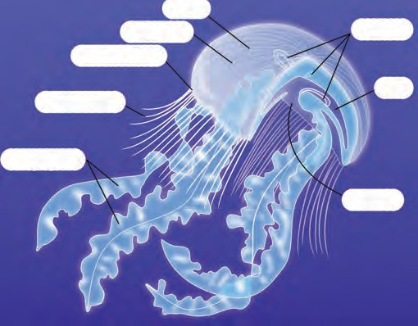

**Mouth**

**Planaria**

**Tentacle**

**Intestine**

**Eye spot**

**Oral arms**

**Mouth**

**Jellyfish**

**Ganglia**

**Nerve chord**

* 1. 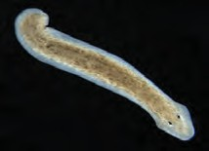**Cell -Tissue grade organization 6.7 Tissue -Organ grade organization**



64

Body organization of human has been shown in the following figure. Use appropriate labels in that figure. Which organs are present in human body?



**Observe**

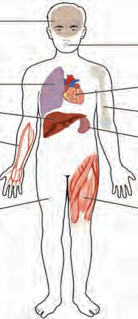

Besides the four types of body organizations mentioned above, Remaining all animals show ‘Organ - system grade organization’ in which different organs are joined together to form organ system that performs specific functions. Ex. Crab, Frog, Human, etc.

1. Body Symmetry

Take the pictures of human body and spongilla and try to take an imaginary section through specific plane of their bodies so as to get two equal halves.

What did you observe?

* 1. **Organ- System grade of organization**

In imaginary sense, if body of any animal is cut through imaginary axis of body, it may or may not produce two equal halves. Depending upon this property, there are different types of animal bodies.

**Asymmetrical Body :** In case of such body, there is no any such imaginary axis of the body through which we can get two equal halves. Ex. some sponges.

**Radial symmetry :** In this type of body, if imaginary cut passes through central axis but any plane of body, it gives two equal halves. Ex. Star fish. In case of this animal, there are five different planes passing through central axis of body through which we can get two equal halves.

**Bilateral symmetry:** In this type of body, there is only one such imaginary axis of body through which we can get two equal halves. Ex. Insects, fishes, frog, birds, human, etc.

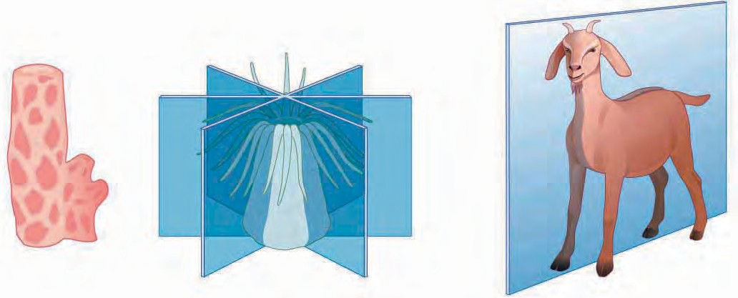**Asymmetrical body**

**Radial Symmetry**

**Bilateral Symmetry**

* 1. **Types of body symmetry**

1. Germ Layers: Diploblastic and triploblastic

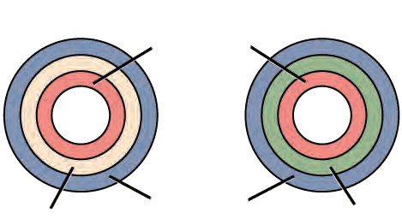In case of multicellular animals, germ layers are formed during initial period of their embryonic development and from those germ layers only, different tissues are formed in the body. In case of some animals, only two germ layers [Endoderm &

Endoderm

ectoderm] are formed. Ex.: All Cnidarians. In most of all the remaining animals, three germ layers are

Dead layer

Ectoderm

Mesoderm

formed i.e. mesoderm besides endoderm & ectoderm.

* 1. **Diploblastic and triploblastic**



65

1. Body cavity (Coelom)

Cavity between the body wall and internal organs is called as body cavity/coelom. In case of multicellular animals, during initial period of their embryonic development, body cavity is formed from either mesoderm. Such type of body cavity is present in animals of phylum Annelida and all phyla coming after Annelida. Such animals are called as eucoelomate (animals with true body cavity). Body cavity is

Eucoelomates

Coelom

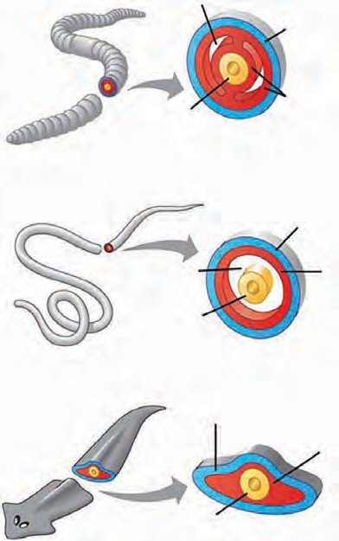Endoderm

Ectoderm

Mesoderm

Ectoderm

absent in case of animals from phyla Porifera, Cnidaria and Platyhelminthes. Such animals are called as acoelomate. In case of animals from phylum Aschelminthes, they have body cavity but it is not formed by the above mentioned two ways. Hence those animals are called as pseudocoelomates.

1. Body Segmentation

If the body of animals is divided into small, similar units, then such body is called as segmented body and each small unit is called

Pseudocoelom

Endoderm Pseudocoelomates

Ectoderm

Endoderm

Acoelomates

Mesoderm

Mesoderm

as segment. Ex. Animals like earthworm from phylum Annelida.

4. Aschelminthes

Acoelomate

Cellular grade

Asymmetrical body

8. Echinodermata

With the help of above mentioned criteria, animals are classified .

10. Chordata

9. Hemichordata

7. Mollusca

Eucoelomate

6. Arthropoda

5. Annelida

Tissue / organ /

organ-system grade

Pseudocoelomate

Bilateral symmetry

3. Platyhelminthes

2. Cnidaria

Radial symmetry

**Phylum**

Kingdom

**Body organization**

**Body symmetry**

**Body cavity (Coelom)**

Kingdom: Animalia (Multicel- lular organ- isms without cell wall)

1. Porifera

* 1. **Animal types as per body cavity**



66

Phylum- Porifera

* + 1. These animals are with simplest body plan and are called as ‘Sponges’. They bear numerous pores on their body. Those pores are called as ‘Ostia’ and ‘Oscula’.
    2. These are aquatic animals. Most of them are marine and few are fresh water dwellers.
    3. Most of the animals have asymmetrical body.
    4. These animals have special types of cells- collar cells.
    5. These animals are always attached to substratum, hence do not show locomotion. Hence, they are referred as sedentary animals.
    6. Their spongy body is supported by spicules or spongin fibres. Spicules are made up of calcium carbonate or silica.
    7. These animals feed upon small organisms taken in their body along with water. Water is taken in through ostia and given out through oscula.
    8. These animals reproduce by budding, an asexual method and / or by sexual method. Besides, they

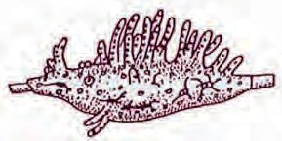

**Spongila**

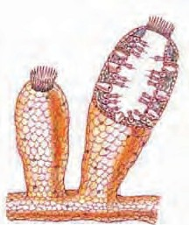

Osculum

Collar cells

Ostia

**Sycon sponge**

have good ability of regeneration. Examples: *Sycon, Euspongia* (Bath sponge),

*Hyalonema, Euplectella*, etc.

Phylum - Coelenterata/Cnidaria

1. Body of these animals is cylindrical or umbrella-like. If it is cylindrical, it is called as ‘Polyp’ and if it is umbrella like, it called as ‘Medusa’.
2. Most of these animals are marine. Only few
   1. **Animals in Porifera phylum**

Tentacles

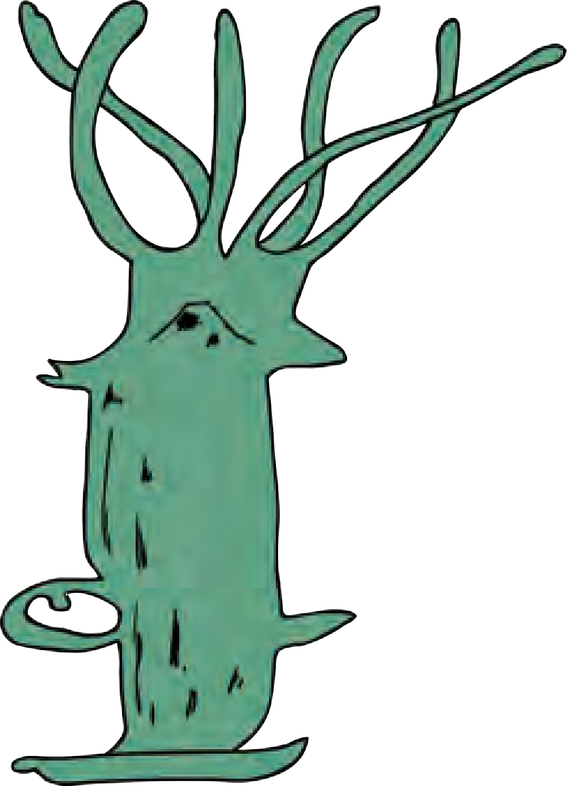

Mouth

Testes

Body

are fresh-water dwellers.

1. Body of these animals is radially symmetrical & diploblastic.
2. Cnidoblast bearing tentacles are present

Ovary

Hydra

New bud

around the mouth. Tentacles are useful

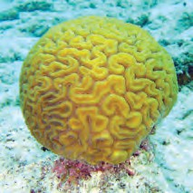for capturing the prey whereas cnidoblasts Coral

inject the toxin in the body of prey. Those are useful for protection too.

Examples: *Hydra, Adamsia* (Sea anemone), *Physalia* (Portuguese- man-of war), *Aurelia* (Jelly fish), Corals, etc.

Tentacles

* 1. **Animals in Cnidaria phylum**



67

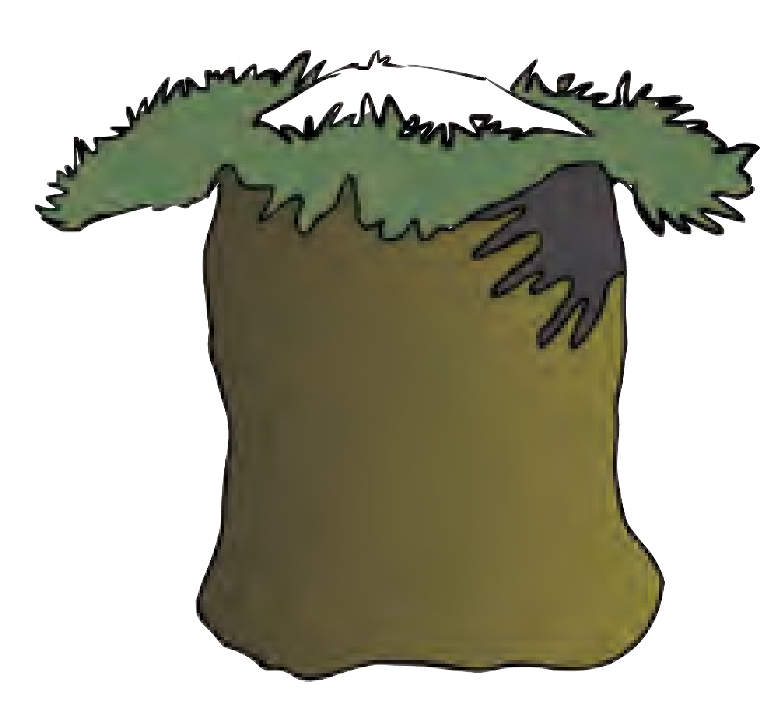

**Sea anemone**

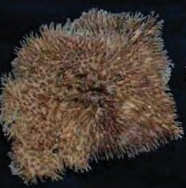

Do you know?

**Bath sponge:** This is black coloured and somewhat round-shaped animal. Its body is mainly made up of fibers of a protein- spongin and due to this, they have good water-holding capacity. It was used for bathing during old days. Besides, it was also used for manufacturing of pillows and cushions. These were also used as wetting material for sticking postal stamps and counting the currency notes.

**Phylum - Platyhelminthes**

* 1. Body of these animals is slender & flat like a leaf or strip. Hence, they are called as ‘flatworms’.
  2. Most of these animals are endoparasites. Few are free-living & aquatic.
  3. Body is acoelomate & bilaterally symmetrical.
  4. These are triploblastic i.e. their body is made up of three germ layers- endoderm, ectoderm & mesoderm.
  5. These animals are hermaphrodite i.e. male

Mouth

Genital aperture

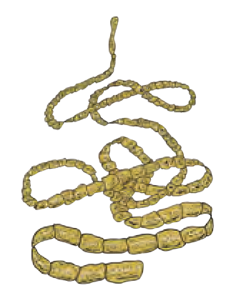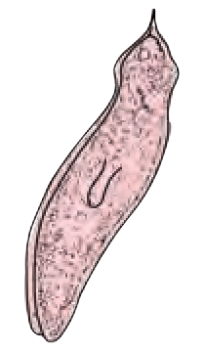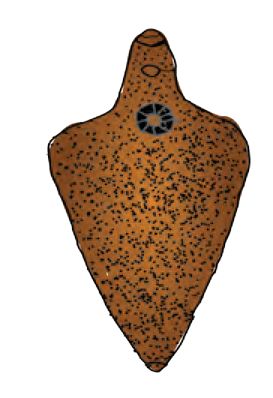

**Planaria**

Leaf like body

**Liver fluke**

##### Oral sucker

Ventral sucker

##### Excretory pore

and female reproductive systems are present in the same animal body.

Examples: Planaria, Liver fluke,Tape worm, etc.

**Tape worm**

* 1. **Animals in phylum Platyhelminthes**

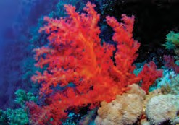

Surprising information

Coral reefs are present in ocean. These reefs are actually colonies of specific cnidarians. A precious stone called ‘Coral’ (पोवळा) and the coral powder (प्रवाळ भस्म) used in ayurveda is derived from these reefs. Collect more information about these corals from internet.

Phylum- Aschelminthes

1. Body of these animals is long thread-like or cylindrical. Hence, they are called as round worms.
2. These animals are either free living or endoparasites. Free living animals are either aquatic or terrestrial.
3. Body of these animals is triploblastic and pseudocoelomate.
4. Body of these animals is non-segmented and covered with tough cuticle.

Mouth

Genital aperture

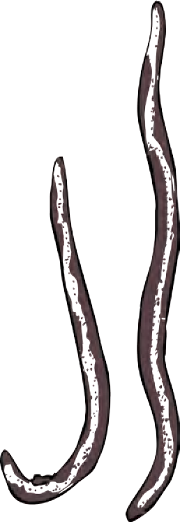

Mouth

**Male Ascaris**

##### hole

**Female Ascaris**

##### hole

1. These animals are unisexual.

Tail

Tail

Examples: *Ascaris* (Intestinal worm), Filarial worm, *Loa loa* (Eye worm), etc.



68

* 1. **Animals in phylum Aschelminthes**



**Internet is my friend**

**Collect the Information**

1. How does the infection of tapeworm in man, liver fluke in grazing animals like goat and sheep occur and what are their preventive measures?
2. How does the infection of round worms like Ascaris, Filarial worm and plant nematodes occur and what are their preventive measures and treatment?

Phylum - Annelida

1. Body of these animals is long, cylindrical and metamerically segmented.
2. Most of the animals are free-living, but few are ectoparasites. Free-living animals may be marine or fresh water dwellers or terrestrial.
3. These animals are triploblastic, bilaterally symmetrical and eucoelomate.
4. They have setae or parapodia or suckers for locomotion.
5. Their body is covered with special cuticle.
6. These animals are either hermaphrodite or unisexual. Examples: Earthworm, Leech, *Nereis*, etc.

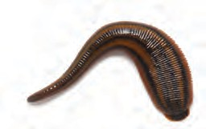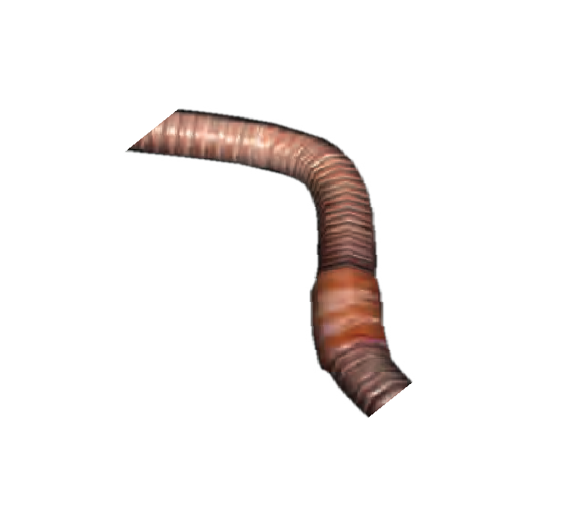

Anus

Segment

Clitellum

**Earthworm**

Mouth

Anus

Mouth Parapodia

Tentacle

Mouth

**Leech**

Anus

**Nereis**

* 1. **Animals in phylum Annelida**

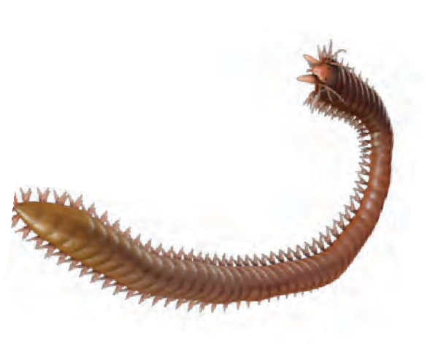

1. Why is earthworm called as friend of farmers?

Get Information 2. How may be the leech used in ayurvedic system of treatment?

Phylum- Arthropoda

1. These animals have jointed appendages. Hence they are called as arthropods.
2. Planet Earth has highest number of animals from this phylum. Hence, this is largest phylum with highly successful animals in animal kingdom.
3. These animals are found in all types of habitats ranging from deepest oceans to highest mountains.
4. Body of these animals is triploblastic, eucoelomate, bilaterally symmetrical and segmented.
5. Chitinous exoskeleton is present around their body.
6. These animals are unisexual.

Examples: Crab, spider, scorpion, millipede, centipede, cockroach, butterfly, honey bee, etc.



69

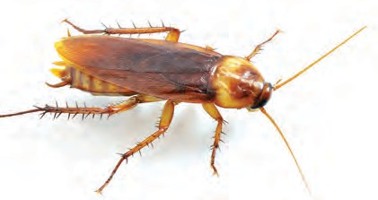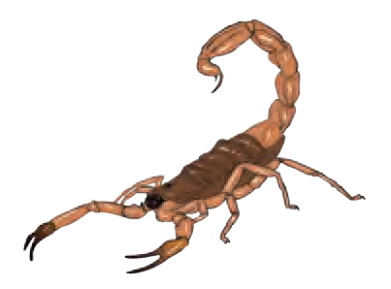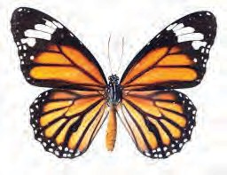

Wings

Thorax

Head

Antennae

Abdomen

Legs

**Butterfly**

**Scorpion**

**Cockroach**

**6.17 Animals in phylum Arthropoda**

**Let's Think**

1. What types of benefit & harm occur to human from animals of phylum- Arthropoda?
2. Which are the animals from phylum Arthropoda those have shortest & longest

lifespan?

1. Why has it been said that only insects directly compete with humans for food?

Phylum- Mollusca

1. Body of these animals is soft and slimy. Hence they are referred as mollusc.
2. This is second largest phylum in animal kingdom.
3. These animals are aquatic or terrestrial. Most of the aquatic molluscs are marine, but few are fresh water dwellers too.
4. 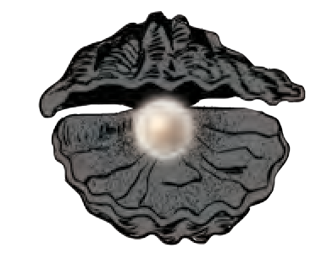Body of these animals is triploblastic, eucoelomate, non-segmented and soft. Except animals like snail, their body shows bilateral symmetry. Their body is divided into three divisions like head, foot and visceral mass.
5. Visceral mass is covered with mantle. This mantle secretes a hard, calcareous shell. This

Siphon

Tentacle

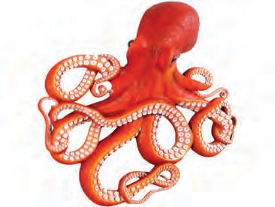

**Octopus**

Eye

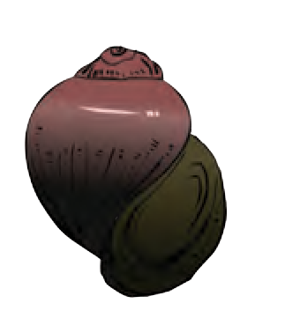Sucker

shell may be external or internal or even absent in some cases.

1. These animals are unisexual. Examples: Bivalve, Snail, Octopus, etc.

**Bivalve Snail**

* 1. **Animals in phylum Mollusca**

Surprising Information!



1. Octopus is most clever animal among all non-chordates. It can change its colour.
2. It can perform three types of locomotions like swimming, creeping & walking.

Books are my friend

Collect the information about pearl production from bivalves by reading appropriate books.

### 70



**Centipede**

**Find out**

What is chitin?

Phylum- Echinodermata

1. Calcareous spines are present on the body of these animals; hence they are called as echinoderms.
2. These animals are found only in ocean.
3. Their body is triploblastic, eucoelomate. And it is radially symmetrical in adult stage. However, they show bilateral symmetry in larval stage.
4. They perform locomotion with the help of tube-feet. Tube feet are also useful for capturing the prey. Some animals are sedentary.
5. They have skeleton made up of calcareous spines and / or ossicles (plates).
6. These animals have good ability of regeneration.
7. These animals are mostly unisexual.

Examples: Star fish, sea-urchin, brittle star, sea-cucumber, etc.

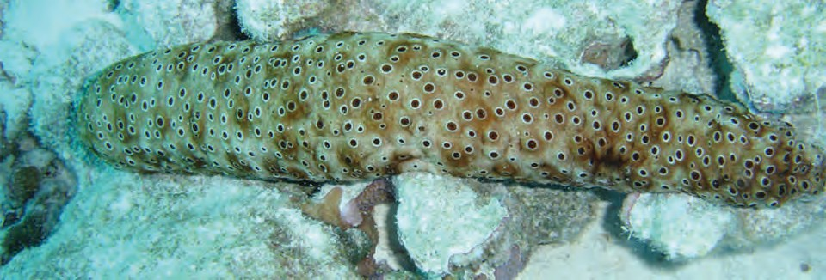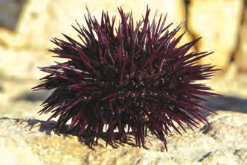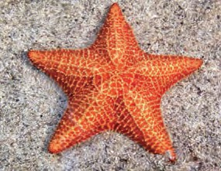

Star fish

Sea-cucumber

Sea-urchin

* 1. **Animals in phylum Echinodermata**



**Do you know?**

In certain situations, star fish can break apart its body parts and regenerate those later on.

Phylum- Hemichordata

1. Body of these animals is divided into three parts as proboscis, collar & trunk.
2. Notochord is present in proboscis region only. Hence, they are called as hemichordates.
3. These animals are also called as ‘acorn worms’.
4. These are marine animals, live in burrows in sand.
5. They have one to many pharyngeal gill slits.
6. They are unisexual or some may be hermaphrodite.

**Saccoglossus**

Proboscis Collar

**Balanoglossus**

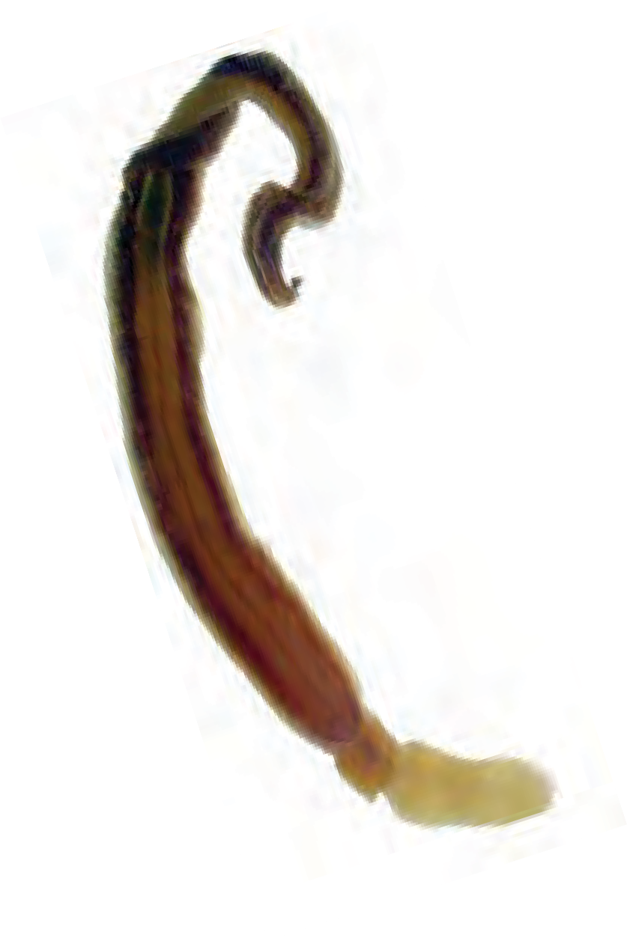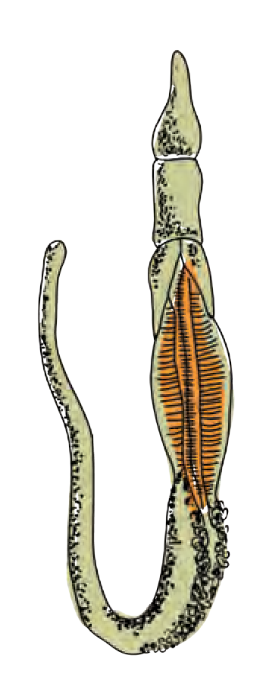

Trunk

Ex.: *Balanoglossus, Saccoglossus.*

* 1. **Animals in phylum Hemichordata**



Through the view point of evolution, *Balanoglossus* is considered as connecting link between non-chordates and chordates. This animal shows the characters of both the groups.

71

Phylum- Chordata

These animals have supporting notochord in their body. All chordates are included in the same phylum. The phylum Chordata is classified in to three subphyla. Following are important characters of phylum Chordata

1. Notochord is present in the body during at least any developmental stage.
2. Pharyngeal gill slits are present in the body during at least any developmental stage.
3. Single, tubular spinal cord is present on dorsal side of body.
4. Heart is present on ventral side of body.
   1. Sub phylum - Urochordata
      1. These are marine animals.

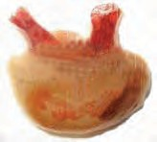

Tunic

Bo

Foot

* + 1. Their body is covered by skin-like test or tunic.
    2. Larvae of these animals are freely swimming and notochord is present in only tail region of larvae. Hence, they are called as Urochordata.
    3. Larvae metamorphose into adults after settling down at bottom of the sea.
    4. Generally, these animals are hermaphrodite.

Branchial aperture

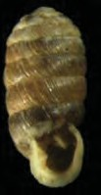

Atrial aperture

dy

Examples: *Herdmania, Doliolum, Oikopleura,* etc.

**Doliolum**

**Herdmania**

Notochord

Segmental Muscles

##### Gonads

* 1. **Animals in Sub- phylum Urochordata**
  2. Sub phylum -Cephalochordata
     1. These are small, fish-like, marine animals.

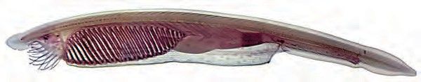

Nerve chord

Liver Intestine

Anus

Pharyngeal gills

* + 1. Notochord is present throughout the body length.
    2. Pharynx is very large and contains gill-slits.
    3. These animals are unisexual.

Ex.: *Amphioxus*.

**6.21 Animals in Sub- phylum Cephalochordata**

* 1. Sub phylum -Vertebrata/Craniata
     1. In these animals, notochord is replaced by vertebral column.
     2. In these animals, head is well developed.
     3. Brain is protected by cranium.
     4. Endoskeleton is either cartilaginous or bony.
     5. Some chordates are jaw-less (Agnatha) whereas some are with jaws (Gnathostomata).



72

Subphylum- Vertebrata is divided into six classes as follows-

* + - 1. **Class- Cyclostomata**

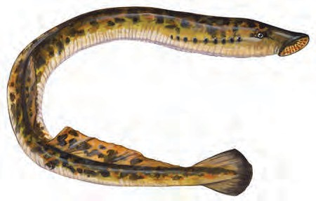

* + - * 1. These animals have jaw-less mouth provided with sucker.

Eye

* + - * 1. Their skin is soft and without any scale.
        2. Paired appendages are absent.
        3. Endoskeleton is cartilaginous.
        4. 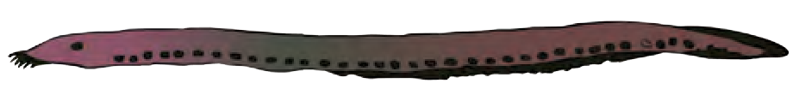Most of the animals are ectoparasites. Examples: Petromyzon, Myxine, etc.
      1. Class- Pisces

Body

Gill slits

Sucker

1. These are cold blooded (Poikilotherms) aquatic animals living in marine and fresh waters.
2. Body is spindle shaped to minimize water-resistance.

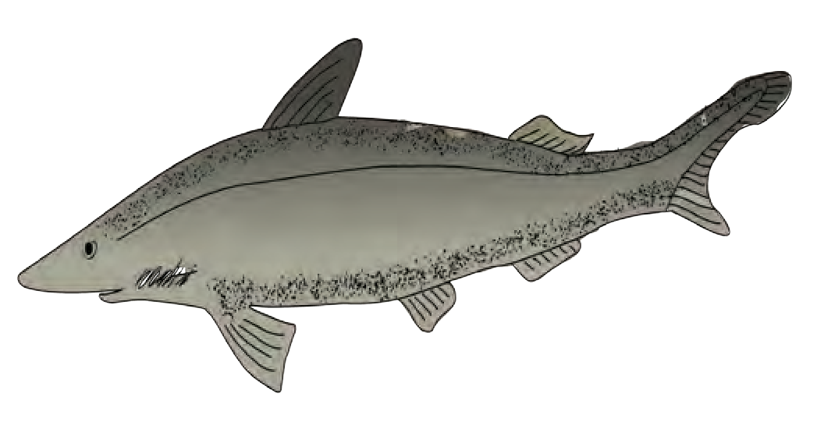

1. They have paired & un-paired fins for swimming. Tail fin is useful as a steering organ during swimming.
2. Exoskeleton is in the form of scales & endoskeleton is either cartilaginous or bony.

Eye

Mouth

* 1. **: Class Cyclostomata-Petromyzon**

Lateral line

Dorsal fin

Caudal fin

Ventral fin Pelvic fin

1. Respiration occurs with gills.

Examples.: Rohu, Pomfret, Sea

Gill slits

Pectoral fin

horse, Shark, Electric ray, Sting ray, etc.

* 1. **Class Pisces : Scoliodon (Dog fish)**
     + 1. Class- Amphibia
          1. These animals are strictly aquatic during larval life and perform only aquatic respiration whereas they can live in water as well as on land during adult life and can perform aquatic as well as aerial respiration.
          2. They have two pairs of appendages. Digits are without claws.
          3. Exoskeleton is absent. Skin is without any derivative and usually kept moist for respiration.

Trunk Soft skin

**Frog**

Mouth

Tympanum

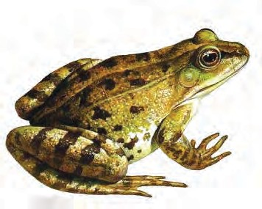

Leg

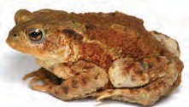

Nares

Fore arm

* + - * 1. External ear is absent but tympanum is present.
        2. Neck is absent. Eyes are prominent with eye lids.

**Toad**

Rough skin

Ex.: Frog, Toad, Salamander, etc.

* 1. **Class Amphibia: Frog and Toad**



73

* + - 1. **Class- Reptilia**
         1. According to the course of animal evolution, these are first true terrestrial animals with creeping movement.
         2. These are cold blooded (poikilotherms) animals.
         3. They creep on the land as their body cannot be lifted up.
         4. Their skin is dry and scaly.
         5. Neck is present between head & trunk.
         6. External ear is absent.
         7. Digits are provided with claws. Examples: Tortoise, Lizard, Snake, etc.
      2. **Class- Aves**
         1. These vertebrates are completely adapted for aerial life.

Eyes

* 1. **Class-Reptilia : Wall lizard**

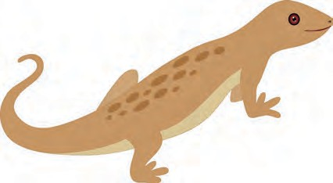

Tail

Scaly skin

Legs

Head

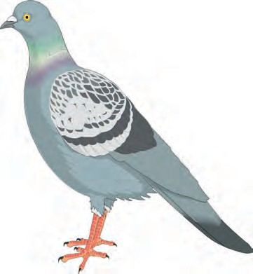

Eyes

* + - * 1. These are warm blooded (Homeotherms) i.e. they can maintain their body temperature constant.
        2. Their body is spindle-shaped to minimize air resistance during flight.
        3. Forelimbs are modified into wings. Digits are covered with scales and bear claws.
        4. Exoskeleton is present in the form of feathers.
        5. Neck is present between head and trunk.
        6. Jaws are modified into beak.

Examples: Peacock, Parrot, Pigeon, Duck,

Beak

Claws

Neck

Penguin, etc.

* + - 1. **Class- Mammalia**
         1. Presence of mammary glands is typical character of mammalia.
         2. These animals are warm blooded.
         3. Body is divided into head, neck, trunk and tail.
         4. Digits are provided with nails, claws, or hooves.
         5. Exoskeleton is in the form of hairs or fur. Examples: Elephant, Human, Kangaroo, Dolphin, Bat, etc.
  1. **Class- Aves: Pigeon**

Eyes

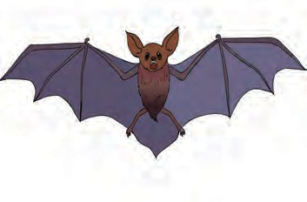

Body

Patagium

Legs

* 1. **Class-Mammalia: Bat**



**Use your brain power**

1. Animals like ghariyal & crocodile live in water as well as on land. Are they am- phibians or reptiles?
2. Animals like whale, walrus live in water (ocean). Whether they are included in pisces or mammalia?



74

**Use of Information Technology**

Prepare the presentation of animal classification using video clips downloaded from internet.

**Books are My Friends**

Read the book- The Animal Kingdom: Libbie Hyman and some other similar books.

1. **Identify me.**



**Always remember**

Varieties of animals are found in our surroundings. We should be cautious about not causing any harm to animals during their studies and observations.

**Exercise**

* 1. I am diploblastic & acoelomate. Which phylum do I belong to?
  2. My body is radially symmetrical. Water vascular system is present in my body. I am referred as fish though I am not. What is my name?
  3. I live in your small intestine. Pseudocoelom is present in my thread like body. In which phylum will you include me?
  4. Though I am multicellular, there are no tissues in my body. What is the name of my phylum?

1. **Write the characters of each of the following animals with the help of classification chart.**

Bath sponge, grasshopper, rohu, penguin, frog, lizard, elephant, jellyfish.

1. **Write in brief about progressive changes in animal classification.**
2. **What is the exact difference between grades of organization and symmetry? Explain with examples.**
3. **Answer in brief.**
   1. Give scientific classification of shark up to class.
   2. Write four distinguishing characters of phylum- Echinodermata.
   3. Distinguish between butterfly and bat with the help of four distinguishing properties.
   4. To which phylum does Cockroach belong? Justify your answer with scientific reasons.
4. **Give scientific reasons.**
   1. Though tortoise lives on land as well as in water, it cannot be included in class- Amphibia.
   2. Our body irritates if it comes in contact with jelly fish.
   3. All vertebrates are chordates but all chordates are not vertebrates.
   4. Balanoglossus is connecting link between non-chordates & chordates.
   5. Body temperature of reptiles is not constant.
5. **Answer the following questions by choosing correct option.**
   1. Which special cells are present in the body of sponges (Porifera)?
      1. Collar cells. 2. Cnidoblasts.

3. Germ cells. 4. Ectodermal cells.

* 1. Which of the following animals’ body shows bilateral symmetry?
     1. Star fish. 2. Jelly fish.

3. Earthworm. 4. Sponge.

* 1. Which of the following animals can regenerate it’s broken body part?
     1. Cockroach. 2. Frog.

3. Sparrow. 4. Star fish.

* 1. Bat is included in which class?
     1. Amphibia. 2. Reptilia.

3. Aves. 4. Mammalia.



75

1. **Complete the following chart.**

|  |  |  |
| --- | --- | --- |
| Body cavity | Germ Layer | Phylum |
| Absent | ------------- | Porifera |
| Absent | Triploblastic | ----------- |
| Pseudocoelom | ------------- | Aschel- minthes. |
| Present | ------------- | Arthropoda |

1. **Complete the following chart.**

|  |  |  |
| --- | --- | --- |
| Type | Character | Example |
| Cyclostomata |  |  |
|  | Gill respiration |  |
| Amphibia |  |  |
|  |  | Whale |
|  | Poikilotherms |  |

1. **Sketch, label and classify**

Hydra, Jellyfish, Planaria, Round worm, Butterfly, Earthworm, Octopus, Star fish, Shark, Frog, Wall lizard, Pigeon.

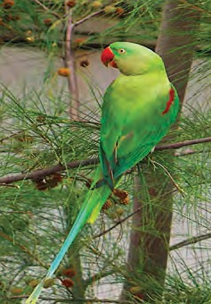

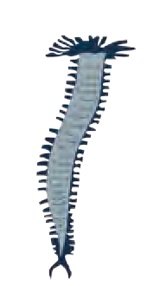

**11. Label the following.**

**Project :**

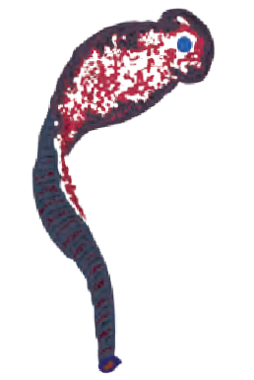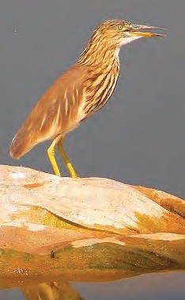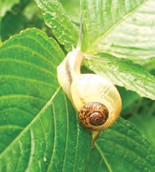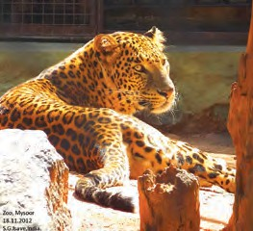In each week, on a specific day of your convenience, observe the animals present around your school & residence. Perform this activity for six months. Keep datewise record of your observations. After the observation period of six months, analyze your observations with respect to seasons. With the help of your teacher, classify the reported animals.

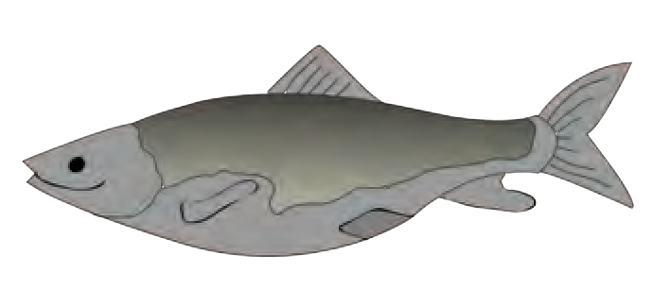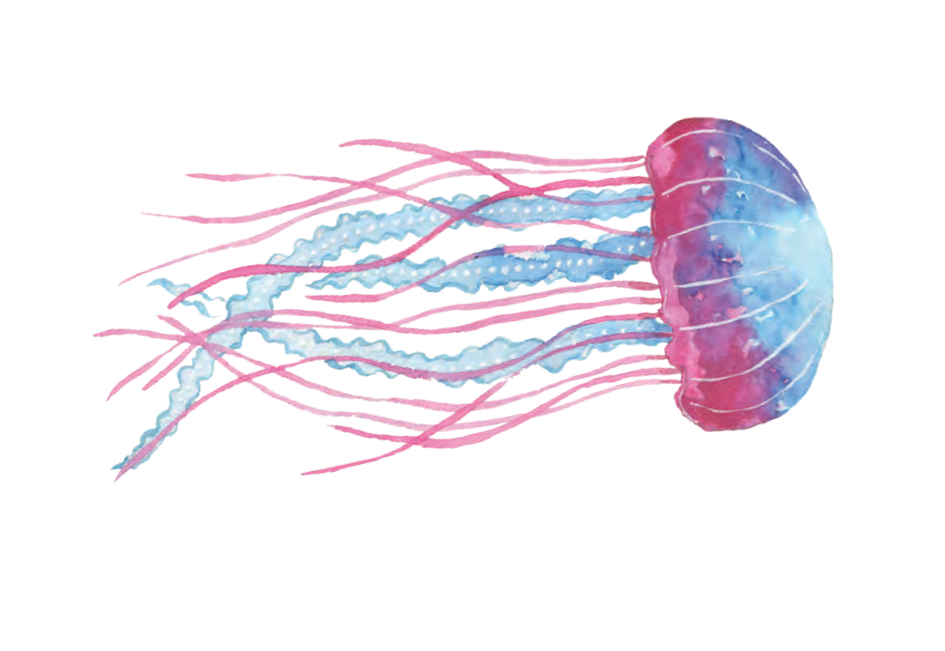



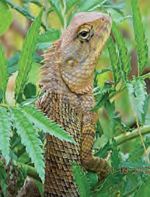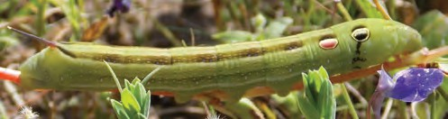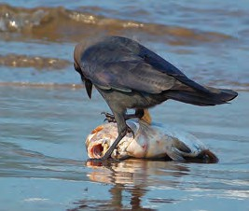Photos with courtesy of : Shri Suresh Isave



76



1. **Introduction to Microbiology**
   * **Applied Microbiology**
   * **Industrial Microbiology**
   * **Products**
2. Which different microbes are useful to us?



**Can you recall?**

1. Which different products can be produced with the help of microbes?

Applied Microbiology

Branch of biology in which study of the enzymes related to some prokaryotes and eukaryotic microbes, proteins, applied genetics, molecular biology, etc. is performed; is called as applied microbiology. This study is used for the society and various products like food and medicines are produced on large scale with the help of microorganisms.

Industrial microbiology

This science is related to commercial use of microbes in which various economic, social and environment related processes and products are included. Various microbial processes useful for this purpose are carried out.

Industrial Microbiology: main features

1. Various productions with the help of fermentation process. Ex. Bread, cheese, wine, raw material for chemicals, enzymes, nutrients, medicines, etc.
2. Use of microbes for garbage management and pollution control.

We use the fermentation process while conversion of milk into yoghurt. Which microbes are useful for this process?



**Can you recall?**

Products

1. **Dairy Products**

Since ancient days, milk is converted into various products for its preservation purpose. Ex. Cheese, butter, cream, kefir, yoghurt, etc. Water content and acidity of the milk changes during formation of these products and texture, taste and flavour is improved.

These processes are performed on large scale with more skill. For production of most of the milk products, bacteria in milk itself are used; only cheese is produced with the help of fungi. Basic process for production of yoghurt, cheese and cream is same. Milk is pasteurized at the beginning to destroy unwanted microbes. It is then fermented with the help of lactobacilli. In this process, lactose sugar of the milk is converted into lactic acid and milk proteins are coagulated with the help of lactic acid. Besides, compounds with taste and flavour are also formed. Ex. Diacetyl has the flavour of butter.



77

1. Yoghurt Products

Yoghurt is a milk product produced with the help of lactobacilli (inoculant). For maintaining the protein content, condensed milk powder is mixed with milk to be fermented for industrial production of yoghurt. Milk is boiled and once it cools to warm temperature, bacterial strains of *Streptococcus thermophilus* and *Lactobacillus delbrueckii* are added to it in 1:1 proportion. Lactic acid is formed due to Streptococcus that makes the proteins to gel out

that gives dense consistency to the yoghurt.

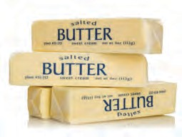Acetaldehyde like compounds are formed due to lactobacilli that gives characteristic taste to the yoghurt. Now a day, various fruit juices are mixed with yoghurt to impart different flavours. Ex. Strawberry yoghurt, banana yoghurt, etc. Shelf life of yoghurt and its probiotic properties can be improved by pasteurization.

1. Butter

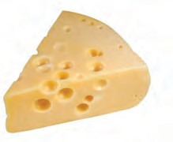Two types of butter like sweet cream and cultured are produced on large scale. Microbes are used for production of cultured variety.

1. Cheese production

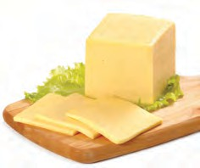Cheese is produced on large scale from the abundantly available cow milk all over the world. First, chemical and microbiological tests of milk are performed. Some colours and microbes like *Lactobacillus lactis, Lactobacillus cremoris,* and *Streptococcus thermophilus* are mixed with milk. It imparts sourness to the milk. After this, to impart the dense texture, whey (water in yoghurt) needs to be removed.

An enzyme, rennet obtained from alimentary canal of cattle was being traditionally used earlier. However, an enzyme protease obtained from fungi is used at present to produce vegetarian cheese. The whey is separated from yoghurt (which has some other

uses). Then, process of production of cheese is started through steps **7.1 Cheese and Butter**

like cutting the solid yoghurt into pieces, washing, rubbing, salting, and mixing of essential microbes, pigments and flavours. Then, cheese is pressed and cut in to pieces and stored for ripening.

Let’s think

1. Which different types of cheese are used in western food like pizza, burger, sandwich, etc?
2. What is difference between those types of cheese?



Do you know?

During industrial production of milk products, strict cleanliness and sterilization is essential as bacteria can be attacked by viruses. Hence, virus-resistant varieties of bacteria are developed. Recently, use of mutant varieties of bacteria has been increased. Artificially, some strains are developed that will help to avoid unnecessary steps / materials.

Freshly prepared cheese is always soft e.g. cottage cheese, cream cheese, mozzarella cheese. On storing for 3 to 12 months, semi-hard cheddar cheese is formed whereas after ripening for 12 – 18 months, very hard cheese called parmesan cheese is formed.

### 78

What for probiotic food is famous?



**Can you tell?**

Probiotics

These are also milk products, but contain active bacteria e.g. *Lactobacillus, Acidophilus, Lactobacillus casei, Bifidobacterium bifidum,* etc. These microbes maintain the balance of intestinal microorganisms i.e. increase the population of microbes helping the digestion and decrease the population of harmful microbes (ex. *Clostridium*). Probiotic products are available in various forms like yoghurt, kefir, sauerkraut (pickle of cabbage), dark chocolate, miso soup, pickles, oils, corn syrup, artificial sweeteners, microalgae (Sea food like *Spirulina, Chlorella*, Blue green algae, etc.).

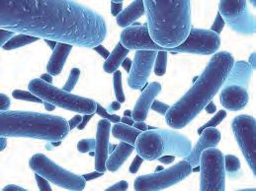Why the probiotics have developed much importance in recent days? These products form the colonies of useful microbes in alimentary canal and control other microbes and their metabolic activities, improve resistance and lower the ill-effects of harmful substances formed during metabolic activities. Useful microbes become inactive due to antibiotics; probiotics make them active again.

Nowadays, probiotics are used for treatment of diarrhoea

and treatment of poultry also.



**Use your brain power**

**7.2 Probiotics**

**Bread**

In the earlier class, you had prepared the solution of dry yeast for observation of yeast. Which substance is prepared by its use on commercial basis?

Different types of breads are produced from flour of cereals. Dough is formed by mixing of baker’s yeast – *Saccharomyces cerevisiae*, water, salt and other necessary materials with flour. Due to fermentation of carbohydrates by yeast, sugar is converted in to carbon dioxide (CO2) and ethanol. Dough rises up due to CO2 and the bread becomes spongy.

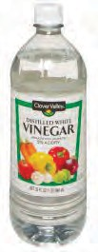Compressed yeast is used in commercial bakery industry. It is available in dry, granular form for domestic use. Yeast produced for commercial use contains various useful contents like carbohydrates, fats, proteins, various vitamins, and minerals. Due to this, bread and other products produced with the help of yeast become nutritive. Ingredients like vinegar, soya sauce and monosodium glutamate (ajinomoto) that are used in presently popular chinese food are produced by microbial fermentation.

Vinegar Production

Vinegar is used in each country of the world to impart sour taste to food materials and for preservation of pickles, sauce, ketch-up, chutneys, etc. Chemically, vinegar is 4% acetic acid (CH3COOH).

Ethanol, an alcohol is obtained by fermentation of carbon compounds like fruit juices, maple syrup, sugar molasses, starch of the roots; with the help of yeast *Saccharomyces cerevisiae*.

7.3 **Vinegar**



79

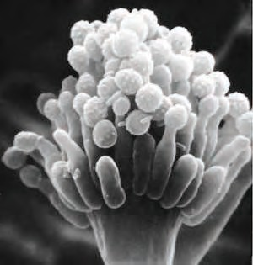Mixture of bacterial strains like *Acetobacter* and *Glucanobacter* is mixed with ethanol for its microbial degradation. Acetic acid and other by-products are obtained through it. Acetic acid is separated from mixture by rarefaction. Acetic acid is bleached with the help of potassium ferrocynide. Then, it is pasteurized. Finally, very small quantity of SO2 gas is mixed to produce vinegar.

Soya sauce is produced by fermentation of the mixture of flour **7.4** *Aspergillus oryzae*

of wheat or rice and soyabean with the help of the fungus *Aspergillus*

*oryzae*.

Production of beverages

|  |  |  |  |  |
| --- | --- | --- | --- | --- |
| Sr.  No. | Fruit | Microbe used | Role of microbe | Name of beverage |
| 1 | *Caffea arabica* | *Lactobacillus brevis* | Separating seeds from fruit | Coffee |
| 2 | *Theobroma cacao* | *Candida, Hansenula, Pichia,Saccharomyces.* | Separating seeds from fruit | Cocoa |
| 3 | Grapes | *Saccharomyces cerevisiae* | Fermentation of juice | Wine |
| 4 | Apple | *Saccharomyces cerevisiae* | Fermentation of juice | Cider |

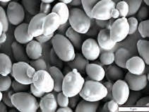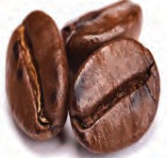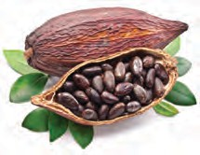

*Saccharomyces cerevisiae* **Fruit and seeds of coffee Cocoa seeds**

7.5 Some ingredients of beverages production



**Can you tell?**

1. Which functions are performed by enzymes secreted in human digestive system?
2. Give names of some such enzymes.

Microbial Enzymes

Nowadays, instead of chemical catalysts, microbial enzymes are used in chemical industry. These enzymes are active at low temperature, pH and pressure; due to which energy is saved and erosion-proof instruments are also not necessary. Enzymes carry out specific processes; hence unnecessary by- products are not formed due to which expenses on purification are minimised.

In case of microbial enzymatic reactions, elimination and decomposition of waste material is avoided and enzymes can be reused. Hence, such enzymes are eco-friendly. Some examples of microbial enzymes are oxido- reductases, transferases, hydrolases, lyases, isomerases, ligases, etc. Process of dirt / muck removal occurs at low temperature too due to mixing of enzymes with detergents. Glucose and fructose syrup can be obtained from corn flour by action of enzymes obtained from bacilli and streptomyces. Microbial enzymes are used in various industries like cheese, plant extracts, textile, leather, paper, etc.



80

Food materials like cold drinks, ice creams, cakes, juices are available in various colours and flavours. Whether these colours and flavours are really derived from fruits?



**Search**



**Use your brain power**

Read the ingredients and their proportion printed on bottles of cold drinks and juices and wrappers of ice creams. Find out the natural and artificial ingredients. Wheat or rice flour is inoculated with Aspergillus.

**Organic acids used in various commercial products and microbes useful for the same**

|  |  |  |  |
| --- | --- | --- | --- |
| Source | Microbe | Amino acid | Use |
| Sugar and beet molasses, ammonia salt | *Brevibacterium, Corynobacterium* | L-glutamic acid | Production of monosodium glutamate (Ajinomoto) |
| Sugar molasses, salt | *Aspergillus niger* | Citric acid | Drinks, toffees, chocolate production |
| Glucose, corn steep liquor | *Aspergillus niger* | Gluconic acid | Production of minerals used as supplement for calcium and iron |
| Molasses, corn steep liquor | *Lactobacillus delbrueckii* | Lactic acid | Source of nitrogen, production of vitamins. |
| Molasses, corn steep liquor | *Aspergillus itaconius* | Itaconic acid | Paper, textile, plastic industry, gum production |

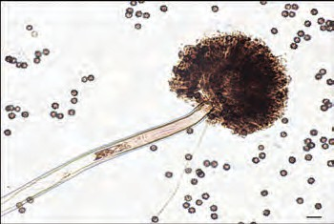

**7.6** *Aspergilus niger*

What is the xanthan gum that imparts thickness to your favourite ice creams, puddings, chocolates, milk shakes, chocolate drinks, instant soups, etc.? This gum is obtained by fermentation of starch and molasses with the help of *Xanthomonas* species. It is variously useful due to properties like solubility in hot and cold water, high density, etc. It is used for production of pigments, fertilizers, weedicides, textile pigments, tooth pastes, high quality paper, etc.

Substances obtained by microbial processing and their roles

|  |  |
| --- | --- |
| **Substances obtained by microbial processing** | **Roles** |
| Citirc, Malic and Lactic acid | To impart acidity |
| Glutamic acid, Lysine, Tryptophan | Protein binding |
| Nycin and natamycin | Microbial restrictor |
| Ascorbic acid (Vit. C), B12, B2 | Antioxidants, vitamins. |
| Beta carotene, lycopenes, xanthenes, lutein | Edible colours |
| Polysaccharides, glycolipids | Emulsifiers |
| Vanillin, Ethyl butyrate (fruit flavour), peppermint  flavour, essence of various fruits and flowers | Essence |
| Xylitol, aspartame | Artificial sweetener (low calorie) |



81

1. What do you mean by antibiotic?



**Can you recall?**

1. Which precautions should be taken about their consumption?

Antibiotics

Many diseases of human and other animals have been controlled due to antibiotics obtained from different types of bacteria and fungi. Antibiotics like penicillin, cephalosporins, monobactam, bacitracin, erythromycin, gentamycin, neomycin, streptomycin, tetracyclins, vancomycin, etc. are used against various strains of gram positive and gram negative bacteria. Rifamycin is effective against tuberculosis.

in etc.



**Can you tell?**

Microbes and Fuels

1. Which different materials are decomposed in biogas plant?
2. Which useful materials are obtained through it? Which is the fuel out of those?
3. Decomposition occurs through which organisms?
4. 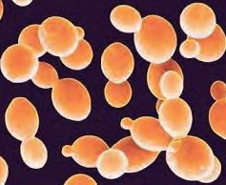Gaseous fuel- methane can be obtained by microbial anaerobic decomposition of urban agricultural and industrial waste.
5. Ethanol, an alcohol is a clean (smokeless) fuel obtained during fermentation of molasses by the yeast- Saccharomyces.
6. Hydrogen gas is considered to be the fuel of future. Hydrogen gas is released during bio-photolysis of water in

which bacteria perform the photoreduction. **7.7** *Saccharomyces* **(yeast)**

Similar to fuels, various industrial chemicals are also produced through microbial process. Ex. various alcohols, acetone, organic acids, fatty acids, polysaccharides, that are useful as raw materials in chemical industry. Some of these are useful as raw materials for plastic and food products.

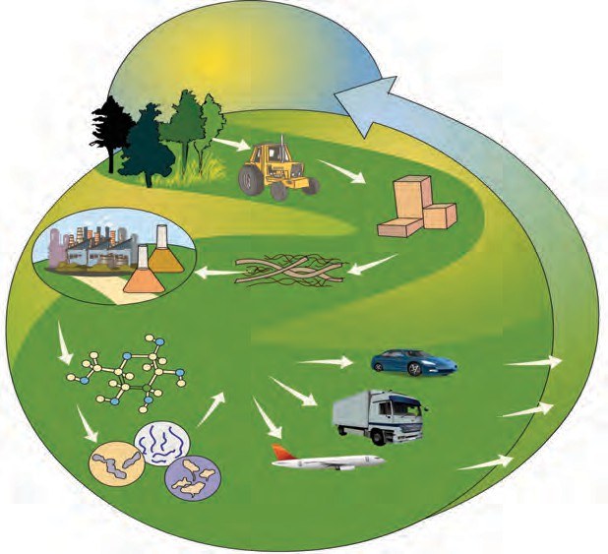

Observe

Observe the fig. 7.7. Discuss about bio-fuel.

**Bio-fuel :** Biofuel is important among the renewable source of good energy. These fuels are available in solid (coal, dung, crop residue), liquid (vegetable oils, alcohol), gaseous (gobar gas, coal gas) forms. These fuels are

**Biomass**

**Conversion of cellulose to glucose**

##### Sugar

**Liquid fuel**

##### Solar energy + CO2

**Harvesting**

**Threshing**

**Cellulose Biofuel**

CO2 CO2

##### CO

CO2

easily available and in plenty of quantity. These are reliable fuels of the future.

**production through fermentation**

### 82

2

* 1. **Biofuel production**

Microbial Pollution Control

Solids wastes, sewage and various pollutants are ever increasing with increase in pollution. Along with it, ever increasing diseases and degradation of environment are the world-wide problems. Especially, cities in densely populated countries like India are affected with these problems. Life of the future generations will be difficult if these problems are not solved at right time and to right extent. Let us see the role of microbes in environment.

You already know that microbes are used for disposal of solid waste through biogas plant and compost production. How urban waste that is accumulated in terms of tonnes, may be disposed off ?

* + 1. Why is it asked to segregate wet and dry waste in each home?



**Let's Think**

* + 1. What is done with the segregated waste?
    2. Which is most appropriate method of disposal of dry waste?

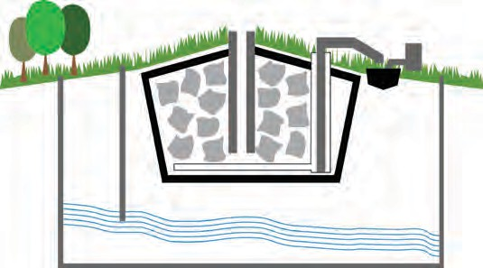

well to monitor ground

**Garbage**

**Methane Gas**

**Soil cover**

**Processing on sewage**

**Plastic Sheet**

Land-filling sites

Degradable waste being accumulated in urban areas is used for this purpose. Large pits are dug in open spaces far away from the residential area

water level

**Collection of sewage**

* 1. **Modern landfill site**

and those pits are lined with plastic sheets as a precaution against pollution of soil due to leaching of toxic and harmful materials.

Compressed waste is dumped in the pit. It is covered with layers of soil, saw dust, leafy waste and specific biochemicals. Bioreactors are mixed at some places. Microbes present in soil and other top layers decompose the waste. Completely filled pit is sealed with soil slurry. Best quality compost is formed after few days. Such land filling sites can be reused after removal of compost.



Observe

Observe the garbage vans of grampanchayat and municipality. Nowadays, there is facility of decreasing the volume of garbage by compaction in those vans. Explain the advantages of this activity.

Sewage Management

In villages, domestic sewage is disposed off either in nearby soil or in biogas plant. However, in cities, sewage needs to be carried to processing unit and acted upon by microbial processes.

Microbes which can decompose any compound as well as destroy the pathogens of cholera, typhoid, etc. are mixed with sewage. They release methane and CO2 by decomposition of the carbon compounds present in sewage. Phenol oxidizing bacteria

decompose the xenobiotic chemicals present in sewage.



83

The sludge that settles down in this process can again be used as fertilizer. Water released after microbial treatment is environmentally safe. Microbes are used for bioremediation of environment polluted due to sewage.



**Collect Information**

1. Which materials should not be present in garbage for its proper microbial decomposition?
2. How the sewage generated in your house or apartment is disposed off ?

Clean Technology

Human being has made a very fast progress in technology. However, environmental pollution is also increasing with same speed. Let us see the ways of control over air, soil and water pollution with the help of microbes.

Microbes have natural ability of decomposing the manmade chemicals. Hydrocarbons and other chemicals are transformed with the help of these abilities.

1. Some microbes remove the sulphur from fuels.
2. Metals like copper, iron, uranium, zinc, etc. leach into environment from low quality metalloids. These are converted into compounds before leaching, with the help of thiobacilli and sulphobacilli.



**Can you tell?**

You must have seen or read the news of dead fishes or oily water accumulating at the sea coasts. Why does this happen?

Spilling of petroleum oil occurs in ocean due to various reasons. This oil may prove fatal and toxic to aquatic organisms. It is not easy to remove the oil layer from surface of water by mechanical method. However, bacteria like *Pseudomonas* spp. and *Alcanovorax borkumensis* have the ability to destroy the pyridines and other chemicals. Hence, these bacteria are used to clear the oil spills. These are called as hydrocarbonoclastic bacteria (HCB). HCB decompose the hydrocarbons and bring about the reaction of carbon with oxygen. CO2 and water is formed in this process.

Plastic bottles are formed from the chemical substance PET (Polyethylene Terephthalate Polyester). Now a day, most of the urban garbage consists of plastic. It has been observed that species like *Vibrio, Ideonella sakaiensis* can decompose the PET. Similarly, species of bacteria like *Actinomycetes, Streptomyces, Nocardia, Actinoplanes* have ability of decomposing rubber from garbage.

* 1. 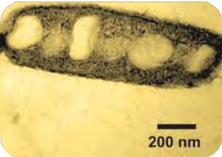*Alcanovorax borkumensis*

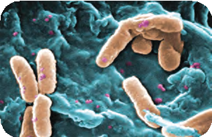

* 1. *Pseudomonas*

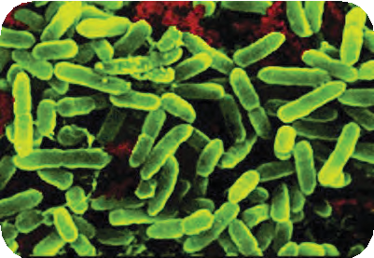

* 1. *Acidobacillus*



84

Sulphuric acid is present in the acid rain and materials coming out of mines. You know that erosion of metals present in statues, bridges and buildings occurs due to it. Sulphuric acid is source of energy for some species of bacteria like *Acidophillium* spp. and *Acidobacillus ferroxidens*. Hence, these bacteria can control the soil pollution occurring due to acid rain.

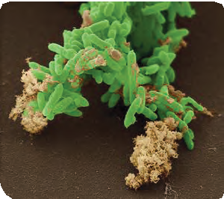

* 1. *Geobacter*

Collect pictures of various useful microbes. Display chart of their information in classroom.

Water soluble salts of uranium are present in the wastes produced during electroplating and in effluent released in environment from the atomic energy plant. *Geobacter* convert these salts of uranium into insoluble salts and thereby prevent those salts from mixing with ground water sources.



**Internet is My Friend**

Microbes and Farming

How the bacteria present in soil and root nodules of leguminous plants are useful?



**Can you tell?**

Microbial Inoculants

Some microbes-containing inoculants are produced by process of fermentation. These inoculants are sprayed on seeds before sowing and some of the inoculants are released into plants. Microbes in the inoculants help in plant growth by supplying nutrients. They improve the quality of vegetarian food. Solution containing *Azotobacter* and artificial nitrogenase is used in organic farming.



**Always Remember**

Plastic being used for storing the garbage is biodegradable polylactic acid. Such material should be used as per need only and environment should be saved.

Soil pollution occurring due to chemical fertilizers is prevented due to use of these solutions. Fluoroacetamide-like chemicals are mixed with soil due to use of chemical pesticides in agriculture. These prove to be harmful to other plants and animals as well as cause skin diseases to human. These pesticides in the soil can be destroyed with the help of microbes.

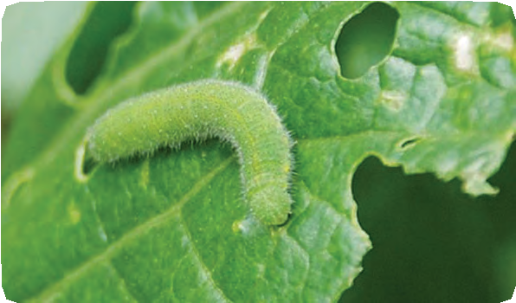Bioinsecticides

Bacterial and fungal toxins which can destroy pests and pathogens can be directly integrated into plants with the help of biotechnology. Being toxic to insects, they do not consume the plants. Similar to bacteria, some species of fungi and viruses are useful as pesticides. Spinosad, a by- product of fermentation is a biopesticide.

* 1. Caterpillar feeding on leaf



85



1. **Rewrite the following statements using correct of the options and explain the completed statements.** (gluconic acid, coagulation, amino



**Exercise**

acid, acetic acid, clostridium, lactobacilli)

1. Process of of milk proteins

occurs due to lactic acid.

1. Harmful bacteria in like in the

intestine are destroyed due to probiotics.

1. Chemically, vinegar is --.
2. Salts which can be used as supplement of calcium and iron are obtained from acid.
3. **Match the pairs**

**‘A’ group ‘B’ group**

1. Xylitol 1. Pigment
2. Citric acid 2. To impart

sweetness

1. Lycopene 3. Microbial

restrictor

1. Nycin 4. Protein binding emulsifier
2. To impart acidity
3. **Answer the following.**
4. Which fuels can be obtained by microbial processes? Why is it necessary to increase the use of such fuels?
5. How can the oil spills of rivers and oceans be cleaned?
6. How can the soil polluted by acid rain be made fertile again?
7. Explain the importance of bio- pesticides in organic farming.



1. Which are the reasons for increasing the popularity of probiotic products?
2. How the bread and other products produced using baker’s yeast are nutritious?
3. Which precautions are necessary for proper decomposition of domestic waste?
4. Why is it necessary to ban the use of plastic bags?

### 86

1. Complete the following conceptual picture.

Cleaning

Sewage after processing

1. **Give scientific reasons**.
2. Use of mutant strains has been increased in industrial microbiology.
3. Enzymes obtained by microbial process are mixed with detergents.
4. Microbial enzymes are used instead of chemical catalysts in chemical

industry.

1. Complete the following conceptual picture with respect to uses.

Xanthan gum

1. **Complete the following conceptual picture related to environmental management.**

Oil spill

Microbes

1. Answer the following.
2. What is role of microbes in compost production?
3. What are the benefits of mixing ethanol with petrol and diesel?
4. Which plants are cultivated to obtain the fuel?
5. Which fuels are obtained from biomass?
6. How does the bread become spongy?

**Project :**

1. Find the ways to implement the zero garbage system at domestic level.
2. Which are the microbes that destroy the chemical pesticides in soil?
3. Collect more information about reasons for avoiding the use of chemical pesticides.







87

# 8. Cell Biology and Biotechnology



* + **Cell Biology (Cytology)** ➢ **Stem Cells**
  + **Biotechnology and Its Applications** ➢ I**mportant Stages in**

**Development of Agriculture**

### Can you Recall

1. What is cell?
2. What is tissue? Which are the functions of tissue?
3. Which technique in relation to tissues have you studied in earlier classes?
4. Which are the various processes in tissue culture?

We have studied the plant production by technique of tissue culture in the last class.

Stem cells are used for that purpose. Whether such stem cells are present in animals?



Observe

Assign names in the figure given below. Explain the various stages those are kept blank.

Cytology

Earlier, we have studied the structure, types and organelles of the cell. This is called as cell biology / cytology. Besides above mentioned points, it includes the study of cell division and many other aspects of the cell.

There are revolutionary changes in the field of human health due to cell biology. Research institutes specially dedicated for research on cells are established at Pune and Bengaluru, India. National Center for Cell Science [(http://www.nccs.res.in)](http://www.nccs.res.in/) at Pune and ‘Instem’ [(http://www.instem.res.](http://www.instem.res/) in) at Bengaluru are involved in valuable research.

* 1. **Diagram**

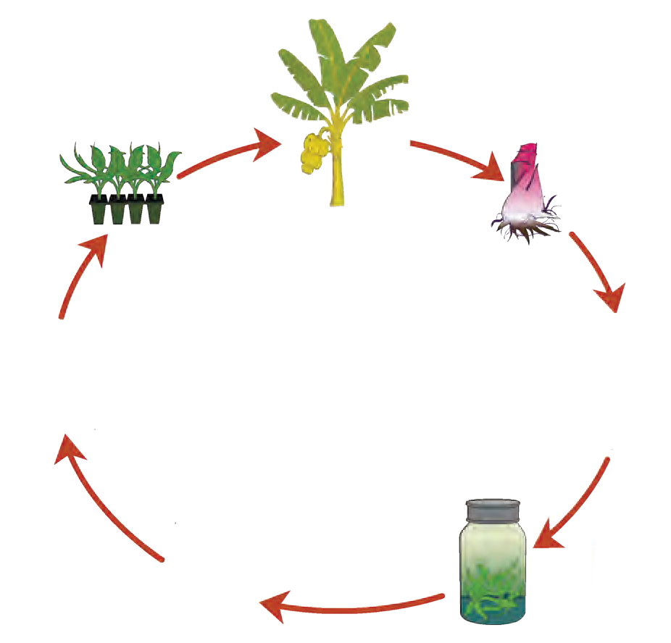

Visit both the websites mentioned above and with the help of your teacher, try to understand the research undergoing in those institutes.

Stem Cells

These are special types of cells present in the body of multicellular organisms. These cells give rise to all other types of cells present in the body of multicellular organisms. Similarly, these cells play an important role in wound healing.

We had studied the stem cells of plants in the previous class. Now, we shall study the stem cells in animals, particularly in human beings.

New organism is formed from the zygote that is formed by union of male and female gamete. At the earliest stage of development, organism is in the form of a mass of cells. All the cells in that mass are almost alike. Those cells are called as stem cells.



88

During further development, these cells form any type of cell, different types of tissues and perform different functions in the body. This is the differentiation of stem cells. However, once the tissues are formed, the cells in those tissues, at the most, can form same types of cells only. This is the case in each part of the body. However, stem cells are present for longer duration in some parts of the body.

Stem cells are present in the umbilical cord by which the foetus is joined to the uterus of the mother. Stem cells are also present in the blastocyst stage of embryonic development. Stem cells are present in red bone marrow and adipose connective tissue of adult human beings. It has become possible to produce different types of tissues and the degenerated part of any organ with the help of these stem cells.



**Stem Cell Preservation**

For the purpose of preservation, stem cell samples are carefully collected from sources like cord blood, red bone marrow or embryo (blastocyst) and are kept in small, sterile vials. Those vials are kept in liquid nitrogen at -1350C to -1900C.

**Use your brain**

Just like the grafting in plants, is the organ transplantation possible in humans?

Stem cell research

In biotechnology, stem cell research is a revolutionary event after cloning. This technique has the potential of bringing about the fundamental changes in the medical science.

**Depending upon source, stem cells are of two types as embryonic stem cells and adult stem cells.**

**Embryonic stem cells**

Division of the zygote starts and thereby it is converted into embryo. Cells of embryo undergo repeated mitotic divisions. Cell differentiation starts from 14th day of conception. Cells of different organs like osteocytes (bone cells), hepatocytes (liver cells), and neurons are formed due to differentiation. Embryonic cells before differentiation are called as embryonic stem cells. 220 different types of cells in human body are formed from single type cells i.e. embryonic stem cells. Thus, stem cells are primary type of undifferentiated cells with self-multiplying ability and they are parent cells of all types of human cells. This property of stem cells is called as pleuripotency. It has been found that if these stem cells are collected well before the beginning of differentiation on 14th day i.e. during 5th – 7th day and cultured with certain biochemical stimulus in laboratory, as per the stimulus, they can transform themselves into desired type of cells, thereby tissues and finally into organs.

Adult stem cells

Stem cells can be obtained from the body of adult person too. There are three main sources of stem cells in the body of adult persons. Stem cells can be obtained from red bone marrow, adipose connective tissue and blood. Besides, stem cells can be obtained from cord blood immediate after birth.

Uses of Stem Cells

* + 1. **Regenerative Therapy**
       1. Cell Therapy: Stem cells are used to replace the dead cells in case of conditions like diabetes, myocardial infarction, Alzheimer’s disease, Parkinson’s disease, etc.
       2. To produce blood cells required in conditions like anaemia, thalassemia, leukemia, etc.
    2. **Organ Transplantation:** In case of failure of organs like kidney and liver, those can be produced with the help of stem cells and transplanted.



89

Discuss about stem cells and organ transplantation in the class with the help of figures given below.



Observe

Organ transplantation

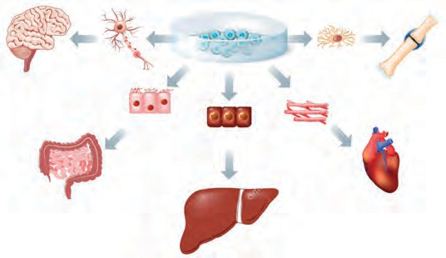

**Neuron**

**Stem cells**

**Brain**

**Bone**

**Intestine**

**Heart**

**Liver**

Various organs in the human body either become less efficient or completely functionless due to various reasons like aging, accidents, infections, disorders, etc. Life of such person becomes difficult or even fatality may occur under such conditions. However, if a person gets the necessary organ under such conditions, its life can be saved.

Availability of donor is an important

* 1. **Stem cells and organs**

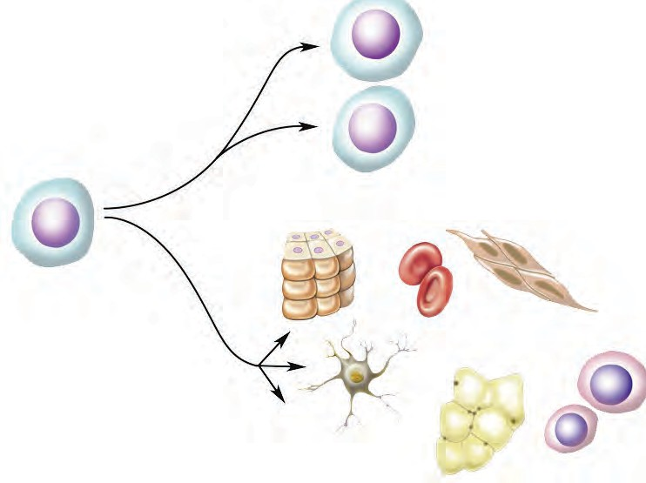

**Can replicate themselves**

**Stem cells**

**Can be transformed into other types of cells**

* 1. **Stem cells therapy**

requirement in organ transplantation. Each person has a pair of kidneys. As the process of excretion can occur with the help of single kidney, person can donate another one. Similarly, skin from certain parts of the body can also be donated.

Various factors like blood group, diseases, disorders, age, etc. of the donor and recipient need to be paid attention during transplantation.

However, other organs cannot be donated during life time. Organs like liver, heart, eyes can be donated after death only. This has led to the emergence of concepts like posthumous (after death) donation of body and organs.

**Organ and Body Donation:** Human bodies are disposed off after death as per traditional customs. However due to progress in science, it has been realized that many organs remain functional for certain period even after death occurs under specific conditions. Concepts like organ donation and body donation have emerged recently after realization that such organs can be used to save the life of other needful persons. A liberal view behind the concept of organ and body donation is that after death, our body should be useful to other needful persons so that their miserable life would become comfortable. Awareness about these concepts is increasing in our country and people are voluntarily donating their bodies.

Life of many people can be saved by organ and body donation. Blinds can regain the vision. Life of many people can be rendered comfortable by donation of organs like liver, kidneys, heart, heart valves, skin, etc. Similarly, body can be made available for research in medical studies. Many government and social organizations are working towards increasing the awareness about body donation.

Visit the websites- <http://www.who.int/transplantation/or-> gan/en/ & [www.organindia.org/approaching-the-transplant/](http://www.organindia.org/approaching-the-transplant/) and collect more information about ‘brain dead’, organ donation and body donation.



90



**Internet is my friend**



**Always Remember**

Organ

donation

and

transplantation is under the control of ‘Transplantation of Human Organs Act, 1994’ and subsequent amendments of 2009, 2011 and 2014 so that overall process would be transparent and any person would not be cheated.



**Recall A Little**

1. What is biotechnology?
2. In which various fields, the biotechnology has been useful?
3. What is the impact of biotechnology on agriculture and other related fields?

Biotechnology

* 1. **Organs that can be donated**

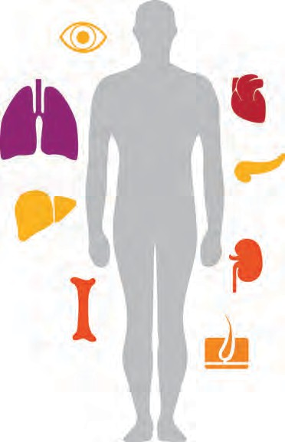

**Eyes**

**Heart**

**Lungs**

**Pancreas**

**Liver**

**Kidney**

**Bone**

**Skin**

We have studied in the earlier class that biotechnology is bringing about artificial genetic changes and hybridization in organisms for human welfare. Various branches of science like cytology, biochemistry, molecular biology, and genetic engineering are included in biotechnology. There is considerable progress mainly in the field of agriculture and pharmacy due to biotechnology. New experiments are being performed for improving the agricultural yield. In pharmacy, experiments for production of antibodies, vitamins, and hormones like insulin have been successful. High-class varieties of crops have been developed through the technique of tissue-culture.

Biotechnology includes following main areas

1. Use of various abilities of microbes like yoghurt production from milk and alcohol from molasses.
2. Use of productivity of the cells. Ex. – Production of antibiotics and vaccines, etc. with the help of specific cells.
3. Use of bio-molecules like DNA and proteins in human welfare.
4. Development of plants, animals and products of desired quality by gene manipulation. Production of human growth hormone with the help of genetically modified bacteria.
5. Use of genetic and non-genetic technique. Non-genetic biotechnology involves use of either cell or tissue. Ex. Tissue culture, production of hybrid seeds, etc.

Benefits of Biotechnology

1. It has become possible to increase the per hectare yield irrespective of the limitations of crop-land area.
2. Expenses on disease control have minimized since development of resistant varieties.
3. Due to development of fast fruit setting varieties, yield per annum has been increased.
4. Development of stress resistant varieties which can withstand variable temperature, water-stress, changing fertility of soil, etc. has become possible.



91

**Development of Biotechnology in India**

Government of India had established the National Biotechnology Board in 1982. This board was transformed into department of biotechnology under the ministry of science and technology, in 1986. Various institutes in India are working under the control of this department of biotechnology. It includes National Institute of Immunology, National Facility for Animal Tissue and Cell Culture, National Centre for Cell Science, National Brain Research Centre, Central Institute of Medicinal and Aromatic Plants. There are facilities of higher education and research in these institutes from where thousands of students have pursued Ph.D. degrees and are contributing to the progress of country in the field of biotechnology.

**Commercial Applications of Biotechnology:**

1. **Crop Biotechnology:** Biotechnology is used in agricultural field to improve yield and variety.
   1. **Hybrid Seeds:** Genes of two different crops are recombined to form hybrids of various crops. This is especially useful for fruits.
   2. **Genetically Modified Crops:** Crops developed with desired characters by integrating foreign gene with their genome are called as genetically modified crops. High yielding varieties with resistance to diseases, alkalinity, weeds, other stresses like cold and drought.

**Bt Cotton:** A gene had been isolated from the bacterium *Bacillus thuringiensis* and integrated with the genome of cotton. Due to this, the toxin which is fatal for bollworm was produced in leaves and bolls of cotton. If bollworm feeds on leaves, the toxin destroys its alimentary canal and the bollworm dies.

**Bt Brinjal:** BT Brinjal variety is developed by using the gene isolated from *Bacillus thuringiensis*. This improved variety of brinjal kills the pest in same way as the Bt cotton does.

**Golden Rice:** A gene synthesizing the vitamin A (Beta carotene) has been introduced in this variety of rice. As compared to the normal variety, this variety which has been developed in 2005 contains 23 times more amount of beta carotene.

**Herbicide tolerant plants:** Weeds always affect the growth of main crop. If herbicides are used to destroy the weeds, it affects the main crop too. Due to this, Herbicide tolerant plants varieties of crops are being developed. Due to this, it has become possible

to selectively destroy the weeds.

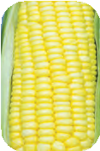 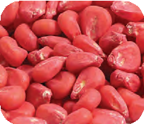

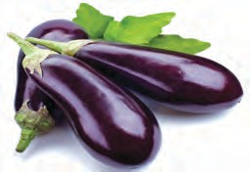

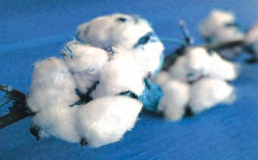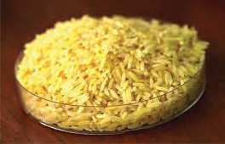

* 1. **Some crops**

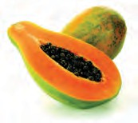



92

* 1. Biofertilizers

Due to use of biofertilizers instead of chemical fertilizers, nitrogen fixation and phosphate solubilization abilities of the plants are improved. Mainly the bacteria like *Rhizobium, Azotobacter, Nostoc, Anabaena* and plants like *Azolla* are used as biofertilizers.

In the last year, we have studied the tissue culture. Genetic improvement of the plants has become possible due to tissue culture and besides, those characters inherited to next generation.



**Make a list and discuss**

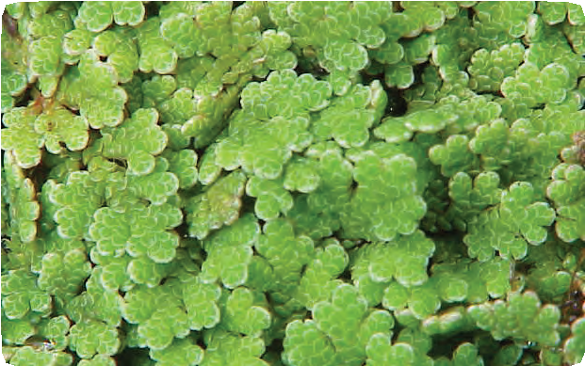

* 1. **Azolla**

1. Animal Husbandry

Give five examples of each of the fruiting and flowering plants developed through tissue culture and mention their benefits.

Two main methods as artificial insemination and embryo transfer are used in animal husbandry. It helps to improve both, the quantity and quality of animal products. Ex. Milk, meat, wool, etc. Similarly, animals with more strength have been developed for hard work.

**USE OF ICT**

Collect information about various hybrid varieties of animals. What are their benefits? Make a presentation of various pictures and videos.

1. Human Health

Diagnosis and treatment of the diseases are two important aspects of the human health management. Biotechnology helps to identify the role of gene, if any, in disease of a person. Diagnosis of diabetes and heart diseases has become possible even before the onset of symptoms, with the help of biotechnology. Diagnosis of the diseases like AIDS, dengue can be done within few minutes. Hence, treatment can be done at the earliest.

Various medicines are used for the treatment of diseases. Ex. The hormone insulin is used in treatment of diabetes. Earlier, insulin was being collected from the pancreas of horses. However, nowadays, due to biotechnology, insulin can be prepared with the help of bacteria. For this purpose, human insulin gene has been inserted into the genome of bacteria. Various vaccines and antibiotics are also produced in the same way.

* 1. **Vaccines and Vaccination:** Vaccine is the ‘antigen’ containing material given to acquire either permanent or temporary immunity against a specific pathogen or disease. Traditionally, vaccines were prepared with the help of pathogens. Completely or partially killed pathogens were used as vaccines. However, due to this, there were chances of contracting the disease in case of some persons. Hence, as an alternative, scientists tried to artificially produce vaccines with the help of biotechnology. For this purpose, scientists produced the antigen in laboratory with the help of gene isolated from the pathogen and used it as vaccine. Thus, safer vaccines are being produced.



93

Now, proteins which act as antigen are injected in pure form instead of injecting the killed or semi-killed pathogens. These proteins keep the persons away from the diseases by keeping the immune system active. Thus, injecting the antigens is safest way in vaccination. Vaccines produced with the help of biotechnology are more thermo-stable and remain active for longer duration. Ex. Vaccines of polio, hepatitis,

**Edible Vaccines:** Work on production of edible vaccines is in progress and presently, potatoes are being produced with the help of biotechnology. These potatoes are called as transgenic potatoes. These potatoes will act against bacteria like *Vibrio cholerae, Escherichia coli.* Consumption of these raw potatoes generates the immunity against cholera and the disease caused due to *E. coli.* What will happen if these potatoes are cooked for consumption?

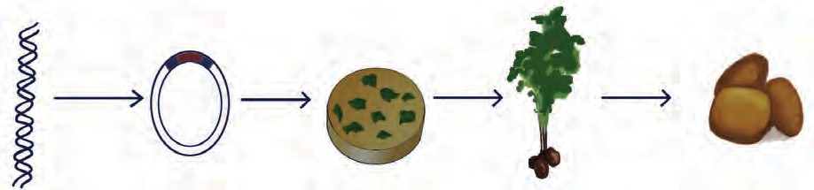**Inject virus in the plant**

Isolation of desired gene from human pathogen

Transgenic plant virus.

Virus infects the pieces of potato leaves.

Entire plant is de- veloped from the leaf pieces contain- ing genes of human pathogen.

Consumption of raw potatoes helps to develop immunity against that

* 1. Transgenic potatoes

pathogen

* 1. **Treatment:** Biotechnology is useful for production of hormones like insulin, somatotropin and blood clotting factors.
  2. **Interferon:** This is a group of small sized protein molecule used in treatment of viral diseases. These are produced in blood. However, nowadays, with the help of biotechnology, transgenic E. coli are used for production of interferon.
  3. **Gene therapy:** Gene therapy to treat genetic disorders in somatic cells has become possible due to biotechnology. Ex. Phenylketonuria (PKU) arises due to genetic changes in hepatocytes (liver cells). It has become possible to treat it with gene therapy. This method is called as somatic cell gene therapy. All the cells except sperms and ova in the body are called as somatic cells



Do you know ?

Indian Institute of Science has developed a transgenic variety of tobacco. If cattles feed upon leaves of this plant, they do not contract a viral disease- rinderpest.

* 1. **Cloning:** Production of replica of any cell or organ or entire organism is called cloning.
     1. **Reproductive cloning:** A clone can be produced by fusion of a nucleus of somatic cell with the enucleated ovum of anybody. Thus, there is no need of sperm to produce the new organism.



94

* + 1. Therapeutic cloning



Internet My Friend

Collect more information about the Human Genome Project, one of the important projects in the world

Stem cells can be derived from the cell formed in laboratory by the union of somatic cell nucleus with the enucleated egg cell. Various diseases can be treated with the help of these stem cells.

See the proteins produced by biotechnology and the names of diseases they are used against-

1. Insulin Diabetes
2. Somatostatin Dwarfism
3. Erythropoietin Anaemia
4. Factor VIII Haemophilia
5. Interleukin Cancer
6. Interferon Viral infection

######  Similar to cells, genes can also be cloned and millions of copies of same gene can be produced. Those can be used for gene therapy and other purposes.

* Controlling the inheritance of hereditary diseases, continuation of generations, enhancing the specific tendency may become possible due to cloning technique. However, there is world-wide opposition to human cloning on various issues.

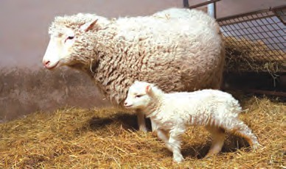

**Peeking into History**

A sheep ‘Dolly’ was born in Scotland by cloning technique on 5th July 1996. Nucleus from the udder cell of sheep of ‘Finn Dorset’ variety had been introduced into enucleated ovum of Scottish sheep. Then, the ovum was allowed to develop in the uterus of Scottish sheep and thereby the ‘Dolly’ had been born. It was showing the characters as per the chromosomes in nucleus and any character of Scottish sheep was not visible.

**Dolly (Clone)**

1. **Industrial Products / White Biotechnology**

Various industrial chemicals can be produced through less expensive processes. Example: Alcohol production from sugar molasses with the help of transgenic yeast.

1. Environment and Biotechnology

It has become possible to solve environment related various problems with the help of biotechnology.

Microbial techniques are already in use for treatment on sewage and solid waste. Sewage is rich in organic matter. If such sewage is released in natural water bodies like rivers, the organic matter in it gets oxidized with the help of dissolved oxygen. Due to this, level of dissolved oxygen in water decreases, adversely affecting the aquatic life. As a remedy on this, sewage should be released in to rivers only after oxidation with the help of microbial technique.

1. Microbes are useful on large scale while production of compost by treatment on solid organic waste material.
2. Bio-remediation, biopesticides, biofertilizers, biosensors, etc, are some new concepts in biotechnological methods.



95

Bioremediation means either absorption or destruction of toxic chemicals and harmful pollutants with the help of plants and microorganisms. If plants are used for this purpose, it called as ‘phyto-remediation’. Some examples of bioremediation are as follows-

* The *Pseudomonas* bacteria are useful for cleaning the hydrocarbon and oil pollutants

from soil and water.

* The fern *Pteris vitata* can absorb the arsenic from the soil.
* Genetically modified variety of Indian mustard can absorb selenium from soil.
* Sunflower can absorb uranium and arsenic.
* The bacterium *Deinococcus radiodurans* is highly radiation resistant organism. It has been genetically modified and used to absorb the radiations from radioactive debris.

* Grasses like alfalfa, clover and rye are used in phyto-remediation.

1. **Food Biotechnology:** Food items like bread, cheese, wine, beer, yoghurt, vinegar are produced with the help of microorganisms. These food items are probably the oldest ones produced with the help of biotechnology.
2. **DNA fingerprinting:** DNA sequence of each person is unique as that of the fingerprints. Due to this, identity of any person can be established with the help of its available DNA. This is called as DNA fingerprinting. It is mainly useful in forensic sciences. Identity of the criminal can be established with the help of any part of its body found at the site of crime. Similarly, identity of father of any child can be established. This research is performed in Center for DNA fingerprinting and Diagnostics, Hyderabad.

**Cleaning of Oil Spillage in Oceans:** If oil spillage occurs, it adversely affects the marine life. Now, cleaning the ocean without any harm to environment in cheaper way has become possible with the help of oil-digesting and fast multiplying bacteria. India born American citizen and scientist Dr. Anand Mohan Chakravarti had for the first time suggested the use of such microbes. Naturally, the credit for this discovery goes to him.

**Important stages in agricultural development**

Green revolution

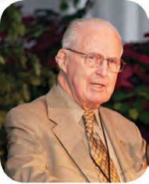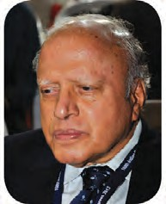Problems of population explosion were started to appear at the beginning of 20th century. Almost all the countries, especially underdeveloped and developing countries had been badly affected by the effects of poor quality and quantity of food. Various methods applied for harvesting maximum yield from

minimum land are collectively called as green revolution.

Dr.M.S Swaminathan

Dr. Norman Borloug

Improvised dwarf varieties of wheat and rice, proper use of fertilizers and pesticides and water management has led to the increased production of food grains and thereby large population had been saved from hunger. Dr. Norman Borlaug (USA) and Dr. M. S.

Swaminathan (India) have valuable contribution in green revolution.



96

Various research institutes and laboratories are engaged in development of new varieties of various crops through research. Ex. Indian Agricultural Research Institute (IARI), New Delhi, National Citrus Research Institute, Nagpur and allied branches, Indian

Institute of Sciences, National Pomegranate Research Institute, Solapur.

Which new species of the rice have been developed in India?



**Collect Information**

White revolution



**Internet is My Friend**

Collect the information and make the chart about the work of various state and national-level institutes related with biotechnology.

Various parts of India were rich in milk and milk products. However, those products were not sufficient to meet the needs of far-flung regions. Dr. Verghese Kurien proved through the cooperative movement and use of biotechnology that Dairy cannot be allied but it will be a mainstream business. He put the cooperative dairy movement of Anand, Gujarat at all time high status.

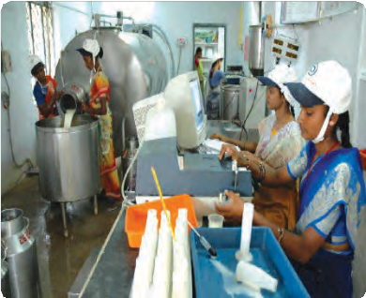While achieving the self-sufficiency in dairy business, various experiments were performed for quality control, newer dairy products and their preservation. Why people from all over the world

are again preferring the local wild varieties?

Blue revolution

Production of various useful aquatic organisms with the help of water is called as blue revolution. Farm ponds and the fishes are very common in East Asian countries. However, people are not only

thinking of cultivating the fishes and shrimps but **8.8 Milk processing and milk products**

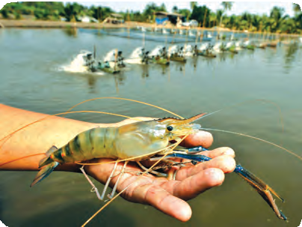other aquatic plants and animals too. Government of India has vowed to increase the production by encouraging the people for pisciculture by launching the program ‘Nil-Kranti Mission-2016’ (NKM-16). 50% to 100% subsidies are offered in this case.

Marine and fresh water fishery is possible on large scale. Fresh water fishes like rohu, catla and other fishery products like shrimp and lobsters are

being cultured on large scale

Fertilizers

* 1. **Pisciculture : Prawns**

Two types of fertilizers are used in agriculture. One of those is organic manure and others are chemical fertilizers. Water holding capacity of the soil improves with soil conservation due to use of manures.



97

Upper layer of the soil essential in agriculture is formed due to humus formation. Various essential elements like N, P, K can be available to crops due to earthworms and fungi. In soil-less farming i.e. hydroponics, liquid chemical fertilizers are used. However, there are more harmful effects of liberal use of chemical fertilizers. It includes decrease in fertility of soil.

Insecticides

Though the natural immunity of plants can prevent the infections, use of insecticides is not under control. Irrespective of the natural friends of farmers like frogs and insectivorous birds, pesticides are used on large scale for increase in yield. Pesticides are in fact a type of poison. This poison enters the food-web through water and food and its bio-magnification occurs. Various pesticides like DDT, malathion, chloropyriphos, etc. have been proved to be dangerous.

Organic farming

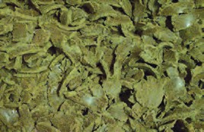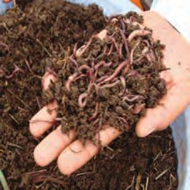

**Oil cake**

**Vermiculture**

Now a days, organic farming and organic products have become buzzwords. Organic products are being available and demand for them is ever-increasing.

Chemical fertilizers and pesticides have been used on large scale. These poisonous chemicals reached the human body through food and water and their adverse harmful effects on human and environment became apparent.

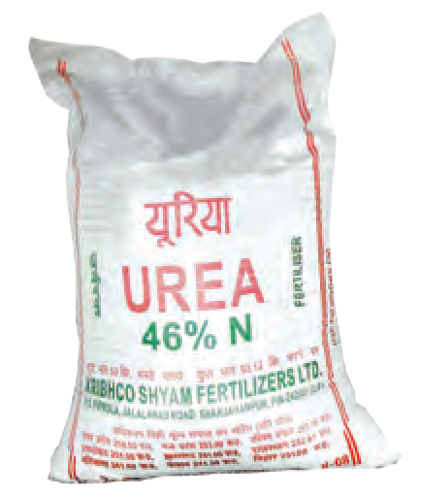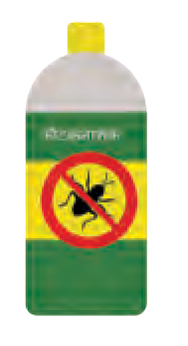

* 1. **Fertilizers and Insecticides**

Various problems like soil fertility and pest infestation have become serious. So as to overcome these problems, farmers are opting for organic farming. It includes complete ban on chemical fertilizers and pesticides and use of local, sturdy varieties and thereby maintaining natural balance. Definitely, this is a welcome decision.

Apiculture

* 1. **Oil cake and Vermiculture**

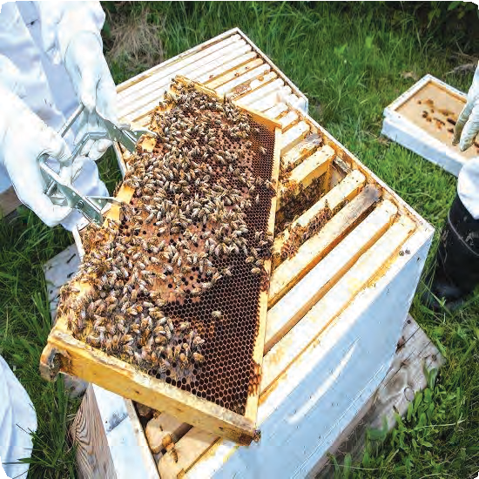

* 1. **Apiculture**

You must have seen the bee hive. Worst method of harvesting / collecting the honey from these hives is driving away the bees by smoking the hive with burning torch and then cutting the hive into pieces. This method causes the destruction of hive and large scale death of bees. However, it is easy to collect the honey without destroying the hive and

bees, if artificial bee boxes are used.



98

Cultivation of Medicinal Plants

India has been gifted with a great biodiversity. Indian citizens have established the humble and strong relation with the nature. We have a great tradition of ayurveda that cures the diseases with

the help of natural sources.

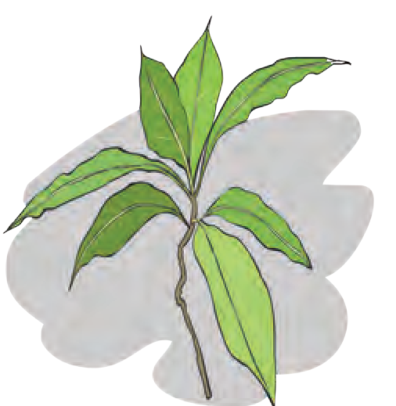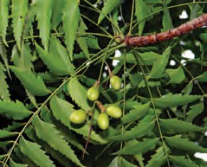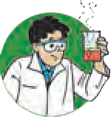

**Try this**

Bring a packet of ‘Balghuti’ from ayurveda shop. Learn the information about each component in it. Collect information about various other medicines and prepare the chart as shown below.

* 1. *Adhatoda vasica* **(Adulsa) and**

|  |  |  |
| --- | --- | --- |
| **Local Name of plant** | **Name of**  **active ingredient** | **Uses** |
| Adulsa | Vasicine present the leaves | Cough |
|  |  |  |

*Azadirachta Indica* **(Neem)**

During earlier days, medicinal plants were collected from the forest. However, due to depletion in forest area, medicinal plants are becoming rare. Hence, medicinal plants are being cultivated.

Which fruit processing industries you observe in your surrounding ? What is their effect ?



**Make a list and discuss**

Fruit Processing

We are daily using various products prepared from fruits. All are consuming the products like chocolates, juices, jams and jellies. All these products can be produced by processing on fruits. Fruits are perishable agro-produce. It needs the processing in such a way that it can be used throughout the year. Fruit processing includes various methods ranging from storage in cold storage to drying, salting, air tight packing, preparing murabba,



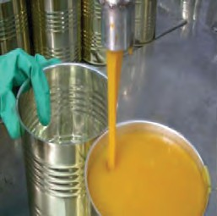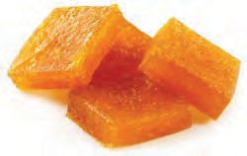

* 1. **Mango processing Unit**

evaporating, etc.

# Exercise

1. **Fill in the blanks and complete the statements.**

a. Methods like artificial insemination and embryo transplant are mainly used for --

b is the revolutionary event in biotechnology after cloning.

c. The disease related with the synthesis of insulin is --.

d. Government of India has encouraged the for improving the productivity

by launching NKM-16.



99

1. **Match the pairs.**
2. Interferon 1. Diabetes
3. Factor 2. Dwarfness
4. Somatostatin 3. Viral infection
5. Interleukin 4. Cancer
6. Haemophilia
7. **Rewrite the following wrong statements after corrections.**
8. Changes in genes of the cells are brought about in non-genetic technique.
9. Gene from *Bacillus thuringiensis* is introduced into soyabean.
10. **Write short notes.**
11. Biotechnology: Professional uses.
12. Importance of medicinal plants.
13. **Answer the following questions in your own words.**
14. Which products produced through biotechnology do you use in your daily life?
15. Which precautions will you take during spraying of pesticides?
16. Why some of the organs in human body are most valuable?
17. Explain the importance of fruit processing in human life?
18. Explain the meaning of vaccination.
19. **Complete the following chart.**
20. **Write the correct answer in blank circles.**

**Uses of stem cells**

1. **Identify and complete the following correlations.**
2. Insulin : Diabetes :: Interleukin : -- -- --
3. Interferon : -- :: Erythropoietin : Anaemia.
4. ------- : Dwarfness :: Factor VIII : Haemophilia.
5. White revolution : Dairy :: Blue revolution : --.
6. **Write a comparative note on usefulness and harmfulness of biotechnology.**

Projects:

1. Visit the organic manuring projects nearby your place and collect more information.
2. What will you do to increase public awareness about organ donation in your area?
3. Collect information about ‘green corridor’. Make a news-collection about it.





Merits of Biotechnology



100

Elders always instruct you to get out of the home to interact with relatives and others and play outdoor games but not to spend time continuously with television, phone and internet.



**9. Social health**

* **Social Health** ➢ **Factors endangering the social health**
* **Stress Management**



**Let’s Think**

Why the children of your age are instructed same in each home? Our lifestyle has been changed to some extent in this age of technology. Each person is busy with own daily routine work and favourite job only. How much is it scientifically correct?

Earlier, we have studied the importance of physical health, cleanliness and staying healthy. However, the concept of health does not end with it only.

Classify your classmates into following groups depending upon the observation for a week.



**Try this**

1. Highly interactive. 2. Occasionally interactive. 3. Non-interactive

Make a list of the friends of each of the above three group members and also mention the group to which you belong.

Social health

Observe the following chart. Discuss about the relationship of various factors shown therein with the social health.



**Observe and Discuss**

Satisfying basic needs of persons-Food, clothing, shelter, medicines.

Education and Job Opportunities

Education

Financial Status

Gardens

Social and Physical conditions of the surrounding

Social environment of the surrounding

Transport Facilities

Social safety Social treatment

Factors affecting

**the social health**

Play grounds

Residential area

Water Toilets

Political conditions (views)

* 1. **Factors affecting the social health**



101

Out of the various aspects of social health, we thought about only one in the above mentioned activity. Social health is the ability of a person to establish relationship with other persons. Ability to change one’s own behaviour according to changing social conditions is an important characteristic of social health. Various factors like strong personality, having large number of friends and relatives, proper use of time during loneliness and with peer-group, trust in others, respect and acceptance for others are important for good social health. We have seen that various factors affect the social health. **Factors disturbing the social health**

Mental Stress

Competition has increased in opportunities for education, employment and business due to increase in population. Children are facing the problems of loneliness and mental stress due to reasons like nuclear family and parents staying outdoors due to job.

There are many bindings on girls and excessive freedom for

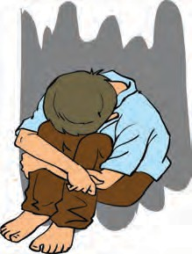boys in some families. Boys enjoy the concession from their domestic duties whereas girls have compulsion for the same on the pretext that ‘should be used to it’. Do you see the advertisements about increasing awareness on avoiding the discrimination between girls and boys or sister and brother in same family on choice for fresh/left-over food, learning medium? In society too, adolescent girls have to unnecessarily face the problems like teasing and molestation. Girls are facing the problem of stress due to such gender

inequality. **9.2 Mental Stress**

Nowadays, everyone has to face the stress due to ever increasing disorder, crime and violence. At the same time, people looking at this as ‘fast and easy way of making money’ may become scapegoats and become part of such system. This is the deadly effect of social illness.

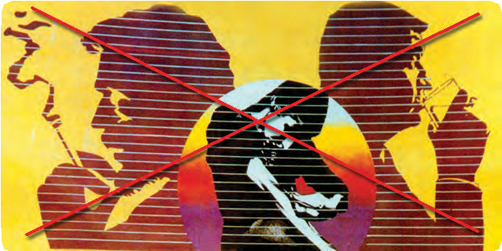Addiction

Peer-group influence is stronger in case of adolescents. Adolescents always prefer the company of friends and follow their good or bad habits instead of following advice of parents and teachers. Children in their early age try upon tobacco, cigarette, gutkha, alcoholic drinks, drugs, etc. due to either peer-

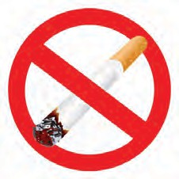-group pressure or symbol of high standard living or as an imitation of elders. However, it may lead to addiction to such deadly substances. Temporarily intoxicating drugs of plant origin and some chemicals may permanently damage the human nervous system, muscle system, heart, etc. Earlier, we have studied the carcinogenic effect of tobacco containing

substances on mouth and lungs. **9.3 Addiction control**



102

Chronic diseases

Ignorance towards the people suffering from chronic diseases like AIDS, T.B, Leprosy and Mental health / disorders and old persons leads to increase in old age homes and this may cause harm to social health.

Whether the incidence shown in the following picture is rational? Express your opinion.



**Think**

* 1. 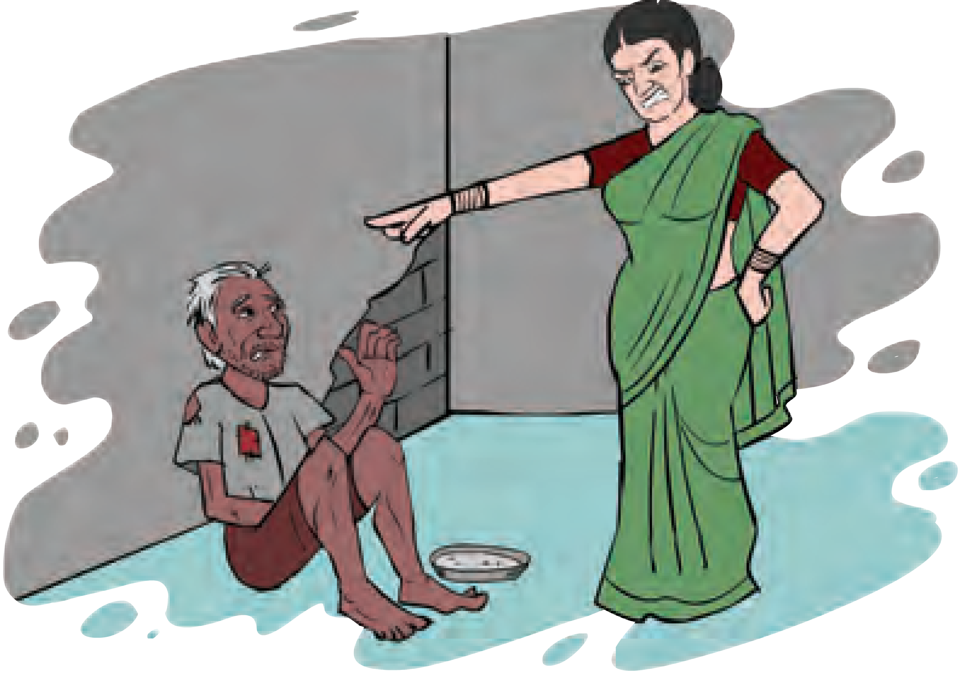An incidence



**Can you tell ?**

Have you ever seen the persons inebriated with drugs or liquor loitering on dirty places? Whether such a pitiful condition of most intelligent human being is acceptable?

You must have read the news about many deaths due to poisonous liquor. Why does it happen?

Liquor is produced from alcohol obtained through fermentation of substances. However, if this process is performed in a wrong way, poisonous liquor is produced and proves fatal for many at a time. Efficiency of nervous system (especially brain) and liver as well as lifespan of person decreases due to alcoholism. Brain development in adolescents is hindered due to alcoholism and thereby ability of memorization and learning becomes slow. Addictive person cannot think rationally. Due to this, the person has to face the social, mental and familial illness along with physical illness.

Communication Media and excessive use of Modern Technology

Two caricatures presenting the situations of the year 1998 and 2017 about playing on playground are given below. Observe those caricatures. Express your opinion about arising of such different situations



**Observe**

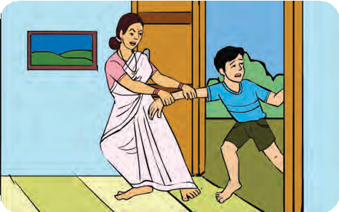

Then

Come for Study!

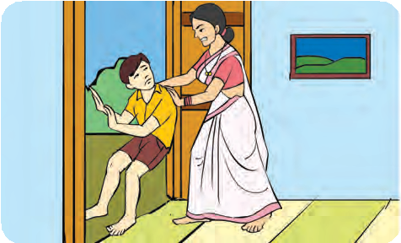

Now

**Go to play!**

* 1. **Different Situations**

Distribute the 24 hours of your daily routine as per various duties you have observed. Make two categories as time spent on your health and time spent on other responsibilities and compare both the categories.



103



**Compare**

Now a days, excessive, unnecessary and irrational use of modern technology and communication media is becoming a sensitive issue through the view point of social health. Persons spending the time with cell phones for several hours are usually unaware of the surrounding. This is also a sort of addiction and leading to endangering of the social health.

Various physical problems like tiredness, headache, insomnia, forgetfulness, tinnitus, joint pains and problems in vision may arise due to radiation of cell phones. More serious fact is those radiations penetrate the bones of children more effectively than the bones of adults. Persons continuously using the computers and internet become solitary. They cannot establish harmonious relations with relatives and other members of the society. Habitually, they become self-centered and thereby they may develop problems like autism and selfishness. They become less sensitive towards others. Chronic effect of such tendency is that they are not ready to help others in need and hence they also do not get it in need.

1. Do you recall the sudden closing of any cartoon serial of for- eign origin being telecast on television?



**Recall a little**

1. Explain details on happenings about blue whale game.

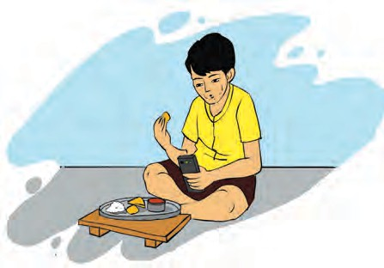Children who watch the cartoon films may imitate the characters of those films. Tendency and behaviour of the children who play the games like virtual war and car races (especially deliberately brought about virtual accidents in games) gradually become negative. Some games available on cell phones and computers are extremely time-consuming and also cause economic losses, to lose concentration on some essential subjects and may also prove fatal.

Along with some useful purpose, huge information available on internet is used for viewing some inappropriate videos too. However, there is a governmental regulation over such media. Website, movies and cartoon films inappropriate for children are banned by the government.

•

Why is there increase in news of death by drowning in ocean, falling in deep valleys or under trains during catching the cell phone selfie?

* There is increasing competition to upload the videos of road accidents instead of helping the

victims. What is the mentality of such people?

* Why are the video-clips of parents threatening or hitting the children not studying as per their

wish or domestic helpers beating the children are very common on social media nowadays?

* 1. **Boy using cell phone while eating**

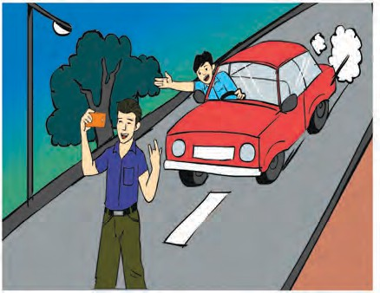

* 1. **Selfie on Road**



**Observe**

Observe the above images Is it rational? Why?



104

Person indulging in such destructive and unnatural activities is usually under stress and such activities are bursting of stress. Medical science has declared such activities as mental illness.

Person indulging in selfie is not aware about the world around and the risks. This is called as selfiecide. Persons indulging in domestic violence, sending messages to others before committing suicide or those who send the video clips of suicidal act are mentally ill and they do so to win the sympathy.

* 1. 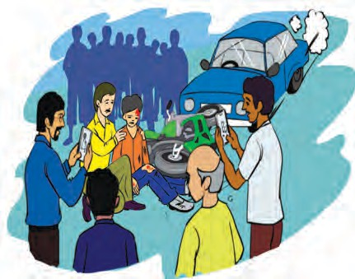**Pedestrian making a video-clip of the accident scene**

Hence, make the constructive use of communication media like television, phone and internet for essential needs and entertainment only but do not go into their clutches by spending hours with those media.

Visit the website [www.cyberswachhtakendra.gov.in](http://www.cyberswachhtakendra.gov.in/)



**Internet My Friend**

Cyber crimes

* + - Banks continuously spread the message on mobile phones about not to disclose the aadhar / PAN / credit card / debit card number and other personal information if demanded by any person.
    - Do not disclose your PIN to anyone while withdrawing cash from ATM machine or purchasing through card payment. Why such instructions are given?
    - Consumers are deceived by showing superior items on websites but actually selling the items of either inferior quality or impaired ones.
    - Bank transactions are done using PIN without the knowledge of consumers.
    - Confidential information about government, institutes and companies is obtained from internet with the help of computer programs or other ideas and misused. This is called as hacking of information.
    - Nowadays, crimes like opening a fake account on Facebook and displaying false information and thereby teasing the girls or exploiting them financially.
    - Misuse or illegal sale of the written literature, software, photos, videos, music, etc. of others by obtaining from internet is called as piracy.
    - Electronic media is also misused by sending derogatory

messages, spreading vulgar pictures and inflammatory statements.







* 1. **Cheating of Consumers**



105

* + - Electronic media is also misused by sending derogatory messages, spreading vulgar pictures and inflammatory statements.
    - Exchange of information through media like email, Facebook and Whatsapp occurs very fast. However, our personal information and phone numbers are automatically spread and thereby reaches the unwanted persons which leads to malpractices like incoming of unnecessary messages. Some of such messages either impair of shut down the mobiles and computers.

All the above mentioned incidences are examples of cyber crime. Committing such crimes is also a mental illness. Later on, the criminal also has to face the mental stress. ‘Cyber crime unit’ has been newly launched in police department. Cyber crime experts collect the details, investigate the cyber crime and thereby find the criminal with the help

of internet.



**Do You Know**

IT Act-2000: This act has been enacted since 17th October 2000 and been amended in 2008. Person committing the cyber crime has to face the punishment like imprisonment for 3 years of fine up to 5 lakh. Maharashtra is at forefront in controlling the cybercrimes and it has been proved to be a first state to start a separate cyber crime unit.

Stress management

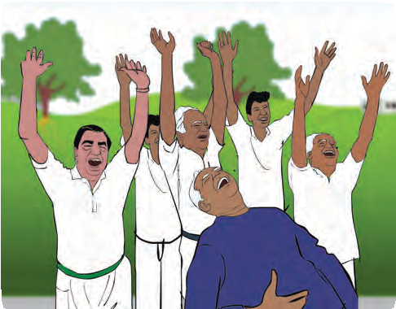Have you seen the loudly laughing citizens in morning in public gardens? Name of this newly popularized concept is ‘laughter club’. These people relieve their mental stress by laughing loudly.

Various ways of expression like establishing communication with friends, peers, cousins, teachers and more importantly parents, noting down our feelings, expressing our feeling with near and dear ones help us to relieve the stress.

Fostering the hobbies like material

collection, photography, reading, cooking, **9.10 Laughter Club**

sculpturing, drawing, rangoli, dancing, etc. help us to properly utilize the free hours. By diverting the energy and mind towards the positive thinking, negative thoughts are automatically neutralized.

Why do you wait for periods of music, P.T., drawing in the classroom?



**Can you tell ?**

Learning and listening to the music, singing keeps us happy and drives away the stress. Music has the power of changing the mindset. Importance of outdoor games is unparallel. There are various benefits of sports like it causes physical exercise, improves discipline, interaction and tendency of unity, loneliness is driven away and person becomes more social.



106

Regular exercising, massaging, visiting the spa too help to relive the stress. Yoga is not limited for asanas and pranayam but it includes discipline, balanced and good food, and meditation also. Deep breathing, yogic sleep, yogasanas, etc. are good for health. Meditation helps to improve the ability of concentration. It imparts positivity in our temperament. Meditation helps the students to improve concentration in their studies. Deliberate inculcation of characters like time management, planning of our own duties and decision power is nothing but cultivating the socially strong and ideal personality.



**Always Remember**

Nature is closest friend of human being. Hobbies like gardening, bird watching, lingering in nature, rearing domestic animal, etc. helps to create positive mindset, improves confidence. Social health can be maintained by keeping ourselves aware about happenings around us, neutralizing the negative thoughts (ex. revenge), etc.

We have all the ways to manage our stress. However, if those are not successful due to certain reasons, it leads to some more serious problems like depression and frustration. Medical advice, counselling and psychotherapy are available for such persons. Similarly, many NGOs also provide helping hand. Let us see the information about some of those.

1. Unified Movement against Tobacco.

This movement has been started by 45 different well-known organizations like WHO, Tata trust, etc. This movement is active for controlling the tobacco consumption and providing guidance to activists against tobacco.

1. Salaam Mumbai Foundation

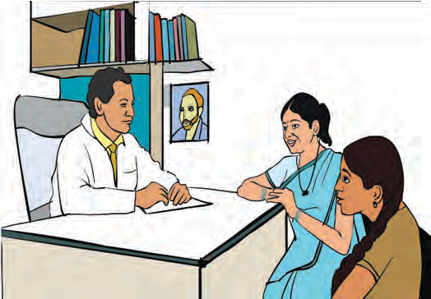This organization runs programs in various schools in Mumbai to empower the children living in slum area in the field of education, sports, arts and business. This organization encourages the children to take education by helping them to improve their health and lifestyle. This trust has made some districts in Maharashtra completely tobacco- free through hard work. Since the year 2002 this organisation is working with various school in urban and rural area for

making the society tobacco-free. This programme is being implemented with the help of Government in about 200 schools in Mumbai and 14000 schools in the rest of Maharashtra. The oath of freedom from tobacco is taken in every school as per the Government letter.

Government Schemes

Phone number / helpline numbers are published in newspaper to help the

children in distress or facing any type of problem. Children contact the

**9.11 Counselling**

helpline to narrate their problems. Proper help and guidelines are offered to children.



107

# Exercise



1. Fill in the blanks with appropriate word.
   1. Laughter club is a remedy to drive away --.
   2. Alcohol consumption mainly affects system.
   3. The act is to curb the cyber

crimes.

1. Answer the following.
   1. Which factors affect the social health?
   2. Which changes occur in persons continuously using internet and mobile phones?
   3. Which problems do the common man faces due to incidences of cyber crime?
   4. Explain the importance of good

communication with others.

1. Solve the following cross-word
2. Continuous consumption of alcoholic and tobacco-materials.
3. This app may cause the cyber crimes.
4. A remedy to resolve stress.
5. Requirement for stress free life.
6. Various factors affect health.
7. Art of preparing food items.

|  |  |  |  |  |  |  |  |  |  |
| --- | --- | --- | --- | --- | --- | --- | --- | --- | --- |
|  |  |  |  |  |  |  |  | 3 |  |
| 5 |  |  |  |  |  | 6 |  |  |  |
|  |  | 4 |  |  |  |  |  |  |  |
|  |  |  |  | 2 |  |  |  |  |  |
|  |  |  |  |  |  |  |  |  |  |
| 1 | A | D | D | I | C | T | I | O | N |
|  |  |  |  |  |  |  |  |  |  |
|  |  |  |  |  |  |  |  |  |  |
|  |  |  |  |  |  |  |  |  |  |
|  |  |  |  |  |  |  |  |  |  |
|  |  |  |  |  |  |  |  |  |  |

1. Which are various ways to minimize stress?
2. **Give three examples of each.**
   1. Hobbies to reduce stress.
   2. Diseases endangering the social health.
   3. Physical problems arising due to excessive use of mobile phones.
   4. Activities under the jurisdiction of cyber crime laws.
3. What will you do? Why?
   1. You are spending more time in internet/mobile games, phone, etc.
   2. Child of your neighbour is addicted to tobacco chewing.
   3. Your sister has become incommunicative. She prefers to remain alone.
   4. You have to use free space around your home for good purpose.
   5. Your friend has developed the hobby of snapping selfies.
   6. Your brother studying in XII has developed the stress.
4. What type of changes occurs in a home having chronically ill old person? How will you help to maintain good atmosphere?

**Project**:

Enlist various factors affecting the social health in your residential area. Decide the necessary changes to correct the situation and implement those changes.





108



**10. Disaster Management**

* **Disaster**
* **Types of disaster**
* **Effect/ Impact of disaster**
* **The nature and extent of disaster**
* **Mock drill**
* **Effect of disaster**
* **Disaster management**
* **First aid and emergency action**

Disaster

1. What is disaster?
2. Which disasters have you experienced in your area?



**Can you recall?**

1. What are the effects of that disaster on local and surrounding conditions?

Variously dangerous events occur many times in the environment. Those are called as disasters. Some of the main natural disasters are floods, wet and dry famine, cyclones, earthquakes, volcanoes, etc. These are ‘all of a sudden’ troubles to the mankind. Such events cause sudden changes in the environment and thereby cause the damage to it. En- vironment is also damaged due to use of natural resources for our development. This leads to sudden disasters, unexpected to human. These can be called as man-made disasters.

United Nations has defined the disaster as ‘the sudden event that leads to the huge loss of life and property. Words like ‘huge’ and ‘sudden’ are important in the definition. As the disaster occurs suddenly, it cannot be predicted. Hence, precautions are not possible. Huge losses to the property occur in the area of disaster. There are long term effects on society due to incidences of life and property loss. Various areas of life like economic, social, cultural, political, law and administration, etc. are affected by it. The life in the area of disaster disturbs totally. There is loss to life and property of the people in distress.

Earlier, we have studied various types of disasters and the measures to be taken. None of the different disasters are similar. Period of each disaster is not same. Some disasters are short term where as some are long term. Reasons behind each disaster are also different. Depending upon the nature of disaster, it can be determined that which component of the environment will be affected more.

Which are two main types of disasters?



**Can you tell?**

Earlier, we have studied the effects of various types of disasters and the precautionary measures to be taken in case any disaster happens. We can classify the disasters in other ways too; like catastrophic disasters. Ex. Cyclones in Odisha, catastrophic earthquakes of Gujarat and Latur, frequently buzzing cyclones in coastal Andhra Pradesh, etc. which lead to total chaos, huge loss of life and property in respective region. However, irrespective of all these, life has always returned to normal within short time. Disasters making the impact for long duration are those whose after-effects are either severe or severity increases with time. Ex. Famine, various problems of crop, strikes of workers, rising levels of oceans, desertification, etc.



109

Observe the following images. Whether the places of disasters are known to you? Discuss the effects of these disasters on public life. How it could have been saved from these disasters? Discuss with your friends in the class-room.



**Let’s Discuss**

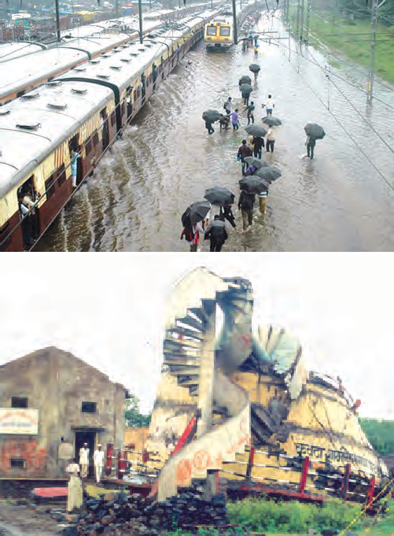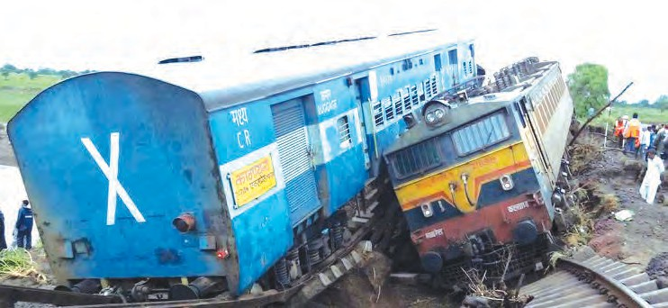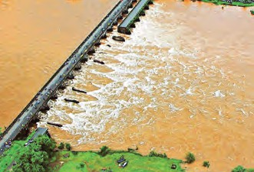

**Internet is my friend**

Search for the video clips of disasters. Discuss in your class about effects of disasters and remedies over it.

**Can you tell?**

How can disasters be classified depending upon

* 1. Some Disasters (Courtesy: Lokmat Library, Aurangabad )

#### Types of Disasters

various criteria?

#### (Geophysical) (Biological) (Man Made)

Geological Ex. Earth quake, volcano, tsunami, land-slides, land-fall, erosion, alkalization, flooding, etc.

Atmospheric Ex. Hot and cold waves, snow-storms, snow fall, cyclones, hail storm,

drought, flood, meteorite, sun spots, etc.

Plant

Ex. Forest fire, fungal dis- ease spreading (Blister), weed, (aquatic, carrot grass, common grass)

Animal Infectious viruses, bacteria (cholera, malaria, hepatitis, plague), insects, bite of poisonous animals,etc.

Unknown poisonous gases.

Atomic test.

Unplanned action Accident..

International War, fire, bomb blast, forced migration, terrorism, rapes, child labour.

* + 1. Which are the destructive effects of flood?



**Can you recall?**

* + 1. Which are the effects of dry famine?
    2. Which are the destructive effects of earthquake?
    3. What is forest fire? What is its effect on environment?



110

#### Effects of disaster

We have understood the serious effects of disaster with the help of above-mentioned questions. Collapsing of bridges, flooding of coastal villages, shortage of food are some of the problems of floods. Collapsing of houses, developing cracks in land are some of the effects of earthquake. Disasters like forest fire and drought also adversely affect the envi- ronment. However, what is exact nature of these disasters? Whether there are any changes in nature before the occurrence of disasters? For how long the effects occur after the oc- currence of disaster? How? It needs to be think over all these aspects. This helps us to understand the nature and gravity of the disaster.

Disasters definitely affect the economy of the nation. That effect is always relative to disaster and economy i.e. if any port is destroyed, there are long lasting effects on econo- my due to huge expenses on its reconstruction. An effect of disaster on social leadership is that if local leadership is not strong enough, citizen become confused. It affects their par- ticipation in rescue and rehabilitation activities. Administrative problems arise during the disaster. If local governing bodies are affected by disasters, related departments cannot answer the problems of disaster efficiently. All the concerned departments are affected by disaster and thereby entire system collapses.



**Complete the chart**

Different problems occurs with disasters. in the con- cept map different effects are mentioned. Read it and fill the blank places.



What will be the effect on yourself and surrounding, if any

Let's Think

accident-like disaster occurs during the sports on playground or in school?

Partial or complete collapsing of buildings, drying out of water sources, contamination of water, Stinky pollution of environment due to decomposing corpses of humans and other animals.

.................................

.................................

.................................

................................

Sudden increase in fund expenditure, shortage of

Economic

Stress on workers, collapsing of transport system, shortage of facilities, etc.

.................................

.................................

.................................

................................

Injuries, emotional / mental stress, increase

funds for development of

other sectors, decrease in productivity.

**Disaster**

Medical

in epidemics, death of victims.

Use your brain power

Depending upon above information, explain the various effects of the disaster of railway accident.



111

Nature and scope of disaster

Taking into consideration the scope of disaster, some of the important facts must be thought over, as follows



Lets Think

Explain the nature and scope of the disaster of flood with the help of six points given beside.

1. Pre-disaster phase

2. Warning phase

1. Emergency phase
2. Rehabilitation phase
3. Recovery phase
4. Reconstruction phase

Taking into consideration the nature and scope of disaster, only three aspects of disaster are important for common citizens.

1. **Phase of emergency:** Important character of this phase is that maximum lives can be saved by quick actions during this phase only. Various actions like search and rescue op- erations, medical assistance, first aid, restoring communication services, removing the people from affected area are expected in this phase. Gravity of disaster can be estimated in this phase only.
2. **Transitional Phase:** Rehabilitation work is started in this phase, after the subsidence of any type of disaster. It includes clearing of debris, restoring water supply, repairing roads, etc. so that it will help to bring normalcy in public life. Rehabilitation of the victims is important aspect of this phase. Generally, different institutes offer the monetary and other type of help to such people. It helps to soothe the mental stress at the earliest if these vic- tims are offered with the permanent mean of earning livelihood and this is true rehabilita- tion.
3. **Reconstruction Phase:** This is highly complicated phase. This phase begins in transi- tional phase. People reconstruct their buildings and facilities like roads and water supply are restored. Farming practices are restarted. However, it takes long time for reconstruc- tion.

Planet Earth has experienced many natural disasters. Listening to the description of those disasters brings numbness to the mind. Most of the disasters and related unprecedented situations have been occurred in the Asian continent and region of Pacific Ocean. Huge loss to the life and the planet Earth has been occurred due to such disasters. Generally, such conditions of natural imbalance have been arisen due to greed of economic progress of human being.

In reality, old problems of several years have become fierce. Ex. Increasing population, its increasing needs emerging problems out of it are now at the extreme end. Such disasters have been increased after the world war-II. Condition of instability arises in the country due to various reasons like economic inequality, racial and religious differences, etc. Inci- dences like terrorism, abduction, social differences have been a routine now.

Production and use of harmful chemicals is under ban in developed countries. How- ever, production of either same or those chemicals which can wipe out the human race is common in developing and poor countries.



112

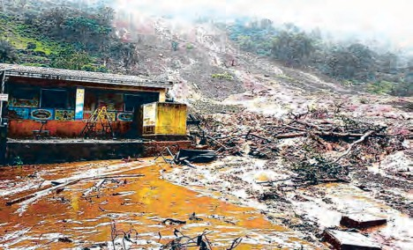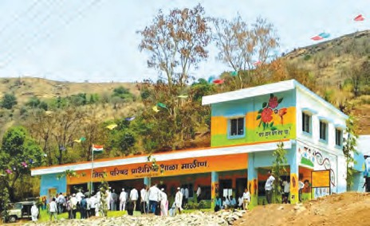

**Do you know?**

In 2014, there had been a huge landslide in the village Malin, Tal. Ambegaon, Dist. Pune. Following is the image of the school reconstructed after the disaster.

Another such threat to human being is from the atomic energy plants. Ex. Radiation leakage occurred after a blast in atomic energy plant at Chernobyl, Ukraine. Its ill-effects are still experienced in the region. This atomic energy plant was only used for electricity generation. Now a day, many countries are equipped with atomic energy. Out of this, risk of radiation leakage is increasing due to carelessness. Hence, importance of disaster management has become the foremost need of almost all the nations. In fact, it is most necessary for citizens of all countries, because they are the main sufferers in any type of disaster. Hence, direct participation of citizens in disaster management is highly necessary. Similarly, disaster management schemes should be changed with respect to location, time and nature of the disaster. It should not be restricted for a particular period. Overall, there may be any type of disaster, it should be overcome. Concept of disaster management has been arisen out of this only.

Disaster management

**Objectives of Disaster Management**

1. Saving of human life during the calamity and release of the people.
2. Supply of essential commodities of the people to reduce the effect of disaster.
3. To restore the human life in the region by creating reconciliation in disaster.
4. Rehabilitate disaster victims.
5. Considering protective measures in disaster, such disaster will not reach in future and take care to reduce their intensity.

Disaster may be minor or major, short-

-time or long-time, it should be overcome and effective disaster management is necessary for it. There is close relationship between disaster management and public participation. Disaster management is either prevention of disasters or making arrangements to face it or at least achieve the abilities to face it.

Disaster is a very fast process, in fact it is accident. What shall we do in such situation? How can we protect ourselves, our belongings and animals?

In case of disaster management, there should be an attempt to minimize the losses. Disasters are never planned but losses due it can be prevented in a planned manner.



113

Disaster management is achieving or time to time improving the ability to face the disasters through scientific and careful observations and analysis of data. For example, preparing the action plan through study of various aspects like preventive measures, rehabilitation and reconstruction and executing that plan is nothing but the management of disaster. Disaster management can be divided into two parts.

Pre-disaster management

This includes the complete preparation and planning to face any type of disaster. For that purpose..

* 1. Identifying the pro-disaster areas.
  2. Collecting the information about intensity of disaster and probable sites of disasters through predictive intensity maps and hazard maps respectively.
  3. Getting special training for disaster management.
  4. Increasing awareness about disaster management among the general public through training programmes, mass media, and etc. Post-disaster management

Post-disaster management

1. Providing all types of necessary help to victims of disasters.
2. Participation of preferably local peoples saved from the disaster in arranging the help to victims.
3. Quick establishment of help centre. Different types of disasters need dif- ferent types of control centres.
4. Categorization of the help material received from control centre, deliver- ing the material to victims and con- tinuous review of the help.
5. Being always prepared for disaster rescue.

Observe the disaster cycle given below and explain each aspect of the disaster of earthquake.



**Observe**

**Preparation:** Plan is prepared to minimize the destruction in any disaster, if occurs.



**Redemption:** Plan for minimizing the damage to the society and country.

**Preparedness:** A plan is chalked out so as to get the quick response from general public and administration.

**Restoration:** This is an important link between measures after disaster and national development. This step is useful for progress of nation and rehabilitation.

**Resurgence** : Resurgence is an important link between emergency measures and national progress. Resurrection is a stage used for the welfare and rehabilitation of the nation.

**Response :**

**Main aspects of disaster management cycle**

Response to the disaster is to be given immediately after the incidence. This factor is followed by the disaster strike in this cycle.

### 114

**Impact of disaster:**

Intensity of various aspects of disaster and disaster management are reviewed.



**Try this**

Which factors will you consider while designing the pre-disaster management plan for your school / home?



**Always remember**

Though avoidance of natural disaster is impossible, loss out of it can be minimized. However man-made disasters can be avoided. Helping each other in the crisis of disaster is our ethical responsibility.

Prepare a survey report with the help of your teacher.

**Structure of Disaster Management Authority**

In case of disaster, an authority has been established at the level of government. Following flow chart indicates the function of control and coordination under the disaster management from national to village level. Disaster Management Act, 2005 has been passed in our country.



National disaster management authority Chairman : Prime Minister

Other Social/ private organisation

State disaster management authority Chairman : Chief Minister

Organisations providing precautionary warning

District disaster management authority

Chairman : Collector

General public

Taluka disaster management authority

Chairman : Tahsildar

Village level Committee

Chairman : Sarpanch

System involved in actual rescue and rehabilitation work

Get information

Visit the District Collector or Taluka Tehasildar office and collect the information about disaster management.

District Disaster Management Authority:

At the district level, district collector is responsible for disaster management and imple- mentation of rehabilitation schemes. Collector is planning, coordinating and controlling the implementation of rehabilitation programme, gives out necessary instructions and re- views the entire system. District collector is also responsible for designing the schemes for each district, separately for each type of disaster and getting those sanctioned from state-level authorities.



115

District-wise Disaster Control Unit:

District control unit is established immediately either after the impact of disaster or getting intimation about it. It reviews about various aspects of disaster, keeps continuous contact with various agencies like army, air force, navy, telecommunication department, paramilitary forces, etc. for getting help. It is also responsible for coordinating with various voluntary organizations for their help in disaster management.



**Internet is my friend**

**Find out more about the activities of international organizations that work for disaster management.**

1. United Nations Disaster Relief Organization
2. United Nations Centre for Human Settlements
3. Asian Disaster Reduction Centre.
4. Asian Disaster Preparedness Centre.
5. World Health Organization.
6. United Nations Educational, Scientific and Cultural Organization.

Who Does What?

National Disaster Response Force has been established as per the Disaster management Act, 2005. Divisions of this force are working in army. Overall, 12 divisions are working in the country. Its headquarter is in Delhi and it is in action all over the country with the help of army. In Maharashtra, National Disaster Response Force is in action through State Reserve Police Force. Personnel of this force have substantial contribution in rescue work in disasters like cyclones, cliff-sliding, building collapse, etc. Website: [http://www.ndrf.gov.in](http://www.ndrf.gov.in/)

* 1. What is first aid?



**Can you tell?**

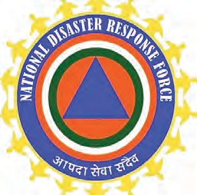

* 1. How can we offer first aid to victims of any disaster?

**First Aid and Emergency Action:**

You have studied in earlier classes about the types of first aid to be offered to the persons injured in disasters. Use of this knowledge is useful for offering the help to classmates or people around you facing any disaster and injured there in.

Sometimes, we have to face the disaster due to our own unawareness. Some symbols given beside are seen used around us. Those symbols can not be ignored. Such symbols are useful to avoid the mishaps.

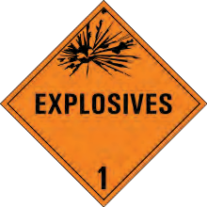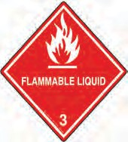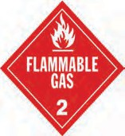

* 1. **Signs**



116

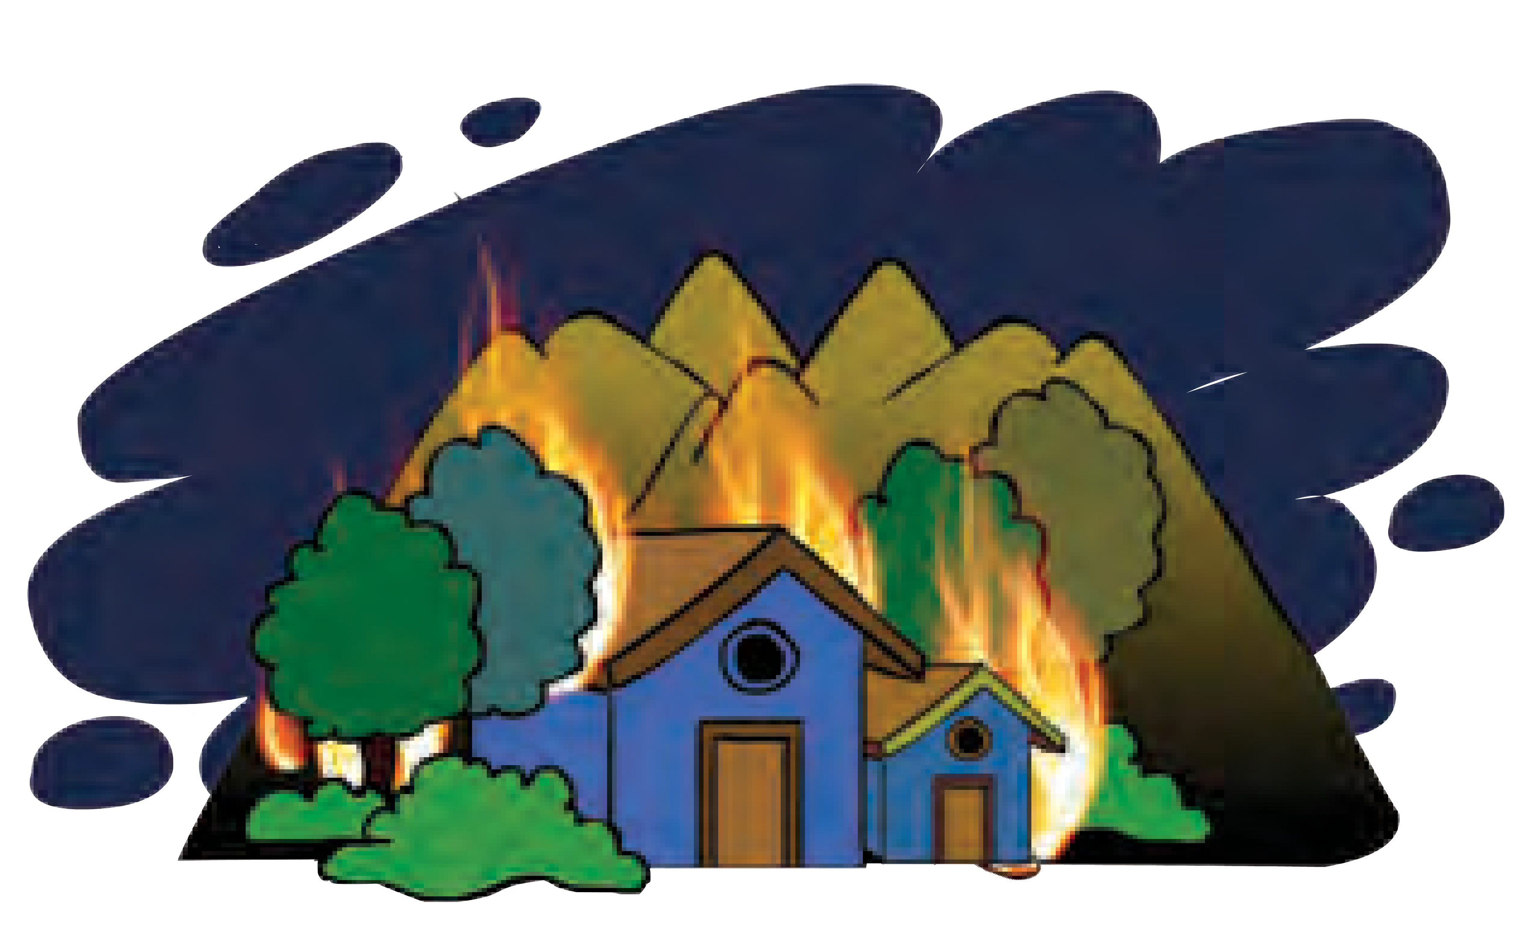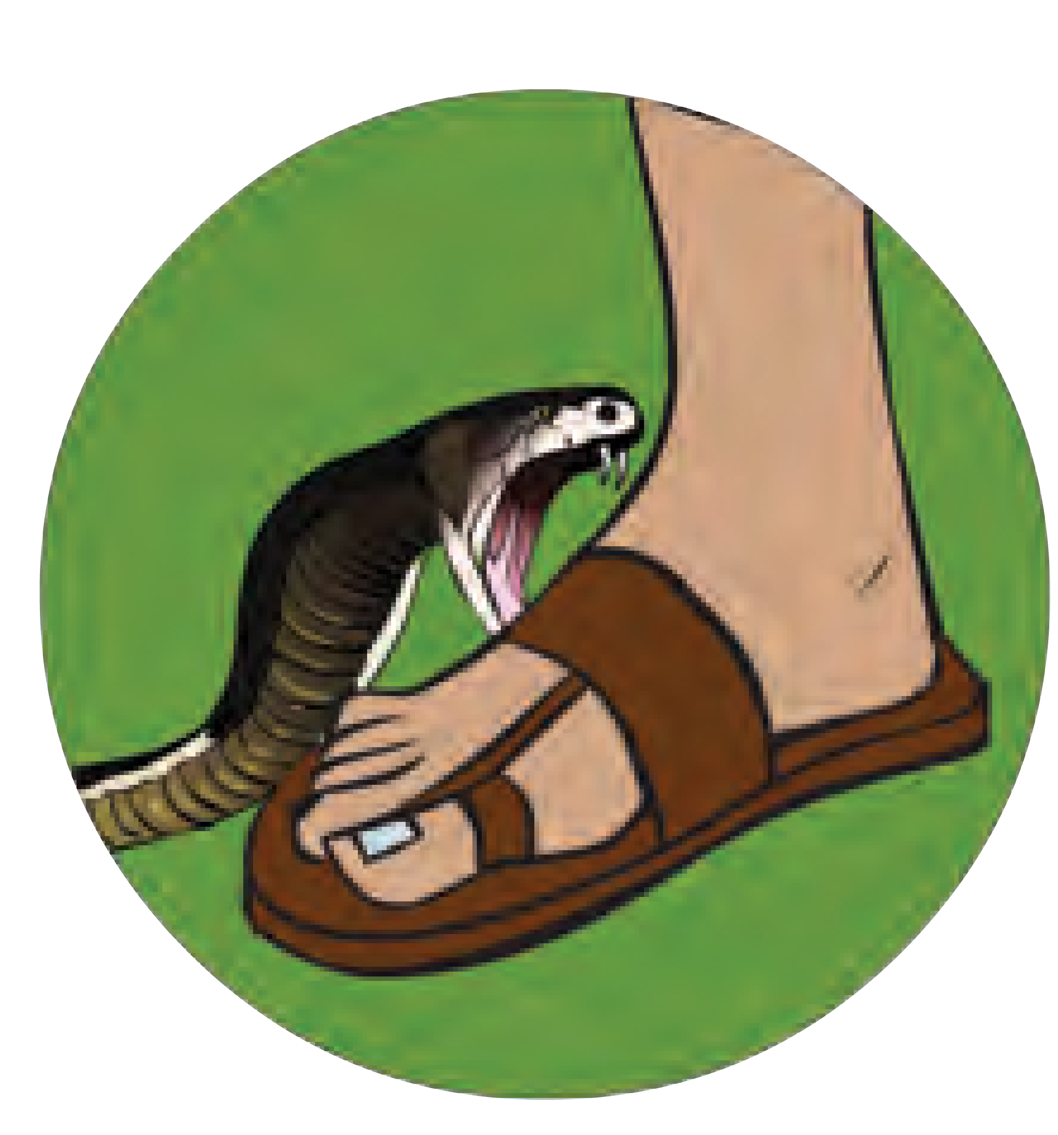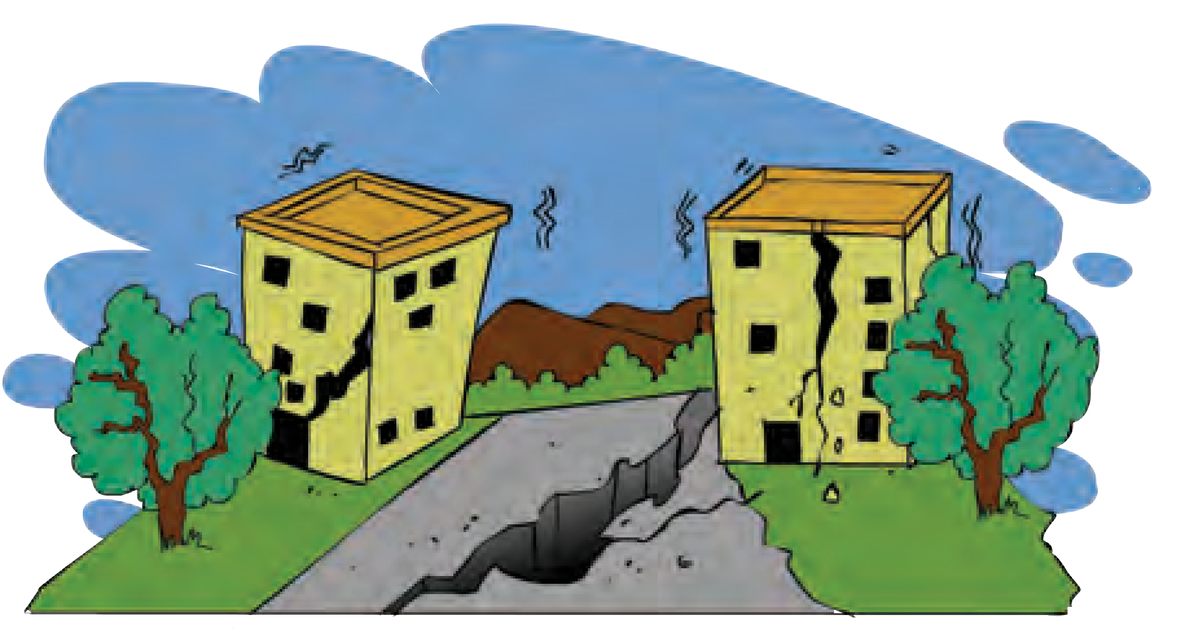

**Let's Think** Following are some pictures of disasters. Which precautions would you take during those disasters?

A B C

**10.2 Various disasters**

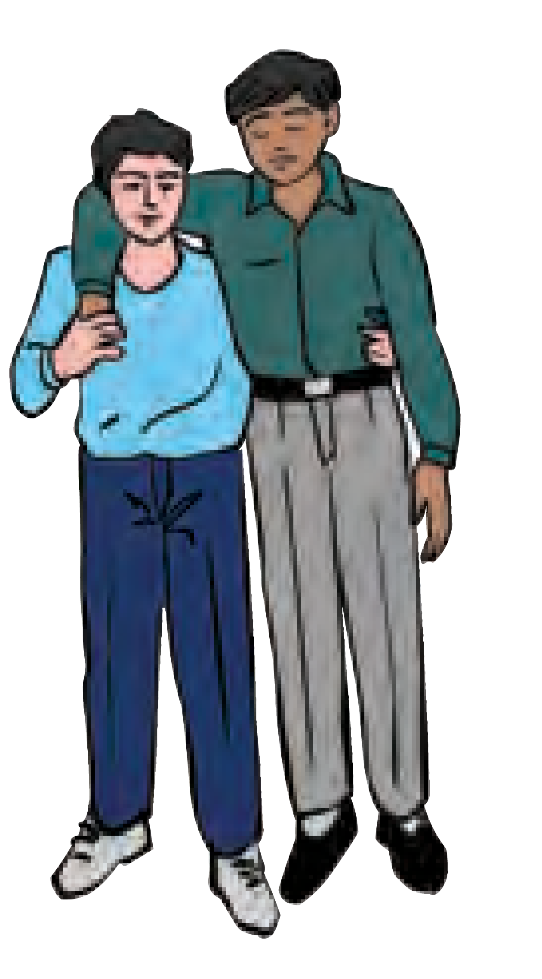Give the reference of following pictures and explain importance of each of those in disaster management. Which are other such activities?



**Observe**

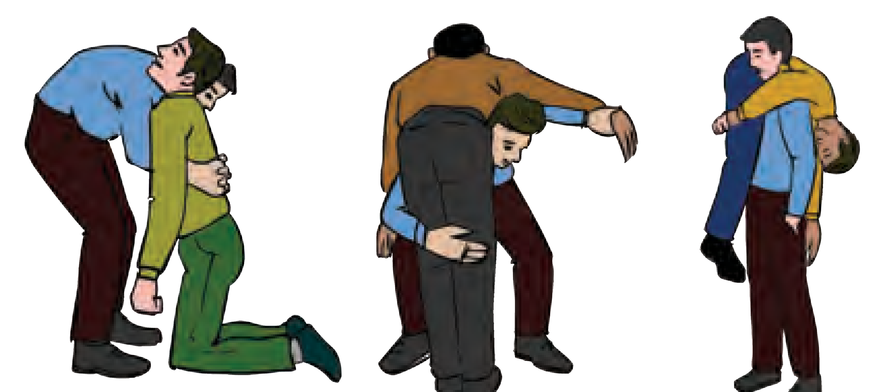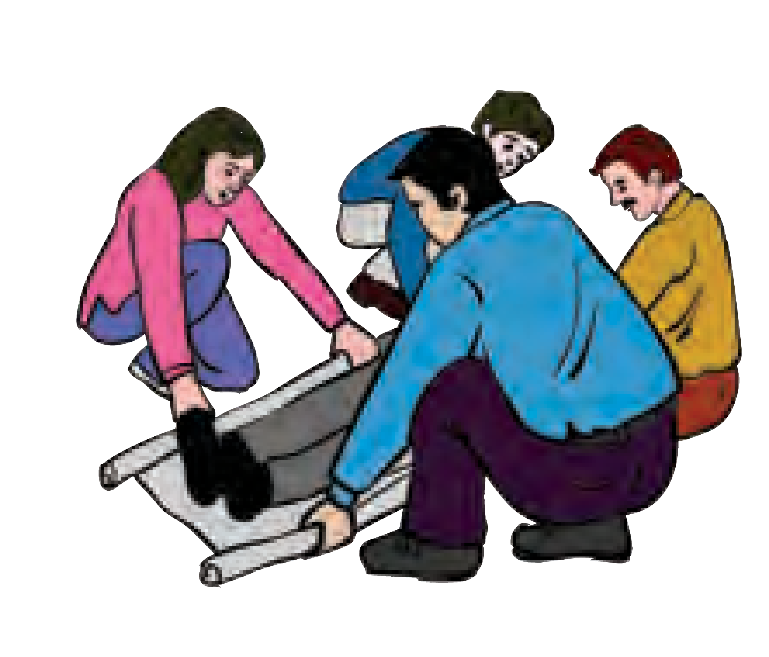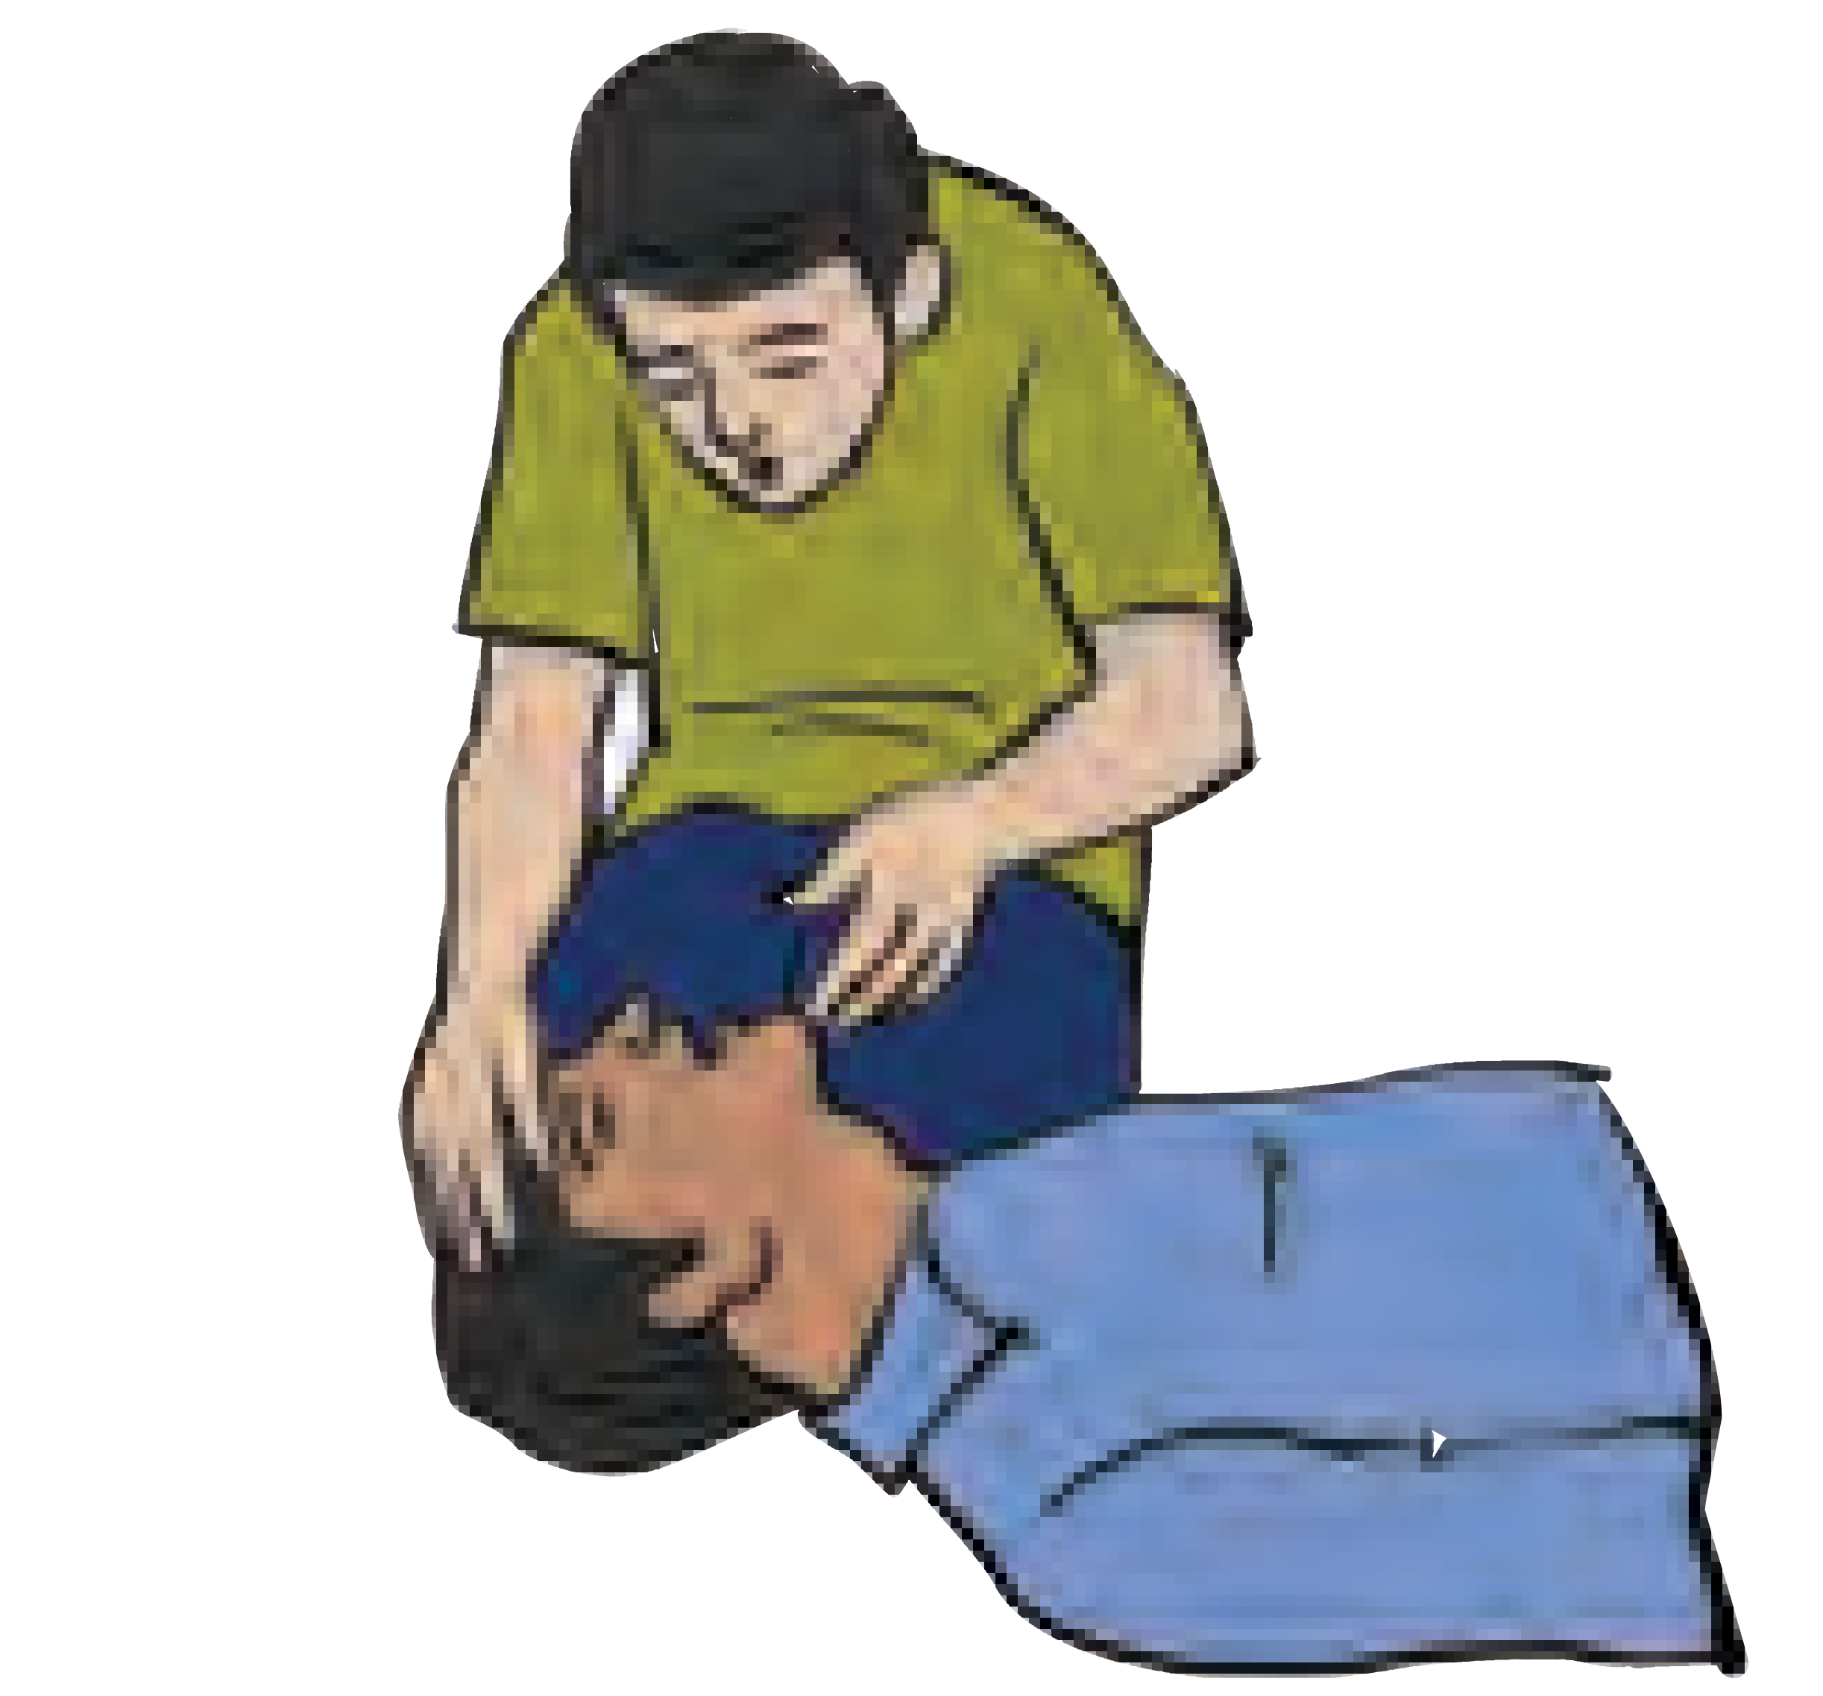

**a b c d e f**

**10.4 Various activities**

In emergency condition, various transportation methods like cradle method, carrying on back, carrying on two hands are to be followed. Those methods depend upon the condition of victim. We face different types of major or minor disasters in our daily life. Varieties of disasters like accidents, stampede, injuries in fighting, electric shock, burns, heat shock, snake bite, dog bite, fire due to electric short circuit, epidemic of any disease, etc. happen around us. Victims of disaster need to be offered some primary help before actual medical treatment. First aid is useful in such circumstances.

Complete the chart as per the objectives of First Aid.



**Complete the chart**

Relieving the pains



Preventing deterioration of condition of victims of disaster

Saving lives

Objectives of First Aid

### 117

Attempt to improve the condition

First Aid Kit

It is essential to have material necessary for first aid with us. That material is available in the first aid kit. You can also prepare a first aid kit. It is also important to use whatever the material available in the given condition for first aid.

Meet the medical officer / doctor from your village and collect information about providing the first aid.



Get information

**The necessary material in first aid box**

1. Bandage strips of different size 8. Antiseptic (Dettol/ Savlon) 15. Scissor
2. Wound gauze. 9. Safety pins 16. Thermometer
3. Triangular and circular bandage. 10. Blade 17. Petroleum jelly
4. Medicated cotton 11. Small pins
5. Hand gloves 12. Needle
6. Clean and dry cloth pieces. 13. Band aid
7. Soap 14. Torch

Mock Drill



**Can you tell?**

Whether there had been mock drill by fire fighters under the disaster management scheme in your school? Which techniques did you see during the drill?

It is a practice to check the preparedness of facing the disaster as early as possible. Virtual / Apparent situation of disaster is created to check the reaction time for any type of disaster. Trained personnel observe their responsibilities to check execution of plan designed for disaster redressal. This helps to check the efficacy of the system prepared for disaster redressal.

Mock drill is arranged on disaster of fire in various schools by the fire fighters. It includes the demonstrations like extinguishing the fire, rescuing the people trapped at higher floors of buildings, rescuing the persons whose clothing have caught the fire, etc. Such activities are also arranged by police force and voluntary organizations.

Objectives of Mock Drill



1. Evaluating the response to the disaster.
2. Improving the coordination between various departments of disaster control.
3. Identification of own abilities.
4. Improving the ability of quick response to disaster.
5. Checking the competency of the planned actions.
6. Identifying the possible errors and risks.

Internet is my friend

Watch the video clip of fire fighting mock drill on you tube and send to your friends and relatives.

### 118

1. Complete the table.

(Motor accident, land sliding, forest fire, theft, riot, war, epidemic, drought, locust attack, financial crisis, flood, famine)

|  |  |  |  |
| --- | --- | --- | --- |
| Disaster | Symptoms | Effects | Remedy |
|  |  |  |  |
|  |  |  |  |

1. Write notes.
   1. Disaster management Authority
   2. Nature of disaster management
   3. Mock drill
   4. Disaster Management Act, 2005
2. Answer the following questions.
   1. Explain the role of district disaster control unit after occurrence of any disaster.

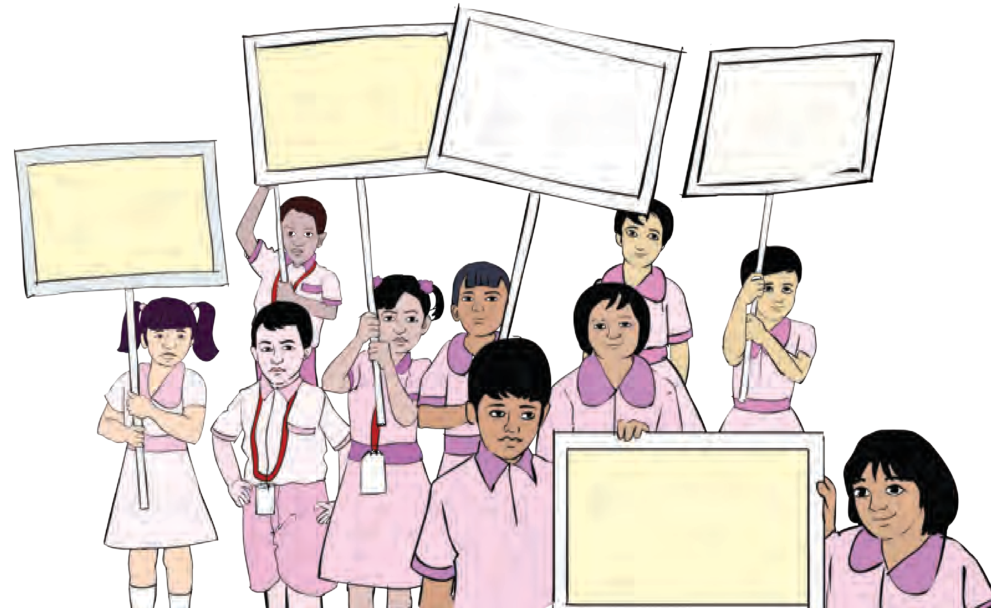

**Always remember**

1. Do not make chaos and push each other while using staircase in the school.
2. Remind important help-lines and use as per need. Ex. Police 100, Fire fighting force 101, Disaster Control Unit 108, Ambulance 102, etc.
3. Follow the traffic rules. Look at left and right sides while crossing the road and ensure that any vehicle in not passing by.
4. Do not touch any unclaimed object. Do not spread rumours.
5. Do not make chaos at the crowded places.

**Give up the addictions and stay happy**

Today’s students are future citizens of country

**Exercise**

* 1. Give the reasons for increase in human disasters after the World War-II.
  2. Which are the objectives of disaster management?
  3. Why is it essential to get the training of first aid?
  4. Which different methods are used for transportation of patients? Why?

1. **On the basis of the structure of disaster- management authority, form the same for your school.**
2. **Write down the reasons, effects and remedial measures taken for any two disasters experienced by you.**



119

1. Which different aspects of disaster management would you check for your school? Why?

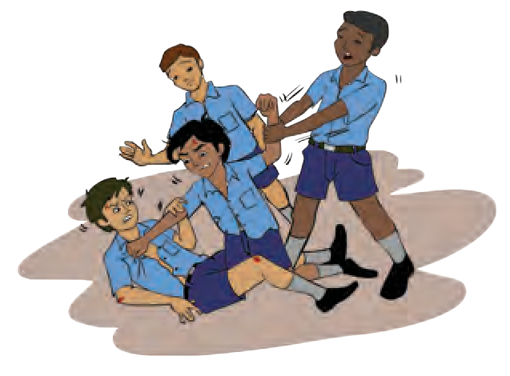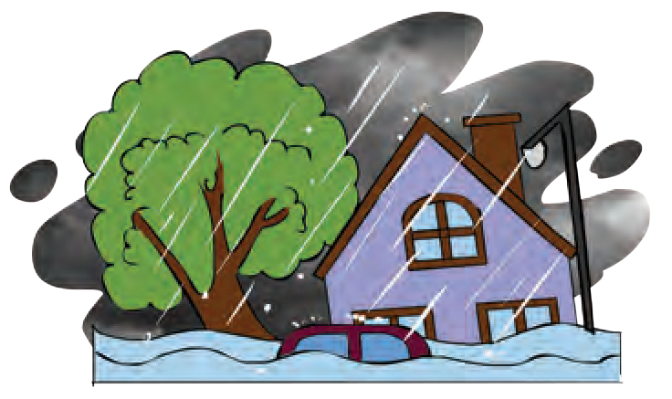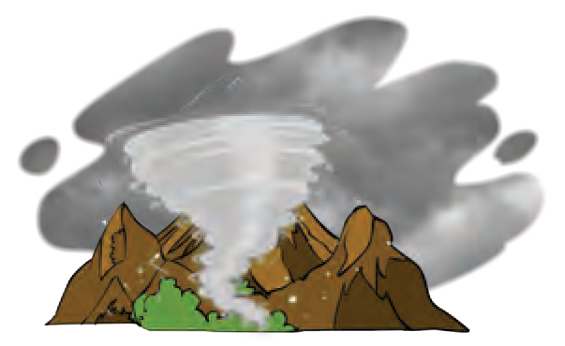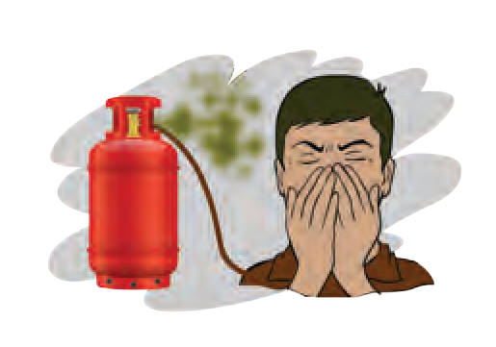

a.

b.

c.

d.

1. **Identify the type of disaster.**
   1. Terrorism b. Soil erosion

c. Hepatitis d. Forest fire

e. Famine f. Theft

1. Some symbols are given below. Explain those symbols. Which disasters may occur if those symbols are ignored?
2. 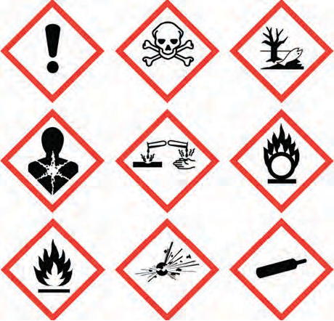**Explain that why is it said like that?**
3. Mock drill is useful
4. Effective disaster management makes us well prepared for future.
5. **Complete the following chart.**

**Properties of Predisaster management**

1. **Following are the pictures of some disasters. How will be your pre- and post-disaster management in case you face any of those disasters?**

**Project:**

1. Demonstrate the activities shown on page no. 106 of std. IX textbook in front of the students of other classes. Make a video clip and send it to others.
2. Form a group of students from your school to demonstrate the mock drill and demonstrate it in the school.





120

